Bayesian Optimization / Scientific Discovery

A Sober Look at LLMs for Material Discovery: Are They Actually Good for Bayesian Optimization Over Molecules?

Authors: Agustinus Kristiadi, Felix Strieth-Kalthoff, Marta Skreta, Pascal Poupart, Alán Aspuru-Guzik, Geoff Pleiss
Affiliation: Vector Institute, University of Toronto, University of Waterloo, University of British Columbia
Publication: ICML, Proceedings of Machine Learning Research
Year: 2024
Link: https://arxiv.org/abs/2402.05015

1. Summary

Problem
- What problem does the paper address?
  - Whether LLMs are actually useful for principled Bayesian Optimization (BO) over molecules, rather than only for heuristic molecular searches. In particular, the paper investigates whether pretrained LLM representations can provide useful prior information for molecular BO and whether fine-tuning them can further improve optimization performance.
- Why is it important?
  - Molecular discovery requires searching an extremely large chemical space while evaluating each candidate through experiments or expensive simulations. BO can reduce the number of required evaluations, but its performance depends on informative representations and reliable uncertainty estimates. The authors therefore examine whether the apparent chemical knowledge of LLMs can actually improve this process.

Method
- Core idea
  - Use LLMs as molecular feature extractors within a Bayesian Optimization framework, while a Bayesian surrogate model is responsible for predicting molecular properties and estimating uncertainty.
  - The paper considers both fixed-feature LLM surrogates, where the pretrained LLM is frozen, and adaptive-feature LLM surrogates, where the LLM is adapted to the BO problem using parameter-efficient fine-tuning (PEFT).
- Novel technique(s)
  - For fixed-feature models, the final transformer embeddings of LLMs are used as molecular representations and combined with Gaussian Processes (GPs) or Laplace-approximated neural networks.
  - For adaptive-feature models, LoRA is used to fine-tune a small number of LLM parameters, and Bayesian inference is performed over the LoRA and regression-head parameters using Laplace Approximation. The pretrained LLM weights are treated as conditioning variables in the posterior.

Main Contributions
- Studies the usefulness of pretrained LLMs for material discovery by using their last-layer embeddings in BO.
- Studies whether fine-tuning through PEFT and then applying approximate Bayesian inference over it is worth the effort in terms of the BO performance.
- Introduces a software library for principled BO on discrete space with LLMs along with its supplementary experiment code.
- Conducts extensive experiments across 8 real-world chemistry optimization problems and 8 recent LLMs, providing empirical ecidence about when and how LLMs can be useful for scientific discovery.

Experimental Setup
- Task: Discrete Bayesian Optimization over predefined molecular candidate pools, including six single-objective and two multi-objective molecular optimization problems.
- Dataset(s): Redoxmer, Solvation, Kinase, Laser, Photovoltaics, Photoswitches, Multi-Redox, and Multi-Laser.
- Baseline(s): Random Search, Morgan fingerprints, MolFormer, general-purpose LLMs including T5, GPT-2-Medium and Llama-2-7B, chemistry-specific T5-Chem, and the LLM-based BO-LIFT method using Llama-2-7B and GPT-4.
- Evaluation Metric(s): Problem-specific best objective value, GAP for normalized BO performance, and Hypervolume for multi-objective BO.

Experimental Results
- Best result
  - T5-Chem generally achieves the best overall BO performance among the fixed-feature models, while LoRA-based fine-tuning further improves the performance of both T5 and T5-Chem on most problems
- Comparison to baselines
  - General-purpose LLM representations such as T5, GPT-2-Medium, and Llama-2-7B generally underperform the simple Morgan fingerprint baseline. In contrast, chemistry-specific representations such as T5-Chem and MolFormer perform substantially better.
  - GPT-4-based BO-LIFT performs better than Llama-2-7B-based BO-LIFT, but a much smaller chemistry-specific T5-Chem combined with a principled Bayesian surrogate performs better while being substantially cheaper.
- Key takeaway
  - LLMs can be useful for molecular BO, but their usefulness depends strongly on domain-specific pretraining or fine-tuning. General-purpose LLM scale and apparent chemistry knowledge do not by themselves produce useful representations for molecular BO.

2. Background & Motivation

Problem Statement
- Molecular material discovery can be formulated as a black-box optimization problem in which a molecular structure is mapped to a property that is expensive to evaluate. The chemical search space is extremely large, while experimental synthesis and computational evaluation limit the number of candidates that can practically be tested.
- Bayesian Optimization addresses this problem by learning a probabilistic surrogate of the expensive objective and sequentially selecting candidates using its posterior predictive distribution. The quality of both the surrogate representation and its uncertainty estimation determines the balance between exploration and exploitation.
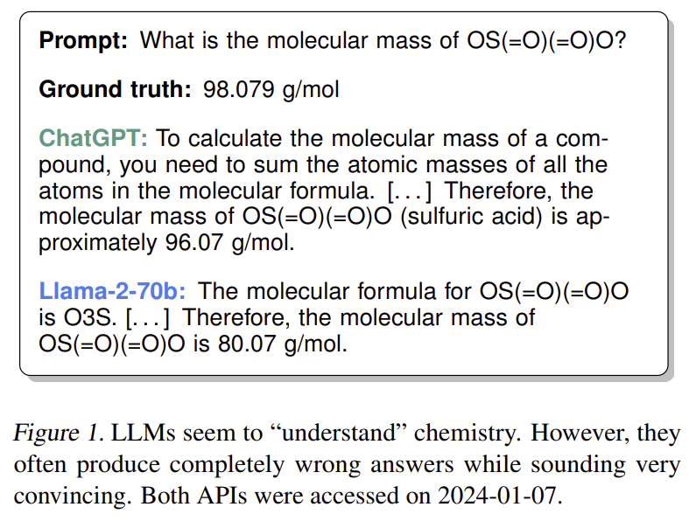

Why is this problem important?
- The molecular search space is estimated to contain at least 10^100 unique molecules, while only a tiny fraction has been experimentally reported. In practical discovery campaigns, researchers therefore work with smaller accessible or synthesizable candidate libraries and need to identify promising candidates with as few expensive evaluations as possible.
- LLMs provide a potential source of pretrained prior knowledge. If their representations capture chemically meaningful information, they could improve the surrogate model and therefore make BO more sample-efficient.

Limitations of Previous Work
- Previous work using LLMs for molecular optimization has primarily relied on heuristic prompting or in-context learning rather than principled Bayesian surrogate models.
- Some methods obtain uncertainty from token probabilities or variability across generated outputs. However, these estimates originate from point-estimated, non-Bayesian LLMs and therefore do not directly represent a Bayesian posterior over the optimization function.
- It is also unclear whether the apparent chemistry knowledge of general-purpose LLMs translates into representations that are actually useful for chemistry-focused BO. The paper therefore investigates this question directly.

3. Related Work

Existing Approaches
- Bayesian Optimization has been widely used for molecular discovery with probabilistic surrogate models such as Gaussian Processes and Bayesian Neural Networks.
- Molecular representations include classical representations such as Morgan fingerprints and learned chemistry-specific representations such as MolFormer.
- LLM-based molecular optimization methods such as BO-LIFT use in-context learning with models such as GPT-4 and Llama-2 to select molecules, but estimate uncertainty heuristically from LLM outputs.
- BoChemian studies the use of text embeddings with Gaussian Process surrogates for Bayesian Optimization of chemical reactions.
- PEFT methods such as LoRA provide an efficient way to adapt pretrained LLMs, while Bayesian methods such as Laplace Approximation can be applied to the trainable parameters.

Differences from Prior Work
- Unlike LLM-based heuristic optimizers, this paper treats the LLM as either a fixed feature extractor or a Bayesian-adapted feature extractor, while explicitly modeling uncertainty through a Bayesian surrogate.
- Unlike previous text-embedding BO work, the paper specifically investigates whether the apparent chemistry capabilities of LLMs justify their use for molecular BO, including the effects of prompting and fine-tuning.
- The paper also provides a probabilistic interpretation of Bayesian PEFT and applies it to molecular BO, rather than using PEFT only as a conventional point-estimate fine-tuning procedure.

4. Method

Overview
- The central idea is to separate molecular representation from Bayesian uncertainty estimation. A pretrained LLM converts the molecular SMILES representation into a final-layer embedding, while a Bayesian surrogate predicts the molecular property and models its uncertainty.
- Two types of LLM surrogates are considered. The first freezes the pretrained LLM and uses its embedding directly. The second adapts the LLM using PEFT and performs Bayesian inference over the trainable PEFT and regression-head parameters.
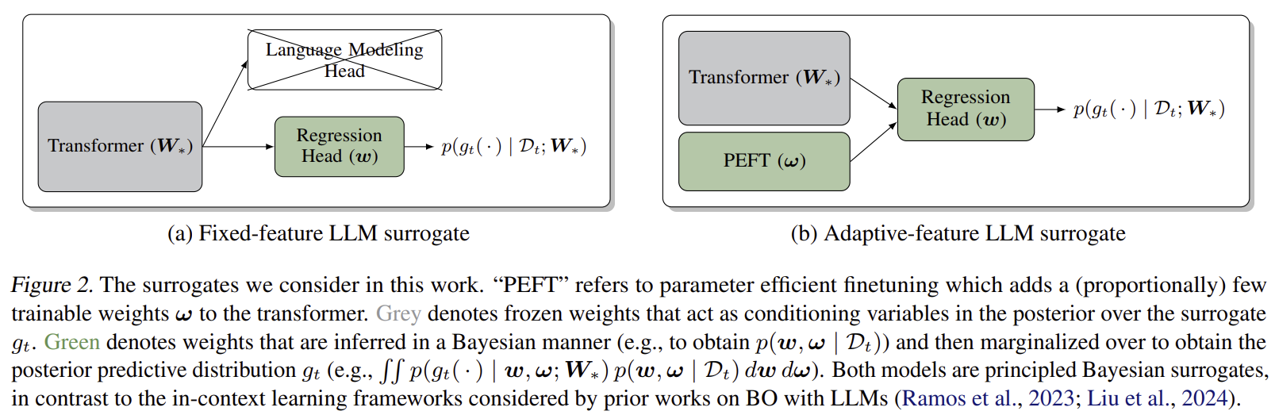

Pipeline
- Convert each candidate molecule into a textual representation, primarily its SMILES string.
- Extract a molecular representation using the pretrained LLM and use it as input to a Bayesian surrogate model.
- Compute the posterior predictive distribution, select the next molecule using an acquisition function such as Thompson Sampling, evaluate its true property, and add the observation to the BO dataset.
- For adaptive-feature models, reinitialize and train the LoRA parameters using the observations collected so far, then apply Laplace Approximation to obtain the posterior predictive distribution before selecting the next candidate.

Model Architecture
- Fixed-feature LLM surrogate
The pretrained transformer is kept frozen, and its final-layer embedding is used as a fixed representation of each molecule. This embedding is then passed into a regression head or surrogate model. A GP or neural network with Laplace approximation is used on top of these embeddings to produce a posterior predictive distribution.
- Adaptive-feature LLM surrogate
The pretrained transformer remains frozen while LoRA adapters are inserted into the model to allow limited adaptation. A regression head with parameters is attached to the transformer. Bayesian inference is then performed over both the regression head parameters and the LoRA adapter parameters, while the original pretrained weights are treated as fixed and only provides a conditioning representation.

Key Components
Component | Purpose
LLM Feature Extractor | Converts the molecular textual representation into a continuous final-layer embedding
Bayesian Surrogate | Models the relationship between molecular representations and target properties while providing predictive uncertainty.
Gaussian Process | Provides a standard Bayesian surrogate for molecular representations.
Laplace Approximation | Approximates the posterior around the MAP estimate and provides uncertainty for neural-network-based surrogate.
LoRA/PEFT | Adapts the pretrained LLM using a small number of trainable parameters while keeping the original weights frozen.
Thompson Sampling | Uses samples from the posterior to select the next candidate and balance exploration and exploitation.

Loss Functions
- The surrogate parameters are trained by MAP estimation, which combines the log-likelihood of the observed molecular properties with a prior over the model parameters. For the adaptive-feature model, the same probabilistic formulation is applied to the regression-head and PEFT parameters while conditioning on the pretrained LLM weights.

Training Strategy
- For fixed-feature models, the LLM parameters remain frozen and only the Bayesian surrogate is trained. The final-layer embeddings can be cached and reused throughout the BO process.
- For adaptive-feature models, the authors use LoRA with rank 4 and jointly train the LoRA and regression-head parameters using MAP estimation. They then apply Laplace Approximation to the LoRA and regression-head weights to obtain their posterior and use Linearized Laplace Approximation to obtain the posterior predictive distribution.
- At each BO iteration, the LoRA weights are reinitialized and trained using the observations collected so far.

5. Experiments

Datasets
- Redoxmer: 1,407 molecules; minimize redox potential of possible flow-battery electrolytes.
- Solvation: Same molecular set as Redoxmer; minimize solvation energy.
- Kinase: 10,449 molecules; minimize docking score of kinase inhibitors.
- Laser: 10,000 molecules sampled from an original set of 182,858; maximize fluorescence oscillator strength.
- Photovoltaics: 10,000 molecules sampled from an original set of 2,320,648; maximize power conversion efficiency (PCE).
- Photoswitches: 392 molecules; maximize π-π* transition wavelength.
- Multi-Redox: 1,407 molecules with redox potential and solvation energy as multiple objectives.
- Multi-Laser: 10,000 molecules sampled from the Laser dataset with fluorescence oscillator strength and electronic gap as multiple objectives.

Experimental Settings
- The experiments perform BO over predefined discrete molecular candidate pools. Each candidate has a ground-truth property obtained from physics-based simulations from the corresponding source studies.
- Molecular representations include 1024-bit Morgan fingerprints, MolFormer embeddings, and embeddings from T5-Base, GPT-2-Medium, Llama-2-7B, and T5-Chem.
- For LLM-based representations, four prompting strategies are evaluated: just-smiles, completion, naive, and single-number.
- Fixed-feature models use GP or Laplace-approximated neural-network surrogates, while the main LLM-feature experiments use Laplace-approximated surrogates. Adaptive models use LoRA-based fine-tuning with Laplace Approximation.
- Multi-objective experiments use multi-output regression and scalarized Thompson Sampling with fixed uniform weighting.

Evaluation Metrics
- Best objective value: Measures the best molecular property discovered as the number of BO evaluations increases.
- GAP: Provides a normalized, problem-independent measure that allows BO performance to be compared and aggregated across different datasets.
- Hypervolume: Measures the volume under the current Pareto frontier for multi-objective BO.
- Monetary/computational cost: Used in the comparison between principled Bayesian surrogates and the GPT-4-based BO-LIFT approach.

Baseline Methods
- Random Search
- GP + Morgan fingerprint
- Laplace Approximation + Morgan fingerprint
- Laplace Approximation + MolFormer
- Laplace Approximation + T5
- Laplace Approximation + GPT-2-Medium
- Laplace Approximation + Llama-2-7B
- Laplace Approximation + T5-Chem
- BO-LIFT + Llama-2-7B
- BO-LIFT + GPT-4
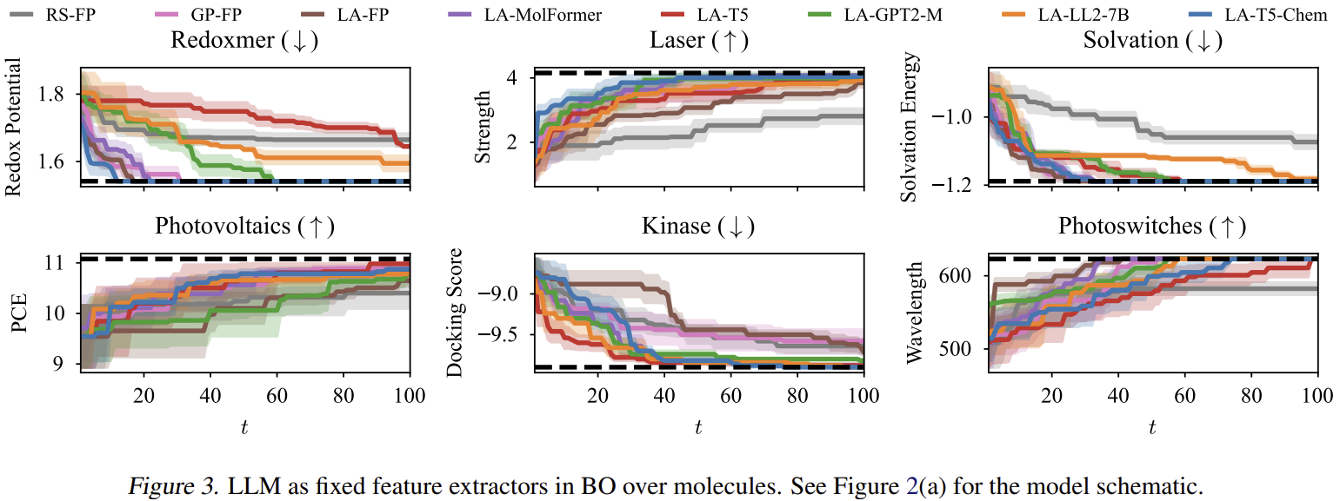

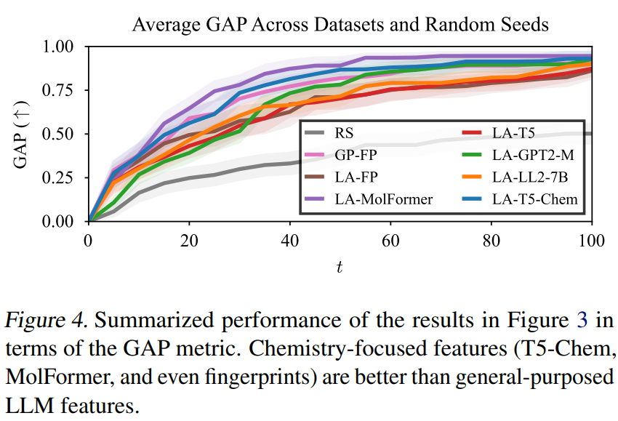

6. Results & Analysis

Main Results
- General-purpose LLM features from T5, GPT-2-Medium, and Llama-2-7B generally underperform the simple Morgan fingerprint baseline, despite the apparent chemistry knowledge demonstrated by these models.
- Chemistry-specific representations, particularly T5-Chem and MolFormer, are substantially better suited to molecular BO than general-purpose LLM representations.
- T5-Chem performs best overall in the multi-objective experiments. In the early stages of optimization, MolFormer can perform better, but it is eventually surpassed by the LLM-based chemistry-specific models.
- Prompting affects BO performance. T5-Chem generally performs best when the input is simply the SMILES string, consistent with its pretraining format, while more prompt engineering is not required to obtain its strong performance.
- GPT-4-based BO-LIFT performs substantially better than the Llama-2-7B version, but remains less attractive than a small chemistry-specific LLM combined with a principled Bayesian surrogate. A GPT-4 BO run costs approximately $12–18, reaching $75.81 for five random seeds in the reduced experiment.
- LoRA-based fine-tuning improves BO performance for both T5 and T5-Chem on most problems. However, T5-Chem fine-tuning decreases performance on the Photovoltaics task.

Ablation Studies
- LLM representation: General-purpose and chemistry-specific LLM representations are compared with Morgan fingerprints and MolFormer to evaluate the importance of domain-specific representations.
- Surrogate model: GP and Laplace-approximated neural-network surrogates are compared. The authors primarily use Laplace Approximation for LLM features because it performs better in their experiments.
- Prompting: The just-smiles, completion, naive, and single-number prompts are compared. Prompt choice affects performance, but T5-Chem generally remains strong across prompts and prefers the SMILES representation used during pretraining.
- Fine-tuning: Fixed-feature and LoRA-fine-tuned T5/T5-Chem models are compared. Fine-tuning generally improves BO performance, although the magnitude varies across tasks.

Qualitative Analysis
- The paper begins with an example showing that LLMs can produce convincing but incorrect answers to simple chemistry questions. For example, both ChatGPT and Llama-2 give incorrect molecular masses for the same chemical structure.
- This illustrates the distinction between appearing to understand chemistry through language generation and actually providing a representation that is useful for molecular property optimization.
- The BO experiments support this distinction: general-purpose LLM representations are often less informative for chemistry-focused BO than simple chemistry-specific representations.
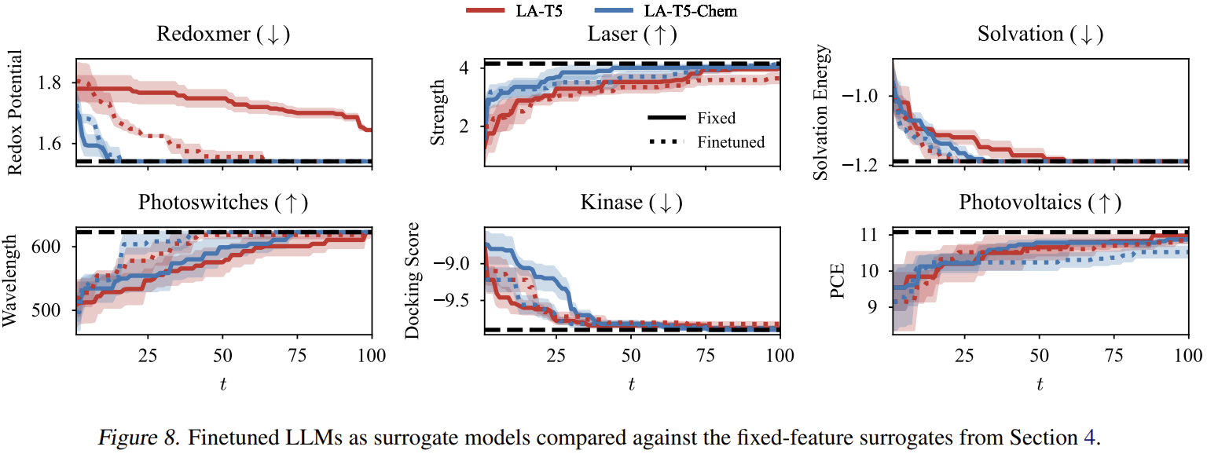

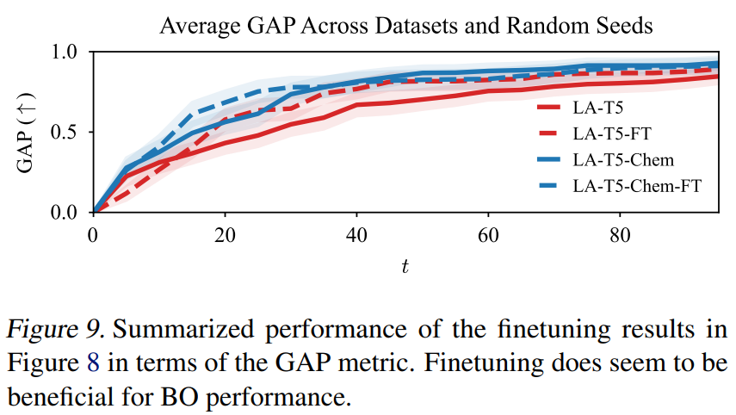

Failure Cases / Error Analysis
- Fine-tuning does not always improve performance. On the Photovoltaics problem, T5-Chem fine-tuning decreases BO performance.
- The authors attribute this degradation partly to using the same LoRA and Laplace hyperparameters across all problems, rather than tuning them for each individual task.
- Adaptive-feature models also require repeated LLM forward passes over the remaining candidate pool at every BO iteration. This is more computationally expensive than fixed-feature models, whose LLM representations can be cached.

7. Discussion

Strengths
- The paper directly tests whether LLMs are actually useful for principled molecular BO instead of assuming that their apparent chemistry knowledge is sufficient.
- It clearly separates representation learning from Bayesian uncertainty estimation, allowing the LLM to provide prior information while the Bayesian surrogate handles uncertainty.
- The evaluation covers multiple molecular properties, six single-objective problems, and two multi-objective problems, making the central conclusion less dependent on a single benchmark.
- The comparison with GPT-4 considers not only optimization performance but also monetary cost, showing the practical advantage of small chemistry-specific models.
- The Bayesian PEFT formulation provides a principled way to combine parameter-efficient adaptation with posterior uncertainty estimation.

Limitations
- The study focuses on discrete BO over predetermined molecular candidate sets and does not evaluate continuous molecular optimization or direct generation of new molecules.
- The experiments are limited to chemistry, so the conclusions about domain-specific LLMs may not directly generalize to other scientific domains.
- Fine-tuning introduces additional computational cost because LLM features cannot simply be cached throughout the BO process.
- The experiments do not fully identify which properties of the chemistry-specific representations are responsible for their superior BO performance.

Future Work
- Study the mechanisms through which LLM representations induce effective exploration-exploitation behavior in Bayesian Optimization.
- Extend LLM-based Bayesian surrogates from discrete molecular candidate pools to continuous molecular spaces.
- Investigate further Bayesian treatment or optimization of the pretrained LLM weights rather than treating them entirely as fixed conditioning variables.
- Apply the framework to scientific discovery problems outside chemistry.

8. Personal Insights

Key Takeaways
- The central lesson is that LLM capability and usefulness as a scientific representation are different properties. A general-purpose LLM can appear to possess chemistry knowledge without producing a representation that is useful for molecular BO.
- Domain-specific pretraining is more important than simply increasing general-purpose LLM scale in this setting. T5-Chem can outperform much larger or more capable general-purpose LLM approaches when used within a suitable BO framework.
- Separating the roles of the LLM and the Bayesian surrogate is important. The LLM provides a learned molecular representation, while the Bayesian model provides the uncertainty required for principled exploration and exploitation.
- Fine-tuning can further improve a useful representation, but it is not guaranteed to help every task. This suggests that task-specific adaptation should be evaluated rather than assumed to be universally beneficial.
- The paper provides a broader lesson for AI for Science: a strong foundation model is not necessarily the most useful component unless its learned representation and uncertainty model are aligned with the downstream scientific decision problem.

Ideas Relevant to the Saegyeol AI Project
- The paper suggests that an AI scientist should not assume that a general-purpose LLM's broad knowledge is sufficient for a specialized scientific task. Domain-specific representations and task-specific adaptation can be more important than simply using a larger general-purpose model.
- For an AI scientist that autonomously conducts scientific research, this raises the possibility of using general-purpose LLMs for high-level reasoning while incorporating domain-specific models or representations for specialized scientific tasks, such as molecular property prediction and candidate selection.
- The paper's separation of representation learning from Bayesian uncertainty estimation is also relevant to autonomous scientific discovery. Rather than asking an LLM to perform the entire optimization process heuristically, different components can be assigned distinct roles: scientific representation, uncertainty estimation, candidate selection, and experimental evaluation.
- More broadly, the paper demonstrates the importance of empirically validating whether an LLM's apparent domain knowledge actually translates into useful scientific performance. This is relevant to an AI scientist system because its research decisions should be evaluated based on actual scientific outcomes and sample efficiency, rather than assuming that a capable general-purpose LLM will automatically perform well in every stage of the research process.

