Bow-Tie Structure of the   
Polkadot Transfer Network

Author: Matija Piškorec, Ben Domenic James Murphy, *et. al*., @ Univ. of Zurich

Published in: IEEE Inte. Conf. on Blockchain and Cryptocurrency (ICBC), 2023.

Speaker: Haeung Choi

**Summary:** To analyze network structure of Polkadot network, bow-tie model is applied. The authors investigated the transfer network consist of transfers of DOT (native currency in Polkadot). And then the authors divided the networks into three components, strongly connected component (SCC), in-component, and out-component. The analysis on the structure of those three components shows that Polkadot network is changing from validator-dominating network to end-user-dominating networks.

1. Introduction

* In this paper, authors provide analysis of the staking dynamics with respect to the bow-tie structure of the transfer network of the Polkadot blockchain.
* (Nominated Proof-of-Stake) The consensus mechanism of Polkadot is a nominated proof-of-stake (NPoS). In this mechanism, nominators stake their DOT (native currency in Polkadot) to validators who actually validate the blocks on their behalf. The validators elected by nominators have responsibility to flawless execute and verify the transactions in the block. If validators don’t operate well, the validators and nominators who delegate their stakes to them will be slashed.
* (Challenges in analyzing NPoS network) A challenge on analyzing the staking dynamics is that the validator election data is stored off-chain. Thus, in order to track the staking relationship between nominators and validators, one need to investigate DOT transfer transactions occurred by staking reward distribution from validators to nominators.
* (Bow-tie model) The bow-tie model is a tool for describing flow of information in a directed network structure by decompose the network into three components: 1) strongly connected component (SCC), consists of highly active nodes directly connected each other, 2) in-component, consists of source nodes who generate information and provide it to SCC, 3) out-component, consist of end users who operate as information sink. By applying this model to a blockchain network, one can analyze the economics of the blockchain. This analysis can provide more insight into the ecosystem of a large decentralized financial system.

1. Methodology
2. Data collection pipeline

The data collection pipeline has three nodes. Blockchain node collect the blockchain datasteam and preprocess using Kafka server. The processed data is store in data persistence node. Then the data of interest is queried by query node implemented by Python query tool, PySpark.

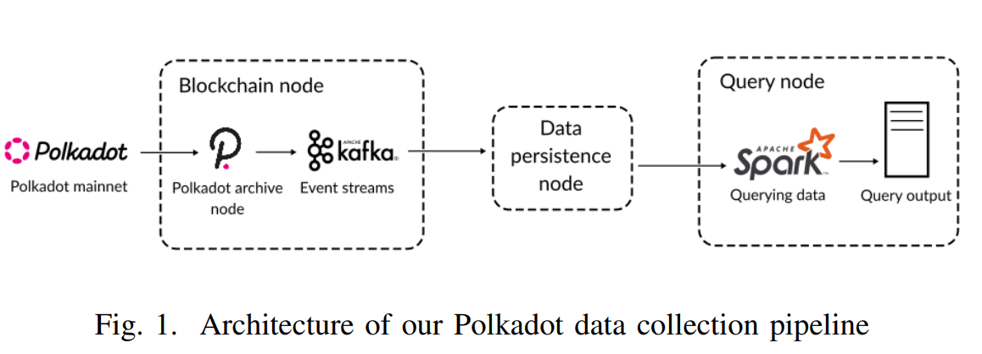

1. Transfer network analysis

The authors used a Python library, graph-tool to calculate the SCC, in-component, and out-component of the Polkadot transfer network from all transfer extrinsic transactions (transactions transferring DOT from relay chain account to another relay chain account). The flow of DOT become a directional graph thus it can be described by bow-tie model such like Fig. 2.

At first, authors calculated a validator network by querying on block reward distribution transactions. The following figure is a visualization of the validator network of era 80. (Era means a period between two validator elections.) And then, the similar method is used to construct transfer networks among all accounts. Based on this transfer network, the authors analyzed the absolute and relative size of SCC, in-component, and out-component of the transfer network. Relative number of nominators and validators is also measured.

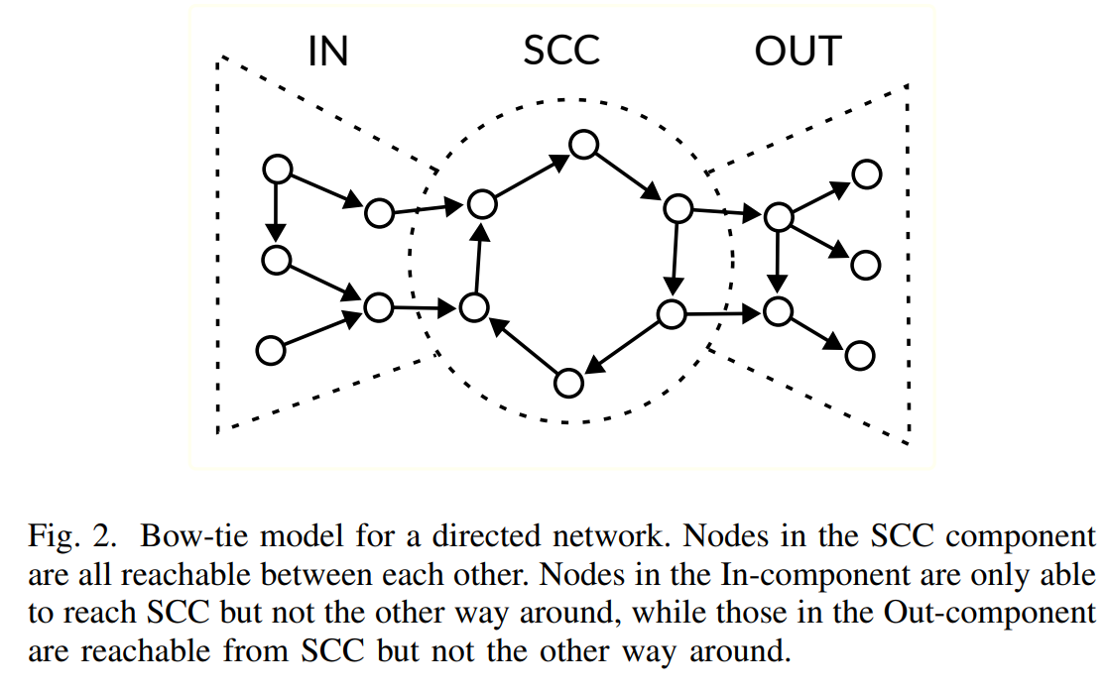

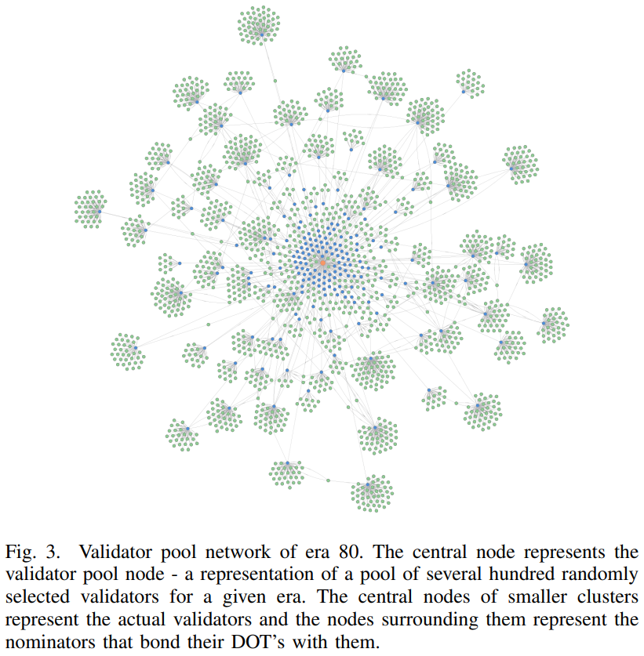

1. Results

In this section, the result of network analysis is described. The Fig. 4 shows the cumulative size of each component in bow-tie model. We can see that the absolute cumulative size of three components are increasing by time. However, the relative size of three components are somewhat different. The figure shows that the relative size of SCC increased over time, while relative sizes of in-component and out-component are decreasing. It implies that the number of users who are just minting or holding DOTs is decreasing, while the number of users who actively exchanges their DOTs with others is increasing.

Fig. 5 and 6 show the size of nominators and validators. As shown in Fig. 5, the cumulative numbers of nominators and validators increasing over time, but the ratios of their size to the total network size are steadily decreasing. Fig. 6 shows that this decreasing of nominators’ and validators’ portion is general trend over all network components, SCC, in-component, and out-component. There was only a temporal exception from April 2021 to October 2021 because of explosive growth of crypto market.

Fig. 7 shows monthly size of the network components. One can see the peak on October 2021 as discussed above. As like the total network size, the sizes of SCC and out-component are decreasing after the peak. However, the size of in-component is maintained even though the decreasing of total network. The authors interpreted this as a continuous influx of new users to the ecosystem.

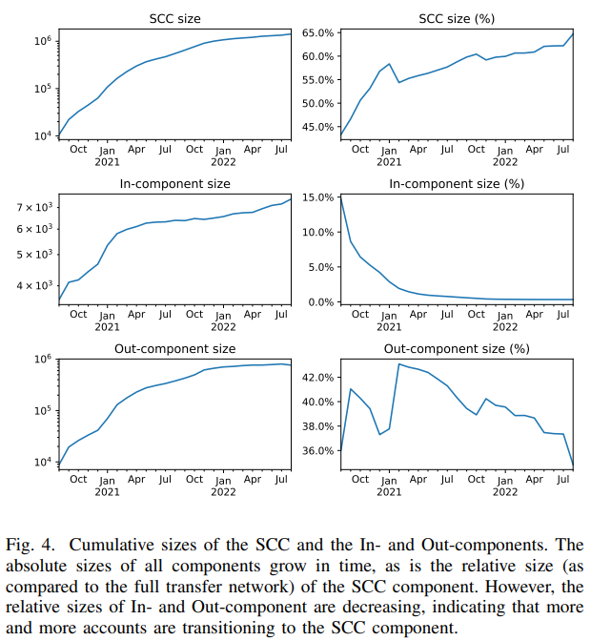

|  |  |
| --- | --- |
|  |  |

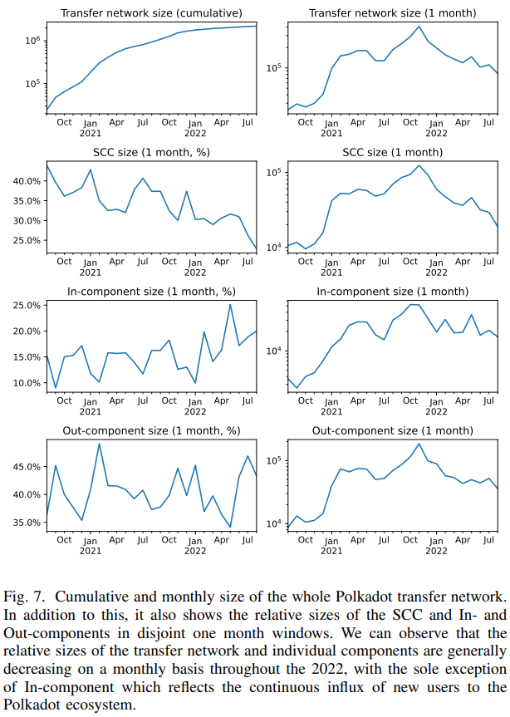

1. Conclusion

* The bow-tie analysis of Polkadot network implies that the network is slowly maturing from a system dominated by nominators and validators into a system populated by regular end-users using the financial service applications of Polkadot.