**Information Bit Error Rate for (7, 4) Hamming Code**

By Heung-No Lee

Date: Nov. 19th, 2020

The aim of this node is to show:

1. What a channel code is,
2. Channel introduces errors at a rate *p*,
3. The error rate can be improved with a simple (7, 4) Hamming code. This is a coding gain.
4. This will offer the sense of possibilities that as the length of a channel code gets longer, the coding benefit will be greater and approaches the channel capacity.

From our Hamming code homework, you have obtained the standard array. The following Table is obtained by student YH Kim.



(**Channel model**) Let the channel model be given by



where  is a codeword sent and  is an error pattern. Mod-2 is the element-wise mod-2 operation. For example,  is 2nd codeword in the codebook, i.e., the first entry in the codebook;  is the error pattern; then .

The table shows a number of useful insights:

1. All possible received words  appear *once and only once* in the entry of the standard array(SA).
2. All 16 codewords are located at the far left column under the label “No error.”
3. At each row, there are eight entries. The first is a codeword and the rest seven are distance 1 neighbors of the codeword. Each codeword is the center of a Hamming sphere of radius 1.
4. Upon reception of a received word, it will be an entry in a row in the SA.
5. The decoder makes a decoding decision to the received word . What decision shall it make?
6. The maximum likelihood receiver makes it to be the center of the Hamming sphere which the received word  belong to.

(Decoder) Let the decoder be a function  making a maximum likelihood decision in which the most likely codeword is selected from the codebook, i.e.,

.

The maximum likelihood decision is made via the following operation

,

That is, ML decision rule becomes the minimum Hamming distance rule.

(Information bit error rate) Let  = 4 be the number of information bits in a codeword.

Let  be the Hamming distance between the four message bits indexed by  and . Let be the size of the message set, i.e., .

We define the information bit error rate formally:



It shall be noted that

1.  is defined as the *expected* value of the information bit error rate .
2. (a) is due the expectation operation.
3. (b) is due to equiprobable message selection.
4. (c) is due to linearity of the code. Namely, for any .

Now note that  and  can be determined from the standard array. For example, for , the information bit Hamming distance between the 1st codeword and the 2nd codeword is 1; the decoder error event  occurs when the received word is one of the 8 error patterns in the 2nd row, i.e., 0001111, 0001110, …, 1001111. Namely, the decision error to the 2nd codeword occurs with the following probability



Continuing to the next decoding error event. The decoding error to the third codeword occurs if the received word is one of the 8 error patterns in the 3rd row, i.e., 0010101, 0010100, …, 1010101, whose weights are 3, 2, 4, 2, 4, 2, 5, 4. Thus,



We can continue on to the 16th codeword.

To calculate the information bit error rate, we need a table of error weight enumeration.

|  |  |  |  |  |  |  |  |
| --- | --- | --- | --- | --- | --- | --- | --- |
| j | W_info(1,j) | Number of patterns with weight w | | | | | |
| Weight =2 | Weight =3 | Weight =4 | Weight =5 | Weight =6 | Weight =7 |
| 2 | 1 | 0 | 4 | 1 | 3 | 0 | 0 |
| 3 | 1 | 3 | 1 | 3 | 1 | 0 | 0 |
| 4 | 2 | 3 | 1 | 4 | 0 | 0 | 0 |
| 5 | 1 | 3 | 1 | 4 | 0 | 0 | 0 |
| 6 | 2 | 3 | 1 | 4 | 0 | 0 | 0 |
| 7 | 2 | 0 | 4 | 1 | 3 | 0 | 0 |
| 8 | 3 | 0 | 3 | 1 | 4 | 0 | 0 |
| 9 | 1 | 3 | 1 | 4 | 0 | 0 | 0 |
| 10 | 2 | 3 | 1 | 4 | 0 | 0 | 0 |
| 11 | 2 | 0 | 4 | 1 | 3 | 0 | 0 |
| 12 | 3 | 0 | 4 | 1 | 3 | 0 | 0 |
| 13 | 2 | 0 | 4 | 1 | 3 | 0 | 0 |
| 14 | 3 | 0 | 4 | 1 | 3 | 0 | 0 |
| 15 | 3 | 3 | 1 | 4 | 0 | 0 | 0 |
| 16 | 4 | 0 | 0 | 0 | 0 | 7 | 1 |

Using the following MATLAB m-file, we can calculate the information bit error rate.

%

% (7, 4) Hammming Code Bit Error Rate

%

% HNLEE

% Information Theory

%

clear all;

Ew = [2 1 0 4 1 3 0 0;

3 1 3 1 3 1 0 0;

4 2 3 1 4 0 0 0;

5 1 3 1 4 0 0 0;

6 2 3 1 4 0 0 0;

7 2 0 4 1 3 0 0;

8 3 0 3 1 4 0 0;

9 1 3 1 4 0 0 0;

10 2 3 1 4 0 0 0;

11 2 0 4 1 3 0 0;

12 3 0 4 1 3 0 0;

13 2 0 4 1 3 0 0;

14 3 0 4 1 3 0 0;

15 3 3 1 4 0 0 0;

16 4 0 0 0 0 7 1];

p=0.01;

N_info=4;

Pb=0;

Weight = [2 3 4 5 6 7];

for ii=2:16,

E_rate = Ew(ii-1, 2)/N_info;

Ew1 = Ew(ii-1, 3:8);

Pb11 = (1-p).^(7-Weight);

Pb12 = p.^Weight;

Pb1=E_rate*sum(Pb11.*Pb12);

Pb=Pb+Pb1

end

===============================================================

The results are given in the following graph.

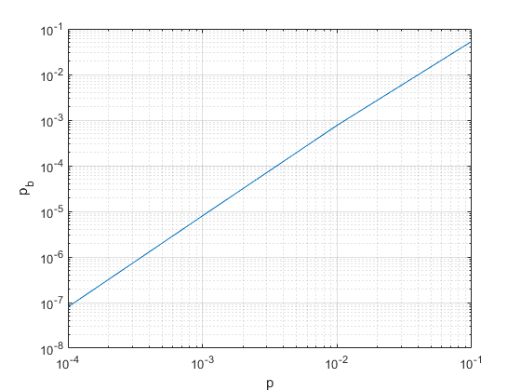

By the way, the point of this example calculation is to show that it is very difficult in general to calculate the exact error rate. We will use upper bounds and lower bounds for the proof of the Channel Coding theorem. One is to use an upper bound called the union bounds.

**Homework #6**

Due by Nov. 30th, 10:30AM.

1. Problem 1. Do this problem.

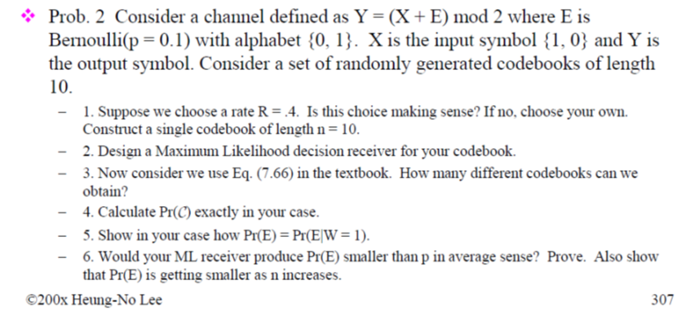

1. Problem 2. Cover and Thomas P7.16
2. Problem 3. Cover and Thomas P7.26
3. Problem 4. Cover and Thomas P7.25
4. Problem 5. Cover and Thomas P7.26
5. Problem 6. Cover and Thomas P7.28
6. Problem 7. Cover and Thomas P7.34
7. Problem 8. Read the proof of the channel capacity theorem in Chapter 7.
8. Write the channel coding theorem. In plain English, succinctly specify what needs to be proved in the forward part of the proof. Do the same with the backward part.
9. What is a random code?
10. What are the items both the sender and the receiver knows? What are the part the receiver does not know?
11. We use Maximum likelihood decision decoder in our information bit error rate. What is the decoder used in the proof of the channel coding theorem?
12. What is the key method to prove the backward part?