|  |
| --- |
| An experimental performance evaluation of a novel radio-transmitter identification system under diverse environmental conditions |

|  |  |
| --- | --- |
| Authors: | Tekbas, O.H. ; Serinken, N. ; Ureten, O. |
| Publication: | Electrical and Computer Engineering, Canadian Journal of (2004.07) |
| Speaker: | Ju-Sung Kang |

**Short summary**: In this paper, **the effects of environmental conditions on a radio-transmitter identification system are investigated**. *Changing in environmental conditions causes the feature vectors to spread over the feature space,* resulting in classification performance degradation. *This performance degradation can be compensated for by training the system with data collected in a range of battery-voltage and ambient temperature levels.* The SNR vs Classification accuracy is also determined for systems operating in noisy channels. The transient features are extracted using a technique based on the amplitudes and phase changes of the received signals.

# **Introduction**

Used feature in this paper : Transient behaviour.

- Duration of feature : a few microseconds ~ a few tens of milliseconds → Type and Model dependency

- Causes : Variety of sources (e.g. Phase-Locked-Loop(PLL) frequency synthesis systems, modulator subsystems, RF amplifiers, antenna, switch and relay characteristics)

- Possible application : Spectrum management operations (i.e. Prevent the unauthorized use of spectrum)

Several Signal Processing procedure for transmitter identification system :

- Step 1 : Capturing the signal with high fidelity and resolution

- Step 2 : Localization of the occurrences of turn-on transient in the signal data;

- Step 3 : Extraction of features.

- Step 4 : Classification of the unknown transient using known signal data.

There are two approaches for using the Transient characteristics for RF Fingerprinting.

1. The recording and analysis of signals from the receiver’s FM discriminator-output (DO) signal (DS system) [1]–[7],

2. The envelope or amplitude characteristics of the received intermediate-frequency (IF) output signal (IF system) [8]–[9].

Because the amplitude & phase information are important for RF Fingerprinting system [10] and these are discarded from the DS systems, second approaches is used in this paper.

* DS systems : The circuit for transfer the instantaneous frequency information to amplitude changes.

This paper is upgraded version of reference paper [10] :

- The characteristics of radio-transmitter fingerprints are examined by analyzing both amplitude and phase information obtained from complex envelope (CE) recording systems.

- This approach offers distinct advantages over DO and IF envelope–based systems;

- It does not describe a classification system.

In this paper,

- A novel radio-transmitter classification system using a CE technique is presented.

- Transient features are extracted by a technique based on the variance dimensions of transient signals and classified with a probabilistic neural network (PNN).

- Better performance for the Complex Envelope (CE) system is obtained in comparison to DO and IF envelope–based systems.

- Performance of the CE system is evaluated under conditions of varying battery voltage, ambient temperature level and channel noise.

- It is shown that performance degradation caused by environmental changes can be compensated by training the system with transients collected under a wide range of environmental conditions.

# **Transmitter Identification System**

Procedures of a transmitter identification system : 1) Acquisition of the signal of interest, 2) Detection of the start of the transient in the signal data, 3) Extraction of the features, 4) Classification of the unknown transients.

# **2.1 Data Acquisition**

The complex-signal recording procedure is :

|  |
| --- |
|  |
| Figure 1. (a) Experimental setup |
|  |
| Figure 1. (b) Quadrature demodulator (I/Q demodulator) |

- Distance between transmitter and receiver is .

- The transmitters were keyed by using the automatic push-to-talk (PPT) control method. And the transmitter was turned on for  and off for .

- The IF output of the receiver at  was processed by an I/Q demodulator.

- The output of I/Q demodulator (i.e. , signals) were sampled and digitized with  resolutions at a rate of .

- Because of the anti-alias filter, the BW of and  signals is  which is centered at about .

Fig. 2 illustrates the  and  components of a typical captured transient signal.

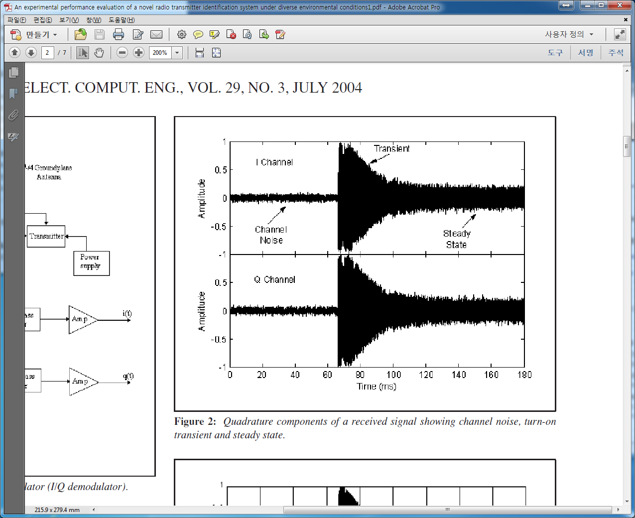

# **2.2 Transient detection**

From Fig. 2, we could see that there are channel noise, transient signal, and regular transmission signals. Because the detection of transient signal could affect the classification system, detection and extraction of transient signal is important.

In this paper, a power-threshold-based approach is used to detect starting point of transient signals.

We could define the complex envelop  such as :

 (1)

The real instantaneous amplitude of IF signals, , can be calculated like this :

 (2)

At here,  means -th sample of the signal 

In this paper, to find the sudden increase of transient signals, comparison of current instantaneous amplitude with running average values is used. ***If the signal amplitude is larger than running average for  samples, we could decide the starting point.*** At here,  is determined by experimental method.

# **2.3 Feature extraction**

Turn-on transient signals show characteristic variations in both amplitude and phase profiles. So, the and  signals can be mapped onto the 2-D complex plane as a rotating vector (i.e. / domain). This rotating vector has unique trajectory (i.e. unique amplitude and phase information). So, it could be used to feature vectors.

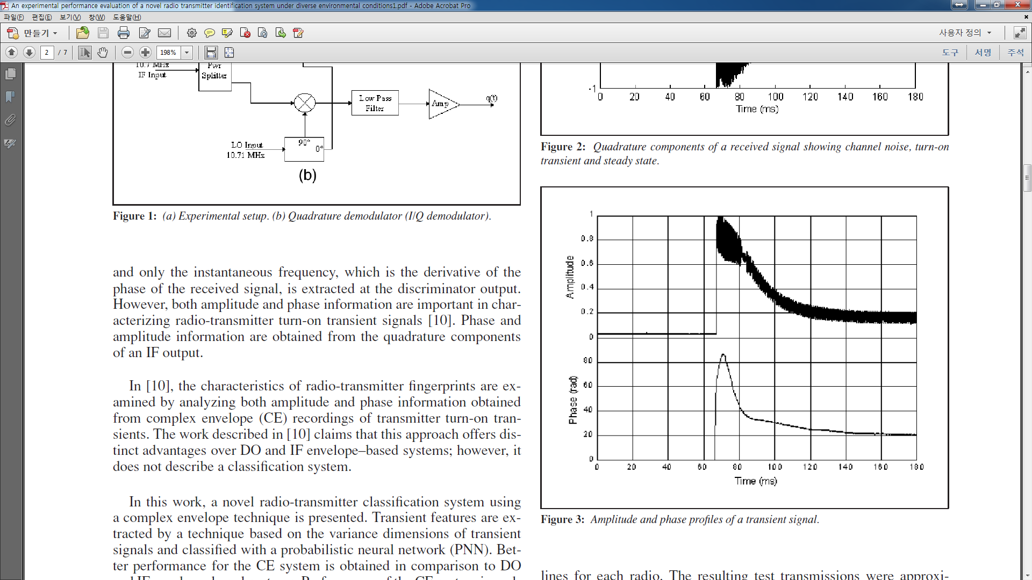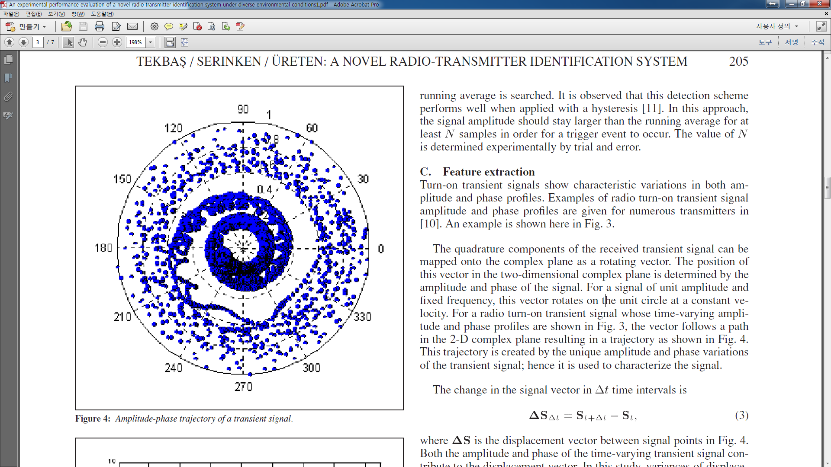

The displacement vector for time interval  () is calculated as :

 (3)

In this study, *variances of displacement vectors, calculated at different  time intervals, are used for feature extraction*. Calculated variance values are plotted versus  on a log-log scale, and the slope of this resulting curve is used as a feature. The features correspond to a variance fractal dimension, and in this specific application, they are related to the spread of the time variation of the signal amplitude and phase at different time scales.

Transient signals and other nonstationary signals can be considered as outputs of chaotic dynamic systems [2], which can be modelled by their dimension measures [12]. However, transient signals are not pure fractals because their properties change with time. In this study, *local fractal dimensions are calculated by a sliding-window technique, whereby the variance fractal dimension is estimated for successive portions (windows) of the signal*. The dimension values obtained in this way are then combined in a vector which composes the feature vector. The transients are reduced to approximately 50 to 200 feature values from 2000 to 3000 complex samples. The exact sizes of the window and feature vector are experimentally determined by trial and error to give the best classification performance.

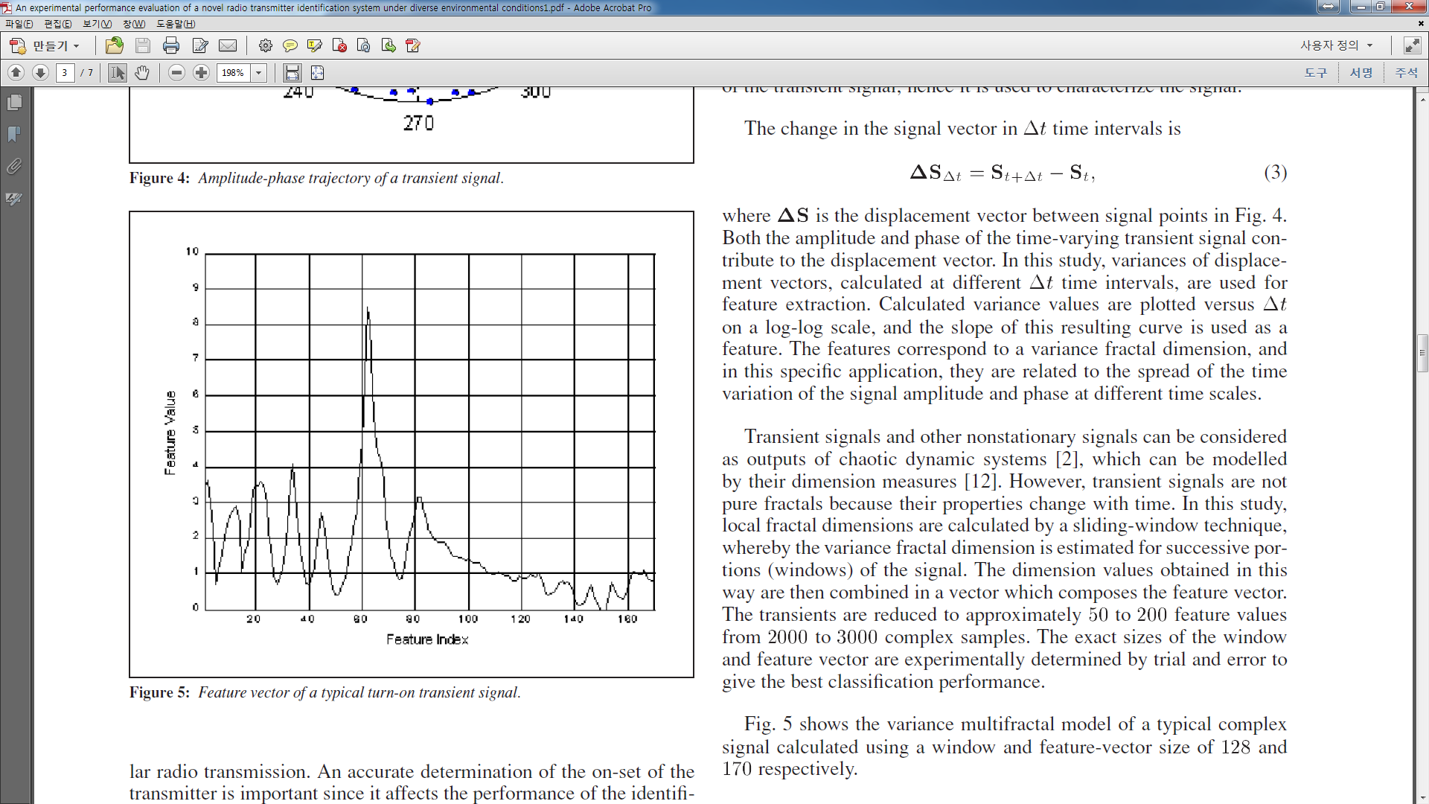

Fig. 5 shows the variance multifractal model of a typical complex signal calculated using a window and feature-vector size of 128 and 170 respectively.

**Sammon mapping [13] :**

- In order to have a better understanding of the intrinsic structure of feature vectors, a mapping technique is utilized.

- Sammon mapping method is the mapping technique which could visualize the multi-dimensional feature vectors on a two-dimensional plot.

- We could suppose that the projected two-dimensional plot has a similar structure to high dimensional plot.

- This positioning could be calculated by minimizing a criterion function based on the Euclidean distance between the original and projected points.

# **2.4 Classification**

Feature vectors are normalized to make the zero mean and average absolute deviation equal to unity. This normalized feature vectors are inputted to **Probabilistic Neural Network(PNN) [14].**

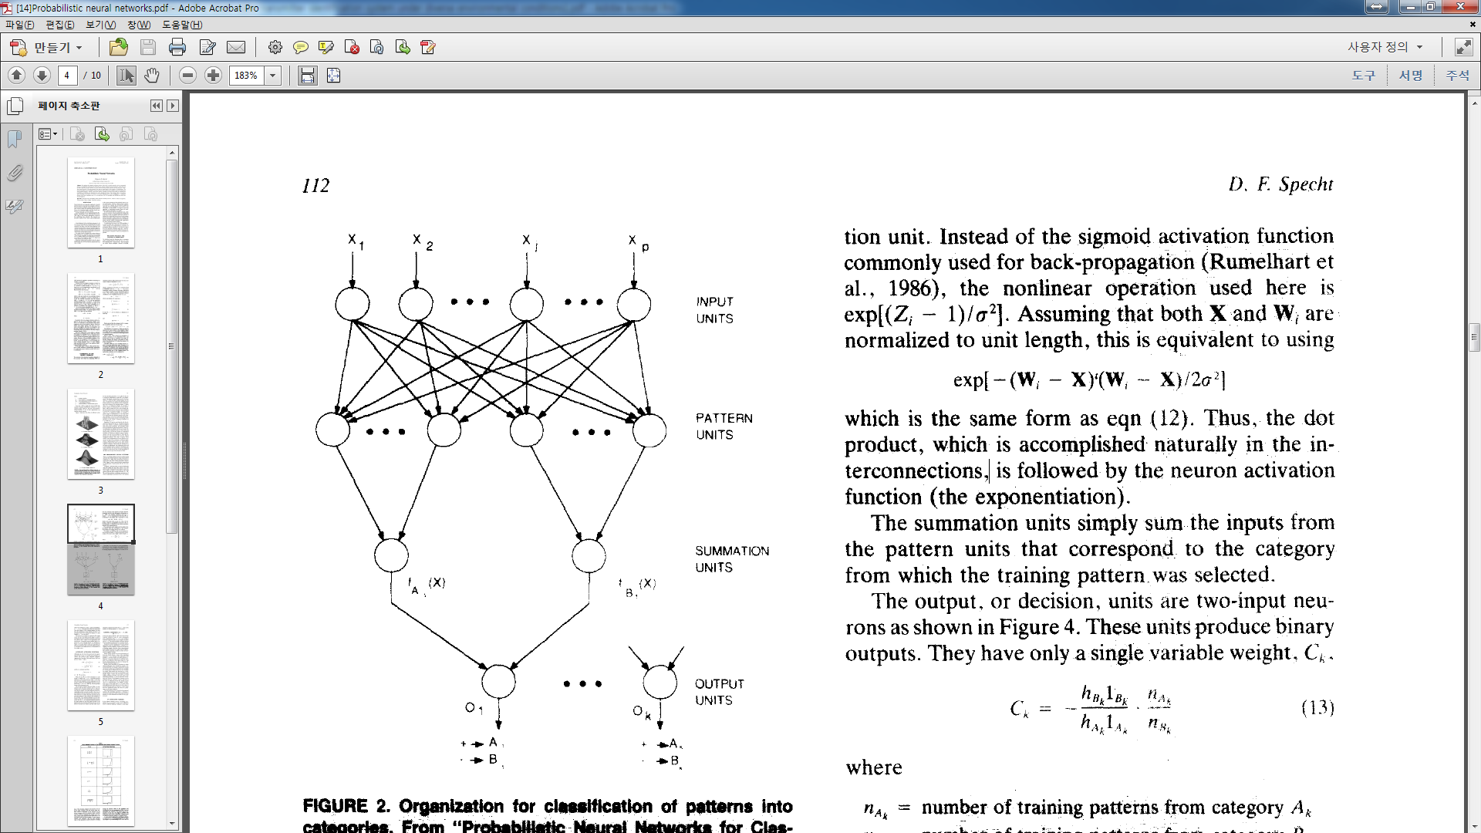 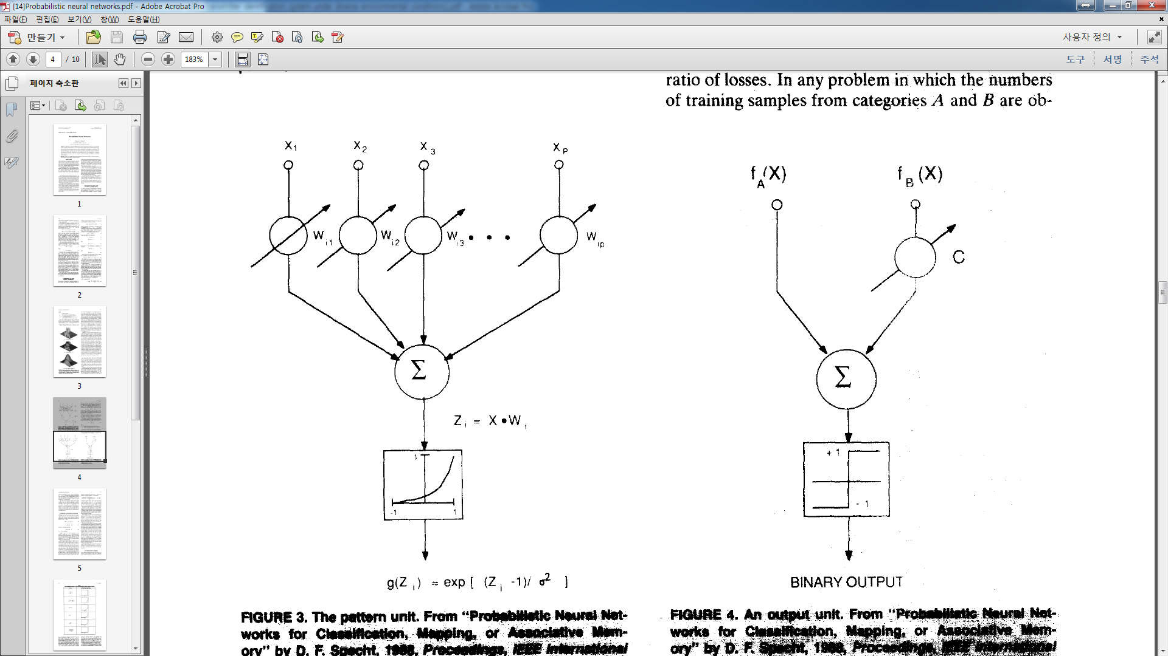

- Each output (summation) neuron of the PNN is dedicated to a single transmitter.

- It simply sums the activation values of all pattern-layer neurons corresponding to known transient samples of that transmitter.

- The final activation levels of all classes (transmitters) are compared, and the output neuron with the highest activation level is declared as the most probable class to which the transient being tested could belong.

- If the activation level is smaller than a preset threshold value, then the input transient sample is rejected as an unknown transient. In this specific study, the rejection threshold was kept high enough so that none of the transients were rejected as unknown.

**Self Organizing map (SOM) [15] :**

- The PNN stores all of the training vectors in memory, and the memory requirement, training and processing time grow linearly with the number of training vectors.

- In order to reduce this effect, a preprocessing stage (a self-organizing map (SOM)) has been introduced before the PNN.

- The SOM is applied to reduce the number of training feature vectors if this number is greater than  for that class, where  is a preset threshold value.

- As a result, the SOM network realizes an abstraction of a big population by generating  feature vectors that represent and summarize the input population for that class.

- The inclusion of SOM preprocessing accelerates PNN training and classification while yielding lower memory requirements.

# **2.5 System Structure**

The overall system structure of the CE system is :

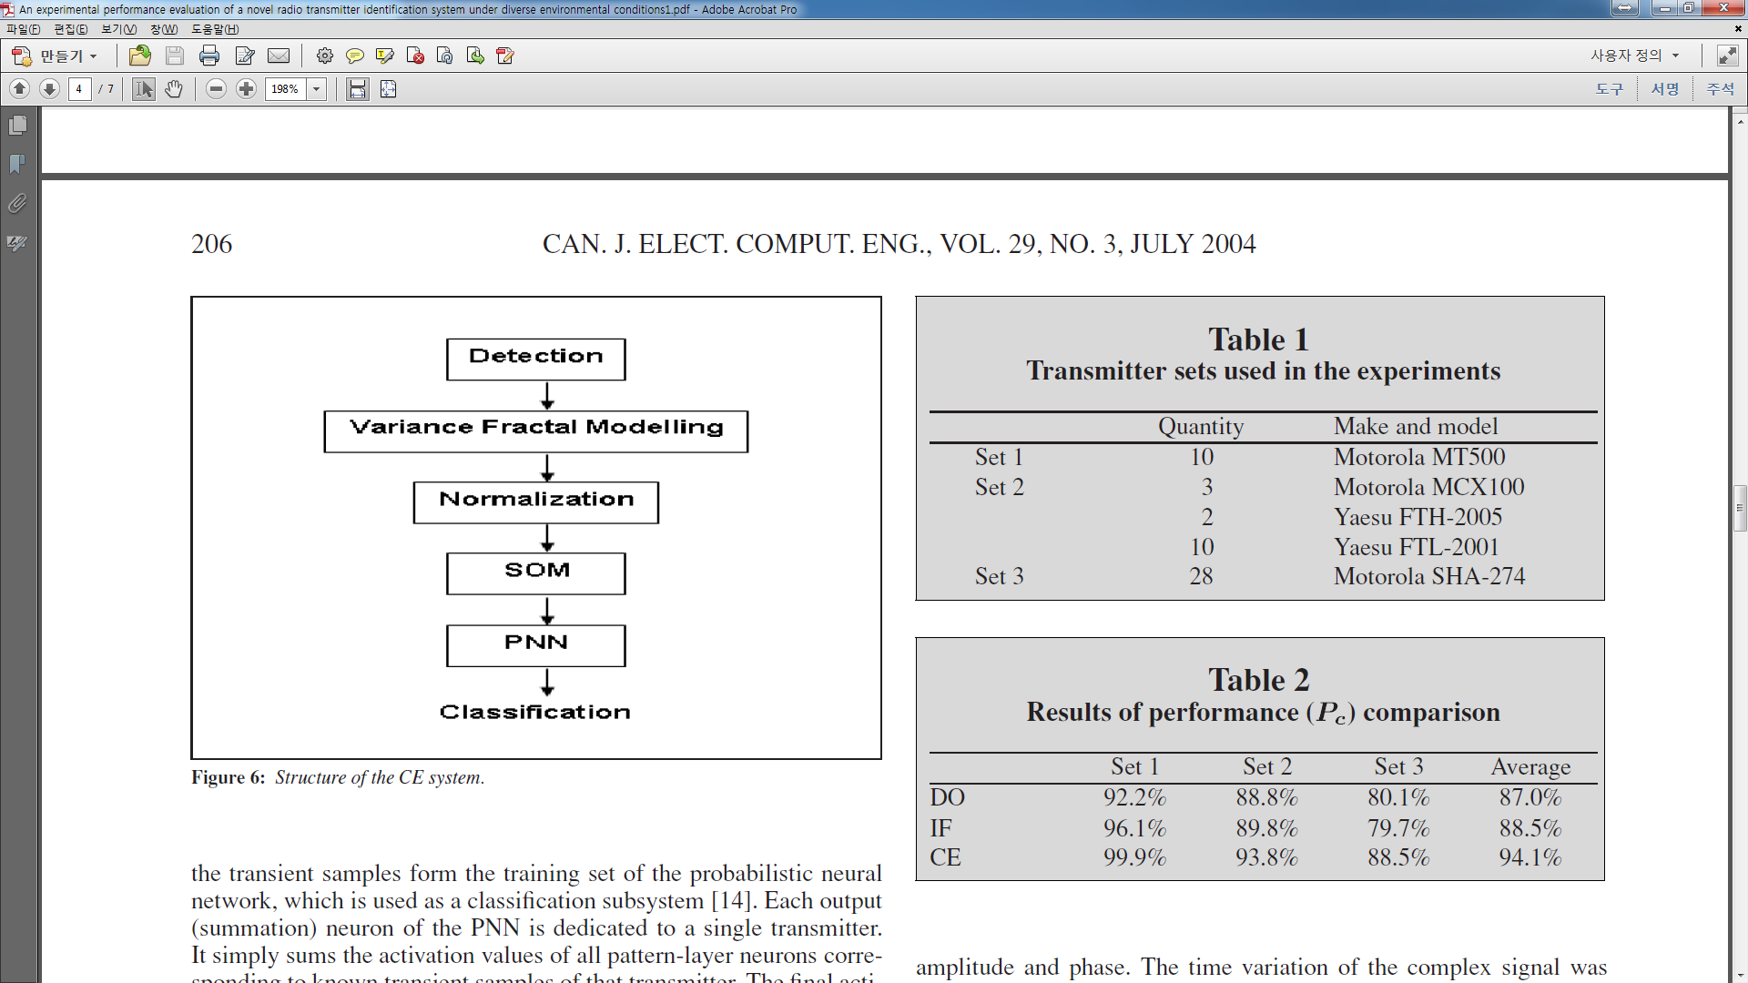

# **Performance comparison**

Three different sets of transmitters were used in the experiments. Transmitters were grouped according to their operating frequencies.

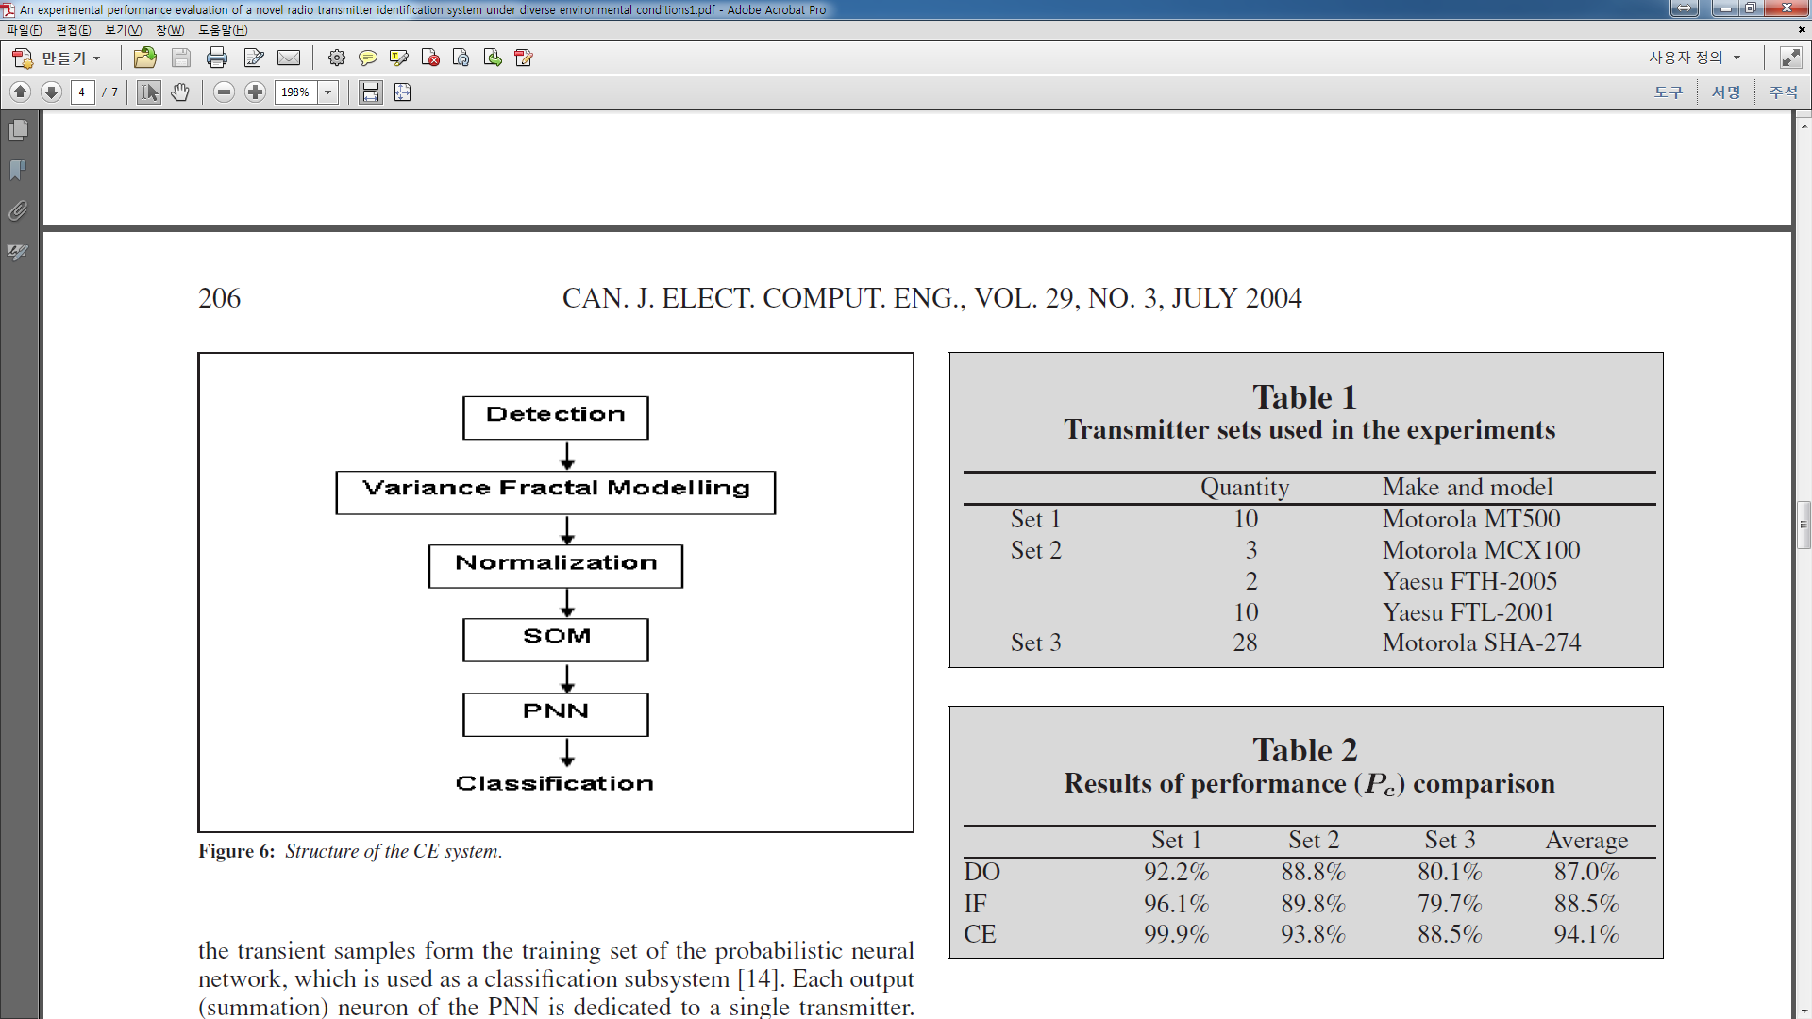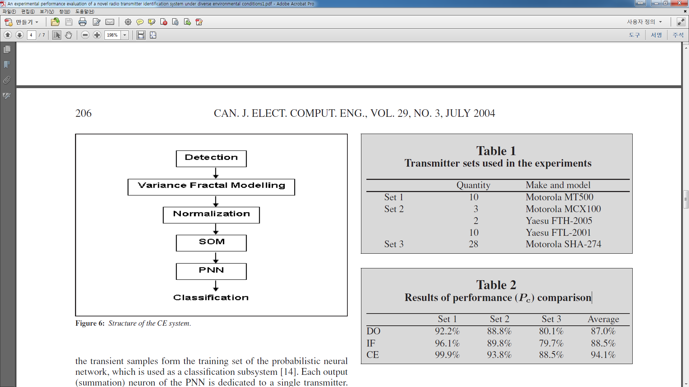

Comparison environment of experiments : CE system vs IF envelope vs DO systems.

- All systems used *variance dimensions* for feature extraction and *PNN* for classification.

- The system parameters (e.g. window length, number of features) were experimentally optimized.

- The DO system used the discriminator output of the radio.

=> This output is related to the time derivative of the received signal’s phase.

- The CE system extracted phase and amplitude information from the IF output using an explained method.

- The IF envelope system, used only the time variation of the signal amplitude, discarding the phase :

 (4)

The experimental results are summarized in Table 2. Total 24 training samples and total 100 testing samples are used and accuracy about classification was calculated. As seen from Table 2, The performance of the CE system is better than the other systems.

# **Investigation of environmental effects**

For investigation of environmental effects, the first set of transmitters are used.

- Operating frequency : 

- Considered environmental effects : power supply voltage variation, ambient temperature change, additive channel noise

# **The effect of variations in power supply voltage**

Transient signals from transmitter Set 1 were recorded at voltage levels from  to .

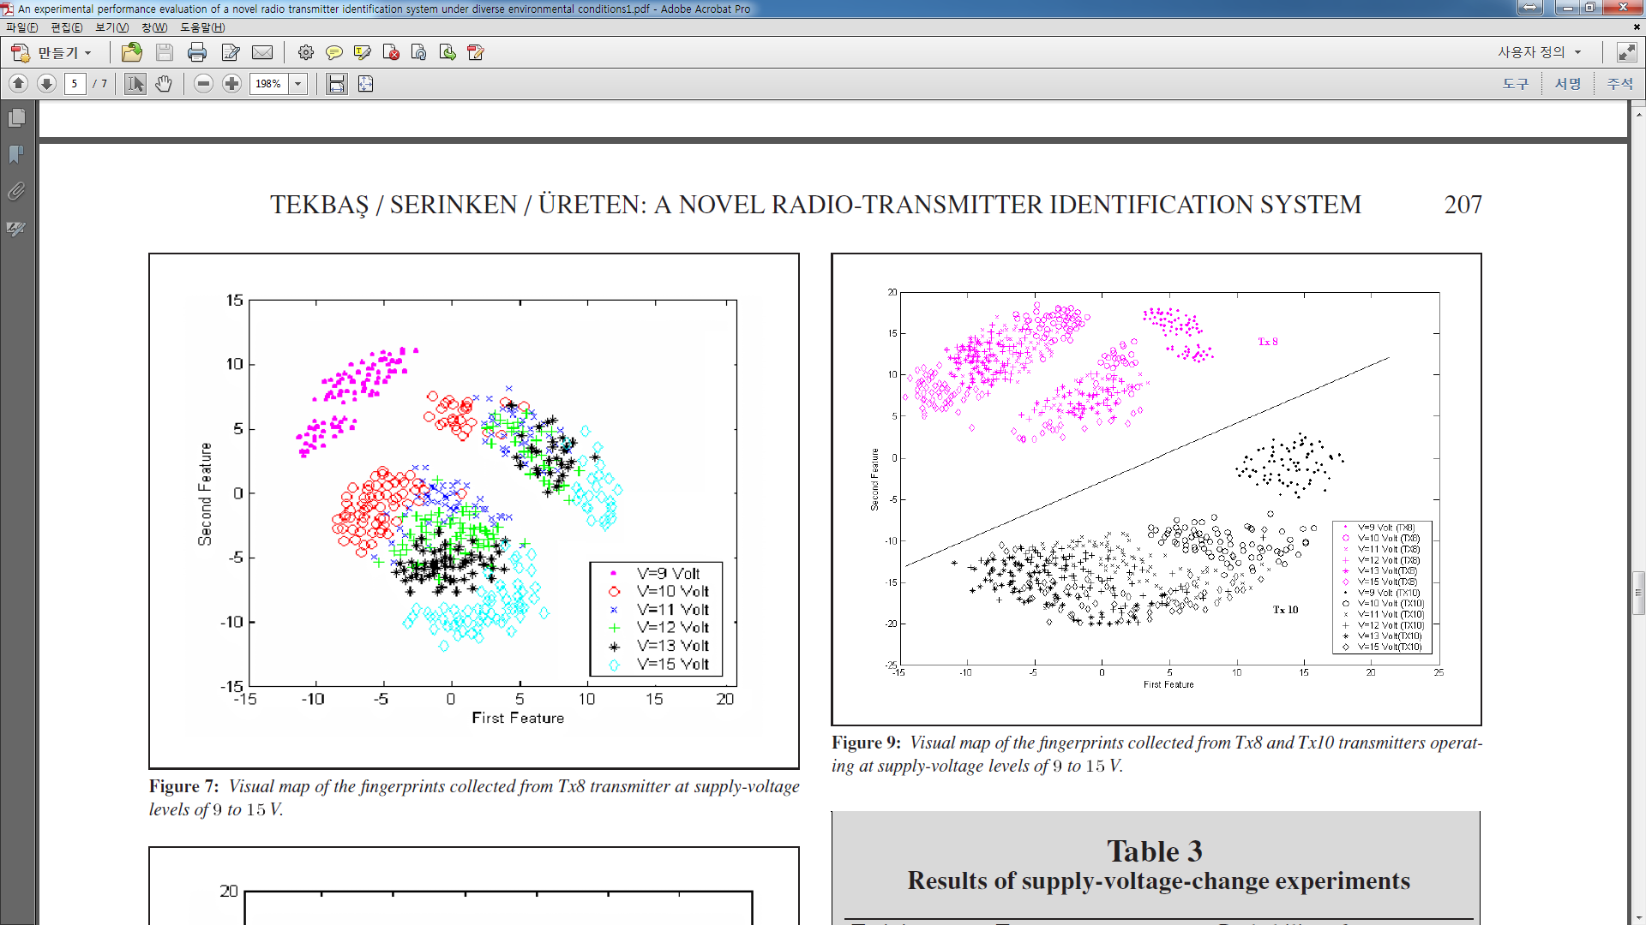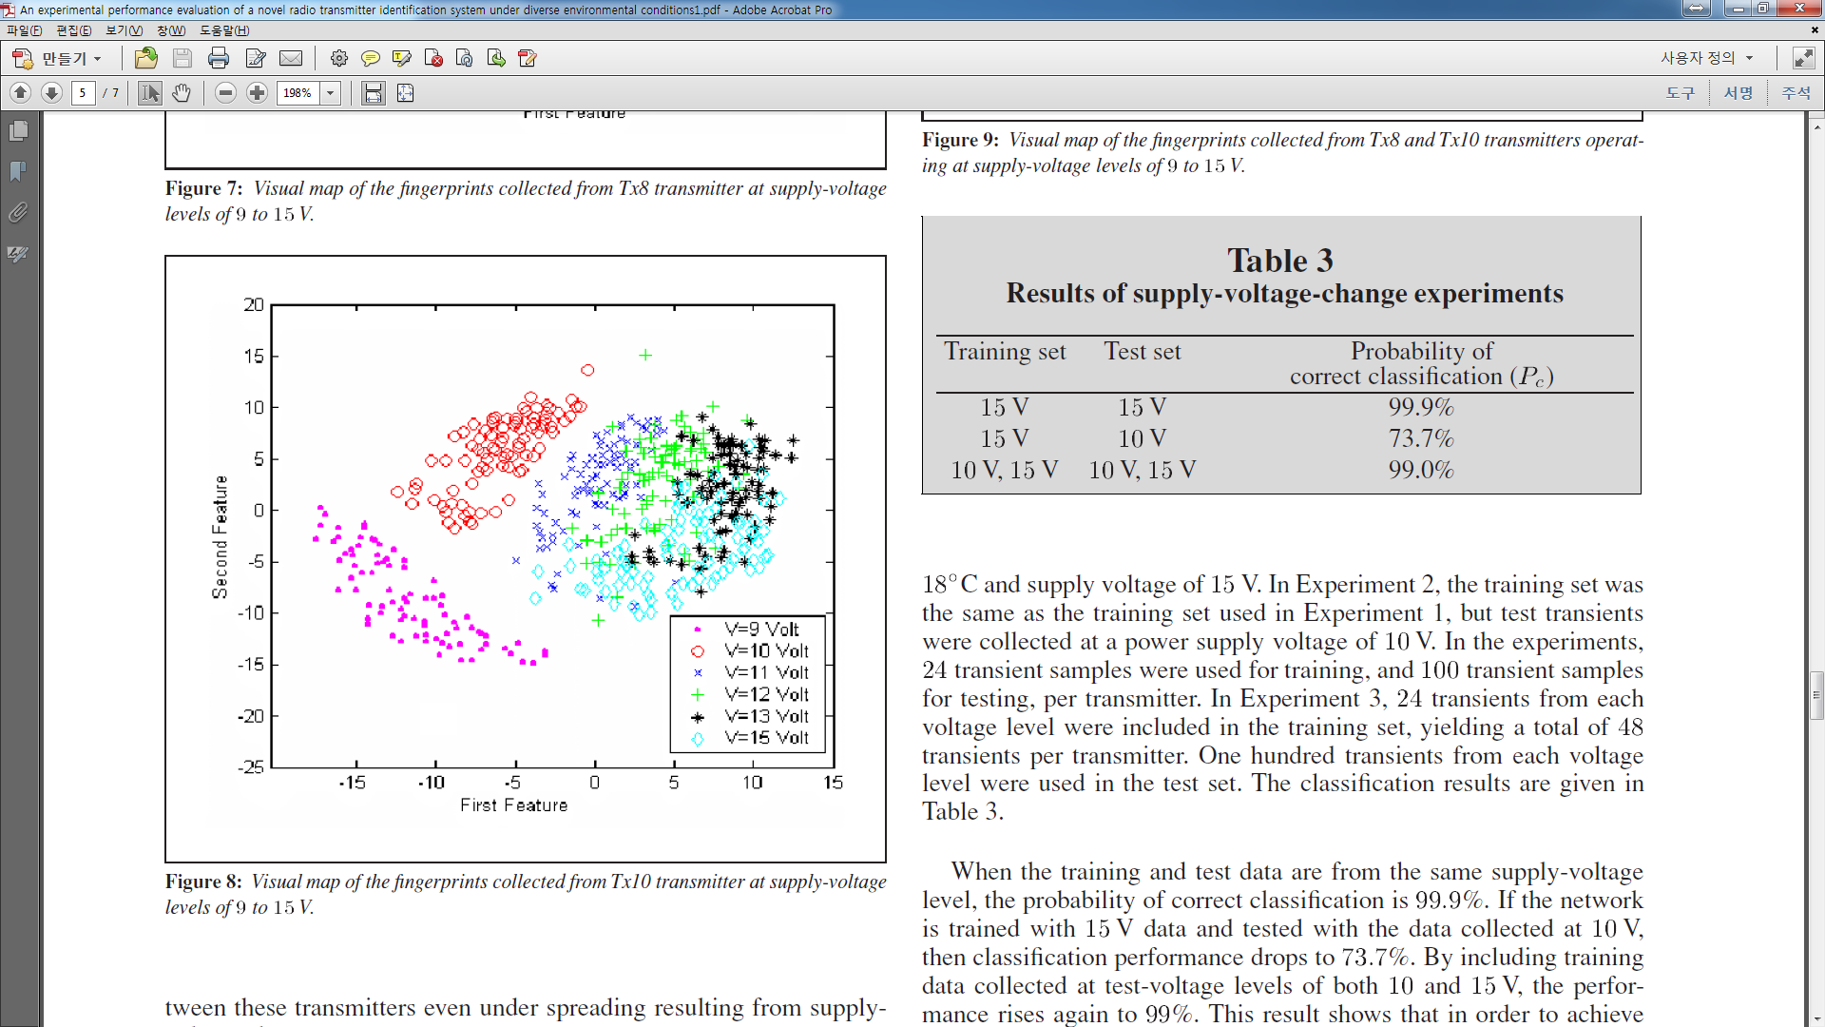



In Fig. 7 & 8 (Tx8 & Tx10 cases),

- 84 transients are displayed for each voltage.

- Transients obtained from different voltage levels are clustered at different regions of the feature space.

- As the voltage level decreases, the fingerprints move on the map, causing a spread of the fingerprints.

A new Sammon map of Tx8 and Tx10 is displayed in Fig. 9

- We could notify the class separation between these transmitters even under spreading resulting from supply voltage changes.



Additional experiments were performed with 10 transmitters to determine classification performance of the CE system for different power supply levels.

- Experiment 1 : all training and testing samples are collected under supply voltage of .

- Experiment 2 : same training samples in exp. 1. And testing samples are collected under supply voltage of 

- Experiment 3 : all training and testing samples are collected under supply voltage of  and .

- All training and testing samples for each voltage are 24 and 100 respectively

In Exp. 1. The accuracy is . And in Exp. 2. The accuracy drops to . But in Exp.3. the accuracy rises again to  because of including the  training samples. From this result, we could know that training the classification algorithms with the data from varying battery voltage levels could help to increase the classification accuracy.

# **The effect of ambient temperature change**

In this paper, a temperature-controlled chamber is used.

- In this chamber, the temperature rose from  to  for 40 minutes.

- In order to obtain the same temperature level, they define the time period

=> (0 min to 2 min), (10 min to 12 min), (20 min to 22 min), (30 min to 32 min)

- 100 transient samples are collected during this time period (i.e. 2 min)

- 20 transient samples are abstracted by using a SOM network.

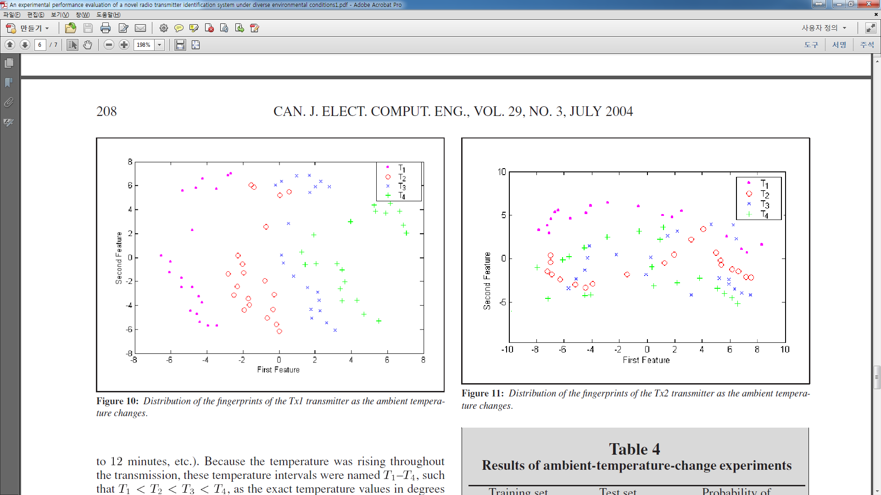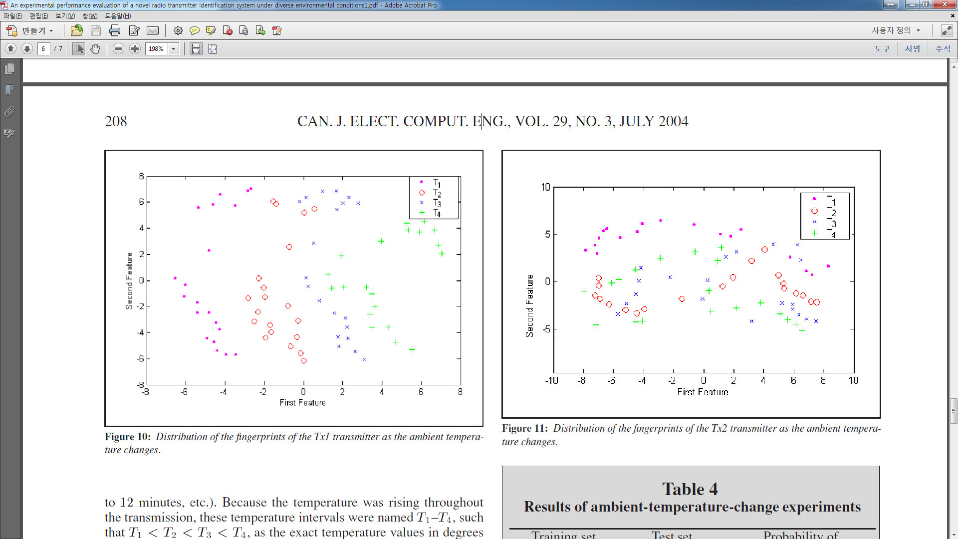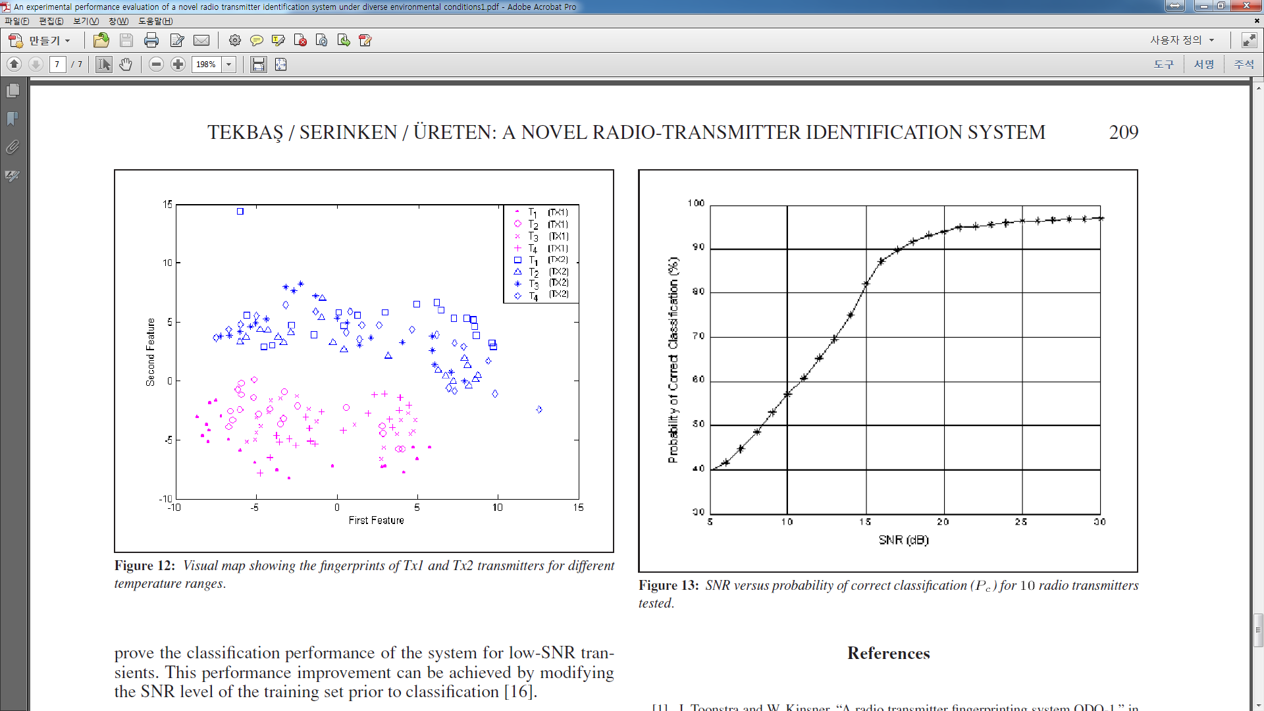

In Fig. 10 & 11 (Tx1 & Tx2 cases),

- In contrast with the voltage data, the fingerprints collected from different temperature ranges show a relatively large amount of spread and overlap in the feature space.

A new Sammon map of Tx1 and Tx2 is displayed in Fig. 12

- We could know that the class separation between these transmitters is exist.

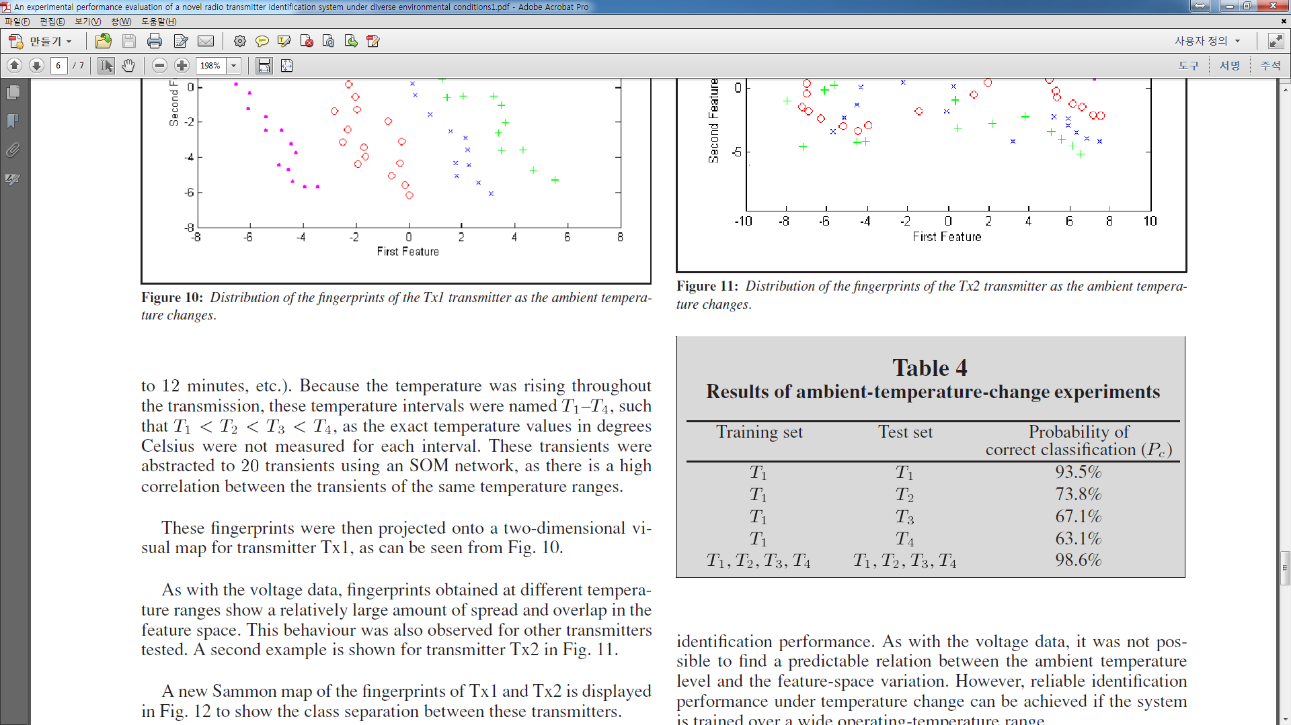

Additional experiments were performed with 10 transmitters to determine classification performance of the CE system for different temperature ranges

- 20 training samples and 80 testing samples are collected from each time slots.

From exp. 1. To exp. 4, the accuracy is changed as  to . But in exp. 5. The accuracy rises again to  because of including the training samples from other time slots. From this result, we could know that training the classification algorithms with the data from varying temperature levels could help to increase the classification accuracy.

# **The effect of additive noise**

Experimental setup :

- In this paper, to make the additive noise, an additive white Gaussian noise generator is used.

- This noise samples are added to the transient signals after scaling for the desired SNR values.

- The classification test for each transient was performed 10times with a different noise-sample sequence.

- 240 training samples and 260 transient samples are collected.

- The SNR for this experiment is calculated as : 

=>  : power of the noise signal,  : power of the noisy transient signal.

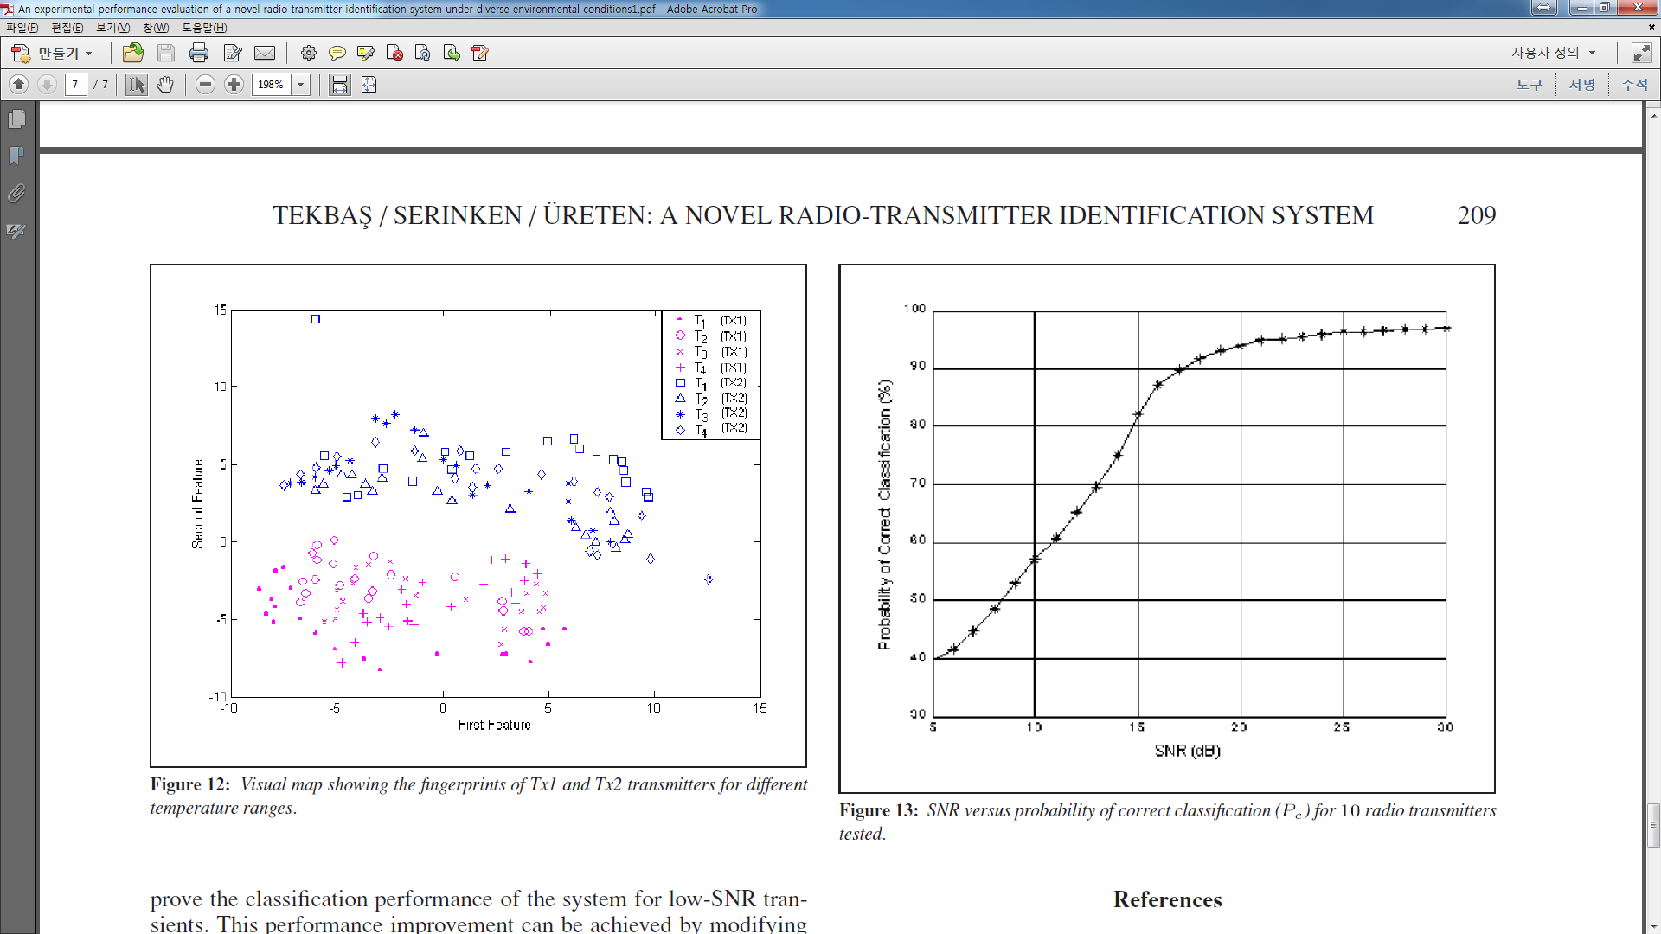

From this result, we could know that if the SNR is higher than 17dB, the reliability of classification decision is higher than 90%.

# **Conclusions**

Based on the experimental results, it was observed that the effects of variation in ambient temperature, power supply and additive channel noise could affect the performance of transmitter identification system.

This fact necessitates a requirement for training of the identification system over a wide temperature range and over the range of supply-voltage levels.

As a result, an data reduction technique (e.g., self-organizing map) is required to alleviate the PNN training and computational complexity in the classification step, due to large training data sets.

The SNR versus classification-rate curve was presented to show the reliability of the system under noisy channels. This curve provides a confidence measure for the classification result of a given SNR value, which can be calculated from transient and transient data.

# **References**

[1] J. Toonstra and W. Kinsner, “A radio transmitter fingerprinting system ODO-1,” in *Proc. IEEE Can. Conf. Elect. Comput. Eng.*, vol. 1, Calgary, Alta., 1996, pp. 60–63.

[2] D. Shaw and W. Kinsner, “Multifractal modeling of radio transmitter transients for classification,” in *Proc. IEEE Conf. Commun. Power and Comput.*,Winnipeg,Man., 1997, pp. 306–312.

[3] N. Serinken and O. U¨ reten, “Generalised dimension characterization of radio transmitter turn-on transients,” *Electron. Lett.*, vol. 36, no. 12, 2000, pp. 1064–1066.

[4] O. U¨ reten and N. Serinken, “Detection, characterization and classification of radio transmitter turn-on transients,” in *Multisensor Fusion*, Netherlands: Kluwer Academic Publishers, 2000, pp. 611–616.

[5] ———, “Bayesian detection of radio transmitter turn-on transients,” in *Proc. IEEEEURASIP Workshop Nonlinear Signal and Image Processing*, Antalya, Turkey, 1999, pp. 830–834.

[6] ———, “Detection of radio transmitter turn-on transients,” *Electron. Lett.*, vol. 35, no. 23, 1999, pp. 1996–1997.

[7] H.C. Choe, C.E. Poole, A.M. Yu, and H.H. Szu, “Novel identification of intercepted signals from unknown radio transmitters,” in *Proc. SPIE Wavelet Applications II*, Orlando, Fla., 1995, pp. 504–517.

[8] A.M. Abdulla, “Identification of push-to-talk transmitters using wavelets and spectral correlation,”M.Sc. thesis, Dept. of Electrical and Computer Engineering, Naval Postgraduate School, Monterey, Calif., Sept. 1996.

[9] R.D. Hippenstiel and Y. Payal, “Wavelet based transmitter identification,” in *Proc. Int. Symp. Signal Processing and Its Applications*, Gold Coast, Australia, 1996, pp. 740–743.

[10] K.J. Ellis and N. Serinken, “Characteristics of radio transmitter fingerprints,” *Radio Sci.*, vol. 36, no. 4, 2001, pp. 585–597.

[11] O¨ .H. Tekbas¸ and N. Serinken, “Transmitter fingerprinting from turn-on transients,” presented at NATO SET Panel Symp. Passive and LPI Radio Frequency Sensors, Warsaw, Poland, 2001.

[12] P. Grassberger and I. Procaccia, “Characterization of strange attractors,” *Phys. Rev. Lett.*, vol. 50, no. 5, 1983, pp. 346–349.

[13] W. Siedlecki, K. Siedlecka, and J. Sklansky, “An overview of mapping techniques for exploratory pattern analysis,” *Pattern Recognition*, vol. 21, no. 5, 1988, pp. 411– 429.

[14] D.F. Specht, “Probabilistic neural networks,” *Neural Networks*, vol. 3, no. 1, 1990, pp. 109–118.

[15] T. Kohonen, “The self-organizing map,” in *Proc. IEEE*, vol. 78, no. 9, 1990, pp. 1464–1480.

[16] O¨ .H. Tekbas¸, O. U¨ reten, and N. Serinken, “Improvement of transmitter identification system for low SNR transients,” *Electron. Lett.*, vol. 40, no. 3, 2004, pp. 182– 183.