|  |
| --- |
| Power and Channel Allocation for Cooperative Relay in Cognitive Radio Networks |

|  |  |
| --- | --- |
| Authors: | G. Zhao et. al. |
| Publication: | IEEE JSTSP, Feb. 2011 |
| Speaker: | Asif Raza |

**Short summary**: In this paper authors mention that cognitive radio relay channels can be divided into three categories: direct, dual-hop, and relay channels. The relay node involves both dual-hop and relay diversity transmission. They develop power and channel allocation approaches for cooperative relay networks. They also develop a low complexity approach that can obtain most of the benefits from power and channel allocation with minor performance loss.

# Introduction

Resource (channel and power) allocation in CR relay networks is considered in the paper. The power and channel allocation for cooperative relay in a three-node CR network, which consists of a source, a relay, and a destination and can operate in multiple spectrum bands, is considered. In this context CR relay channels(CRRCs) can be divided into three categories as shown in Fig. 1.

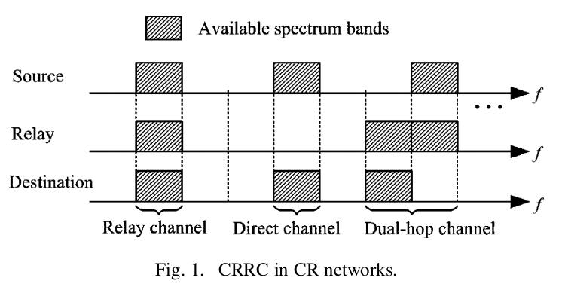

These relay channels have their advantages over each other. For example a dual-hop channel has a bottleneck in throughput whereas a relay channel loses half of its throughput due to its half-duplex constraint. While a CR transmitter and at its intended CR receiver using direct channel on their respective links can result in scarcity of the available spectrum bands for other users in highly congested areas. In this paper authors propose to assign the spectrum band of the relay channel to assist the transmission in dual-hop or direct channels.

Authors in this paper first introduce CRRC in a CR network with four typical spectrum bands, and then discuss power constraints for both the source and the relay. Finally they obtain end-to-end throughput of CRRC.

# CR System Description

## Cooperative Relay Channel

The network design considered is shown in the following figure.

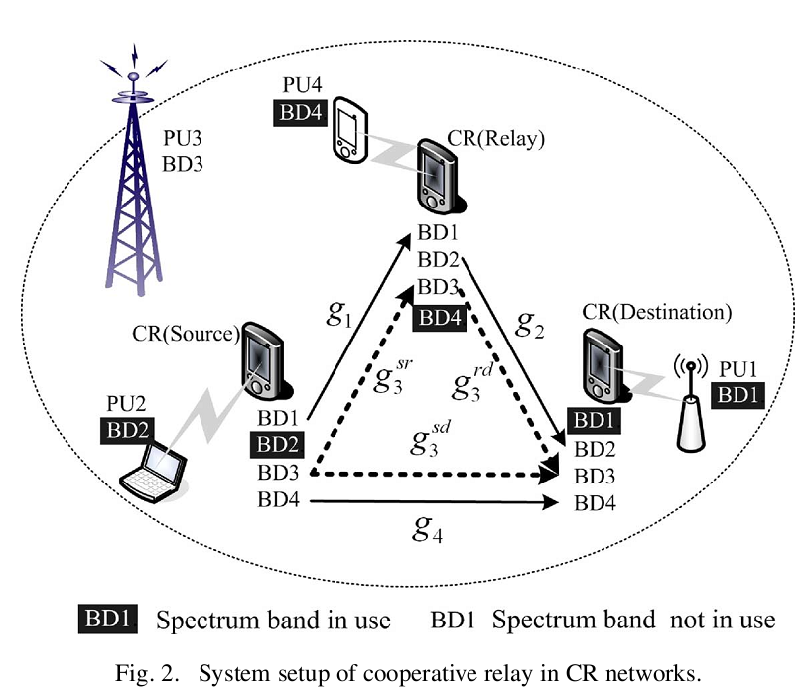

In the network setup every CR node is equipped with an omnidirectional antenna and can simultaneously sense four licensed spectrum bands, BDi. Each of them belongs to a PU exclusively. The primary user 1 (PU1), PU2 and PU4 are using BD1, BD2 and BD4 channels respectively. However they have local effect only. The PU3 has large coverage area and effects the whole CR network. However, for example, if PU3 is not transmitting then BD3 is available to relay node. The source-relay (sr), relay-destination (rd) and source-destination (sd) links are using channel powers over BD3 as ,  and  respectively.

## Transmit Power Constraint

Let ,  represents power allocation vectors for source and relay nodes over all four BDs, respectively. The power constraint is defined as:and total power is defined as: where  and maximum powers that source and relay are able to transmit.

## End-to-End Throughput

End-to-end throughput on direct transmission on BD4 can be expressed as:  where is channel power over BD4. For dual-hop transmission in BD1 and BD2, both operates serially thus the end-to-end throughput is smaller of two hops, i.e., . The throughput on relay channel is: . The overall throughput of CRRC is given as: .

# Power and Channel Allocation

Due to complexity, the channel and power allocation is considered independently.

## Channel Allocation: four possible transmission modes are defined as:

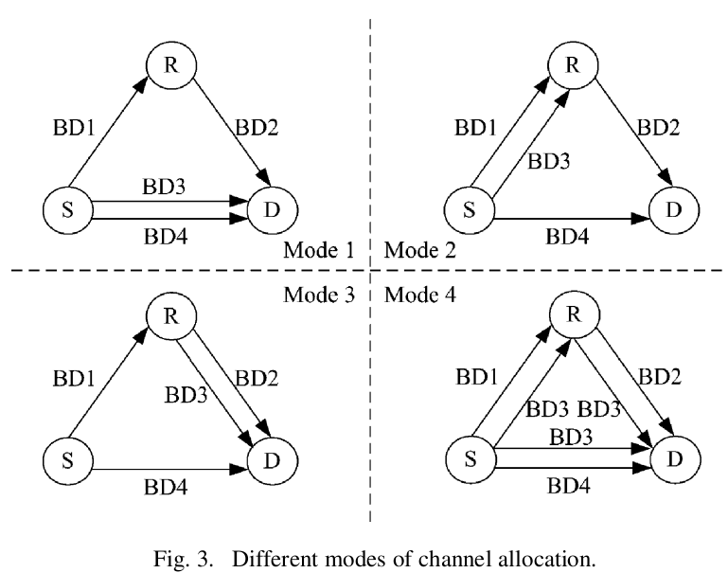

## Objective of channel allocation is to select proper mode to maximize overall end-to-end throughput. The throughput for each mode is defined in end-to-end throughput section. It requires power allocation for each mode.

## Power Allocation: for first 3 modes, power allocation at relay node is defined as:

## 

Subject to:







Similarly power allocation at source is defined as:



Subject to:









where  represents throughput on link from source to relay node. Similarly the throughput on link from relay to destination can be defined in similar way. Here  represents power allocated to source by using water-filling solution[2],. The last constraint in above problem is non-convex.

For mode 1 and 3, the last constraint can be converted into inequality constraint as. The problem then becomes convex optimization problem and can be solved by using water-filling solution.

For mode 2 there are more than one spectrum bands for first hop of dual hop transmission. In this case the last constraint of the defined problem is non-convex. It is transformed into equality constraints as:

*Step 1*: Perform power allocation without considering the constraint and obtain the power allocation vector .

*Step 2*: Check whether meets the constraint. If so, it is the power allocation vector that we need for the source. Otherwise, reduce the sum power constraint of the source and perform power allocation until meets:

 where 

*Step 3*: Obtain the inequality constraints by and 

For mode 4: 🡪 use SD link (direct transmission) if  but if  then all three links should be used in relay diversity transmission i.e., 

In this case power allocation at relay is:  and source needs to divided its power into three parts; direct, dual and relay diversity.

Direct transmission case; ,

Dual-hop case; ,

Relay transmission; 

The overall end-to-end throughput can be maximized as:



Subject to: 

* When  then objective function becomes:



* When  then objective function becomes:



In both of the cases, the problem is convex problem and can be solved by using water-filling solution as:







In brief, the power and channel allocation in CRRC can be summarized as follows:

• List all possible modes of the channel allocation

• Perform power allocation for each mode

• Pick the mode with the largest overall end-to-end throughput by exhaustive search.

# Numerical Results

The parameters used for evaluation are: number of CR nodes=3; number of spectrum bands = 4; spectrum bandwidth = 1 MHz; noise at CR node= -126 dBW; path loss between two CR nodes = 126 dB; maximum allowable power on each spectrum band i.e. Pmax=3W;

## Different Source / Relay Power Constraints

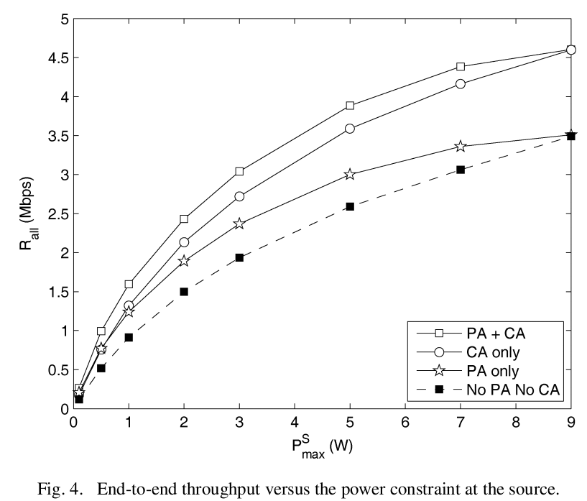 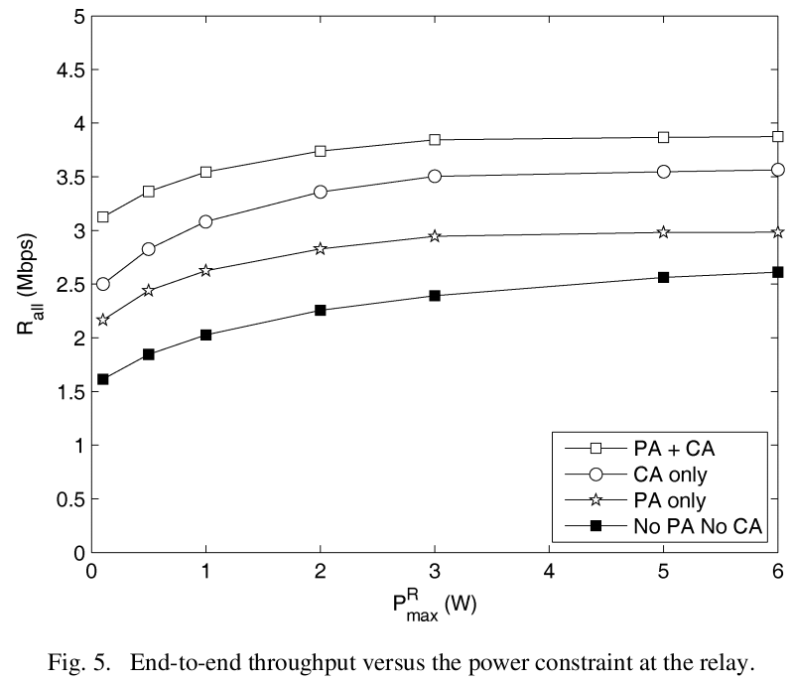

PA= Power Allocation, CA = Channel Allocation, = maximum power at source, = maximum power at relay, Rall= end-to-end throughput. “No PA No CA” is Mode 4 used as a baseline for comparison. The notable observation in Fig. 4 is that CA continue to increase throughput for increase in sum power constraint however PA can only improve throughput when . This is because when the sum power constraint is large enough, the per band power constraint will limit the transmit power. {Then the source sends signals with maximum allowable transmit power on each spectrum band. This is equivalent to equal power allocation, i.e., Pmax no power allocation.} Therefore, channel allocation is more effective than power allocation in CRRC. In Fig. 5 the throughputs of different schemes grow almost at similar scales. However when the sum power constraint is large enough, the throughput will be capped by per band power constraint.

1. Low Complexity Approach:if the CR system works in Mode 4, the relay has toconduct both *du*al-hop and relay diversity transmission, which *complicates the system. Therefore, we omit Mode 4 and only consider Modes 1, 2, and 3 for the power and channel allocation.*

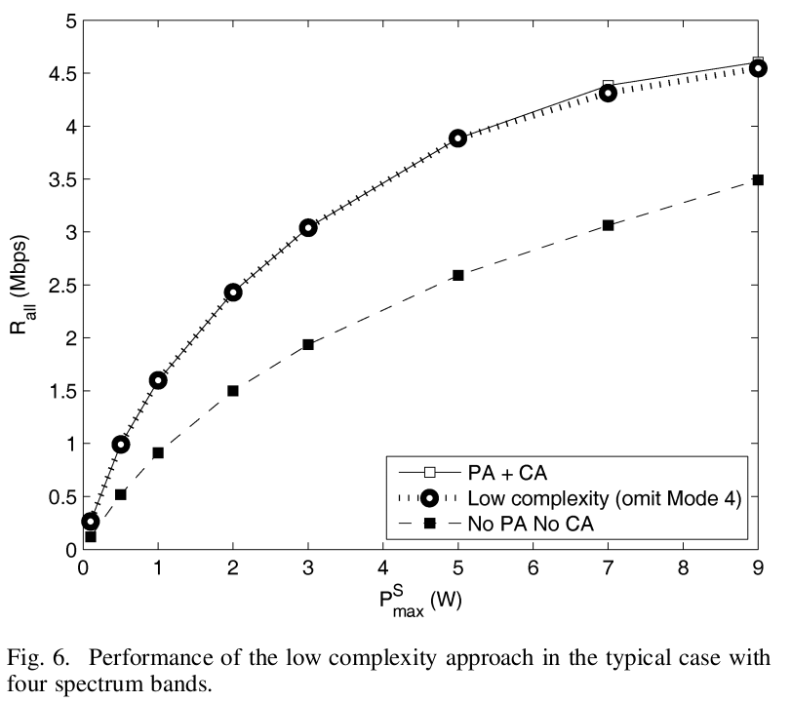

We can find that the low complexity approach of omitting Mode 4 has similar performance to the method of considering all four modes. Furthermore, when the sum power constraint at the source is larger than 9 W, it only decreases the throughput from about 4.6 Mbps to about 4.5 Mbps compared to the scheme with power and channel allocation, i.e., about 2% performance loss.

## Performance in Multiple Spectrum Bands:

When N independent spectrum bands are used, there are L=N/4 relay channels on average. It is shown in fig. 7 that low complexity scheme has performance close to power and channel 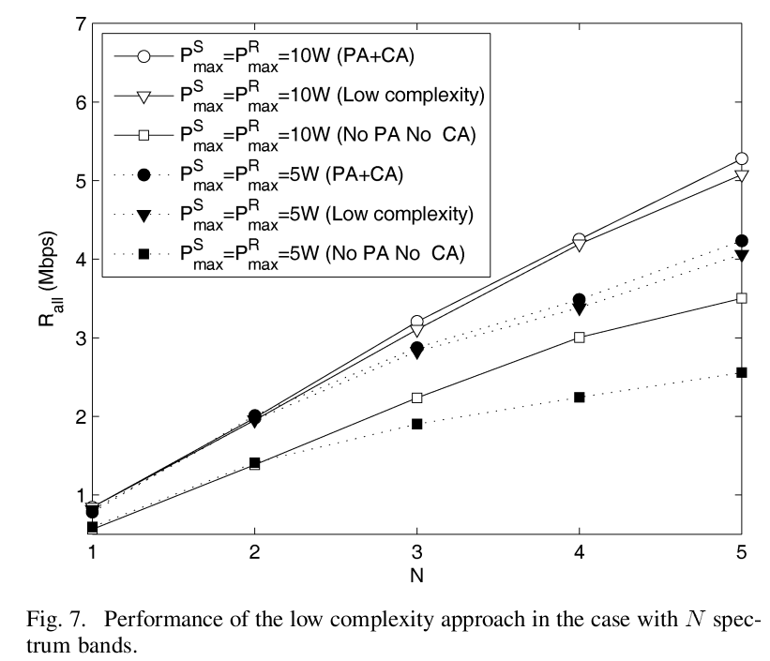

allocation scheme for both 5W and 10W sum power constraints. Moreover it outperforms the scheme with no power and channel allocation in both of the power constraint cases.