|  |
| --- |
| Robust Compressive Data Gathering  in Wireless Sensor Networks |

|  |  |
| --- | --- |
| Authors: | Yu Tang, Bowu Zhang, Tao Jing, Dengyuan Wu, Xiuzhen Chen |
| Publication: | IEEE T. On Wireless Comms, June.2013 |
| Speaker: | Jongmok Shin |

# Introduction

-In this paper, authors address the problem of data gathering in WSNs with outlying sensor readings and broken links.

-Traditional approaches rely on in-network data compression (ex)wavelet transform, joint entropy coding and so on), which may suffer from following two major drawbacks:

1) High communication overhead(in the worst case O() single-hop transmissions are needed to collect the data from N sources)

2) Some approaches such as the distributed source coding rely on a static correlation structure, which may not be easily obtained in a dynamic environment.

-The recent breakthroughs in CS theory motivate us to investigate compressive data gathering.

-The main contributions of this paper are as follows. (Authors target the robustness of compressive data gathering: the accuracy of the recovered data at the sink is significantly affected by outlying sensor readings and broken links, whose existence makes the collected signal uncompressible)

1. Authors argue that compressible data may lose its compressiveness in WSNs due to outlying sensor readings and broken links.
2. They propose two CS based approaches, with one focusing on detecting and recovering (correcting) outlying sensor readings and the other inferring the broken links.
3. They perform an extensive simulation study to evaluate the performance of the proposed methods over various parameter settings and compared to other popular in-network compression algorithms.

# Fundamentals of compressive sensing

Let  be a  column vector in . Given an  orthogonal basis  with each  being a column vector,  can be expressed by (1),

 (1)

where  is the coefficient sequence of x in the transform domain .The signal is -sparse if it is a linear combination of  basis vectors. That is, only of the coefficients are nonzero and the other  ones are zero. If , instead of acquiring all the N values from , CS aims to reconstruct  by taking only a small set of measurements:

 (2)

Where  is a  vector,  *measurement matrix*, and is a matrix. For a  vector , it has been proved that if holds the Restricted Isometry Property(RIP), can be recovered with only measurements at an overwhelmingprobability through the following -minimization



where c is a constant depending on each instance.

The definition of RIP is as follows: a matrix  obeys RIP with 

 (3)

holds for all -sparse vector .

( should project all -sparse vector  with equal energy.)

If the measurement vector is corrupted with noise (AWGN),

 (4)

Then the -minimization is

, (5)

where  bounds the amount of noise in the data.

# System model and motivation

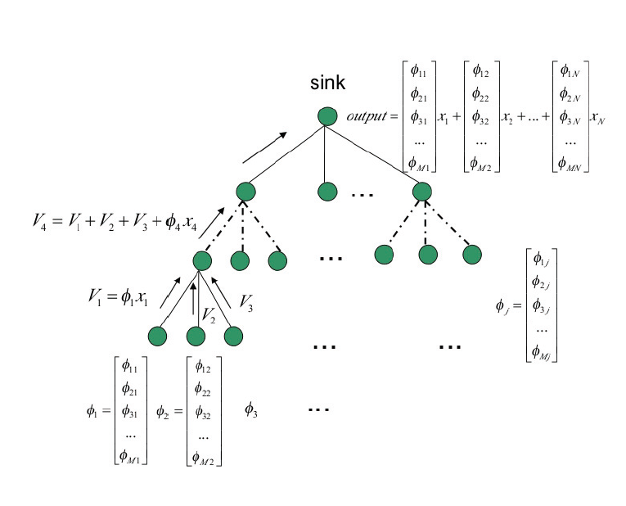

Fig.1. The architecture for compressive data gathering. Each observation at the data sink is a random projection of all sensor readings.

In Fig.1, the shortest path tree spanning all sensor nodes and rooted at the data sink is adopted to gather the readings of the whole network. The objective is to collect the original sensor readings from all sensors. If no compression policy is employed, number of messages are required. However, compressive data gathering requires messages, with . This architecture is detailed as follows.

Let be the number of sensors and be the set of sensor readings forming a column vector in . Each sensor reading is multiplied with a vector of random values and the resultant vectors are added together forming partial projections from the non-leaf nodes along the paths to reach the root, which computes the final random projections of the sensor readings. The random vectors associated with the sensor nodes constitute the column of the measurement matrix. Thus the data received at the sink is:

  (6)

This architecture can preserve high fidelity data recovery at the data sink only if the original sensor readings (vector ) are compressible. In principle this is true as the values in are the samples of a real-world smooth signal and they are spatially correlated.

However, our sensor network is not perfect. Its sampled datamay not be compressible due to the outlying readings and broken links.

-The outlying readings: Malfunctioning sensors may report outlying readings. Since outlying readings are typically uncorrelated with each other and uncorrelated with normal sensor readings, the spartcity of the signal in its transform domain may be violated.

-Broken links: It may exist due to power depletion or sensor malfunction. In compressive data gathering, a broken link may affect multiple sensor readings.

Therefore, in this paper, authors focus on solving both problems.

# Outlying sensor reading identification and broken link detection

A. Outlying sensor reading identification.

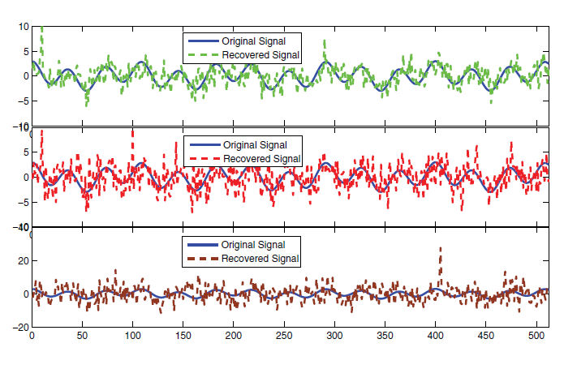

Fig.2. The recovered signal with outliers.

They randomly select sensors to be outliers and test the impact of outlying readings on compressive data gathering. Figure.2 illustrates the recovered signal when we have one, two or 100 sensors reporting outlying readings. We observe that even with only one sensor reporting an outlying reading, the recovered signal deviates from the original one significantly.

Outlying sensor reading detection is a challenging problem in compressive data gathering because the data collected at the sink are the random linear projections of the real sensor readings, which renders the popular statistics-based outlier detection algorithms inapplicable. To solve this problem, we resort to the compressive sensing theory again.

Sensor outlying is itself a sparse event in the primal domain(I, the identity matrix) of x since we assume that only a very small of sensor readings is outlying sensor readings. Therefore, outlying sensor readings can be identified based on the compressive sensing theory. Let (the vectors of the readings of all the sensors, normal sensor readings, outlying sensor readings )

Note that is sparse in its transform domain , but  is not. However,  is sparse with respect to . Therefore, we have

 (7)

where  can be reconstructed by any CS recovery algorithm.

B. Broken Link Detection.

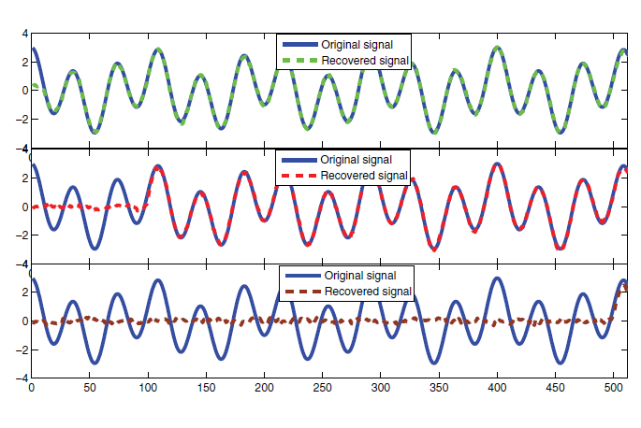

Fig.3. The recovered signal with broken links.

As shown in Fig.3, the existence of broken links makes the direct utilization of compressive sensing on x invalid.

-Dashed line of the first graph: when the link connecting the node at position 10 to the tree is broken.

-Dashed line of the second graph: when the link connecting the node at position 113 to the tree is broken.

-Dashed line of the third graph: when the link connecting the node at position 487 to the tree is broken.

In this subsection, they propose an approach to infer the broken links based on the compressive sensing theory.

Let  be a binary variable denoting the status of the link from sensor j to its parent node in the routing tree. Then if and only if the link from to its parent is broken. Let  be the vector of the link statuses. Note thatis sparse in the primal domain of since we assume that only a very small number of links are broken at any instant of time. In other words, is sparse with respect to the identity matrix , i.e., . Let  be the parent of. Denote by the vector of observation characterizing the broken links. Each observation is the random projection of the link statuses. If  locally concludes that the link to is broken, simply adds a vector of random values to the partial projections of  for broken link detection. All the random values used for the projection form the observation matrix. At the data sink, the received value can be written as

 (8)

which can be solved easily based on any CS sparse recovery algorithm.

# The result of simulation

In this section, they show the performance of robust compressive data gathering in sensor networks.

Definition: For each sensor be the true and the estimated reading, respectively. The Average relative error(ARE) is defined to be the average of the ratio between the difference of the estimated reading and the true reading vs. the true reading:

 (9)

1) Compressive Data Gathering In a Perfect Network: They first evaluate the performance of compressive data gathering when the network is perfect: neither broken links nor outlying sensor readings exist in the network.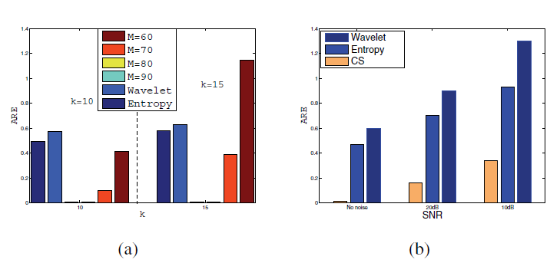

Fig.4. The ARE of the three algorithms

Fig.4(a) is without the random noise case, (b) is with the random noise case.

In Fig.4(a), the ARE increases as  increases and the ARE decreases with an increasing , while for entropy coding and wavelet transformation, their AREs slightly increase with an increasing k. Because they are not dependent on the number of k, but the correlation among the transmitted data.

In Fig.4(b), we could notice that the ARE of compressive data gathering when noise exists is greater than that of the case when there is no noise. Overall, the compressive data gathering achieves a lower ARE than the other two methods. This is because the noise damages the original data correlation, leading to inaccurate data decompression in conventional data gathering methods.

2) Outlying reading detection and recovery: For outlying reading detection they consider the following scenario. Let be the percentage of outlying sensors. In other words, the vector of outlying sensor readings is sparse.

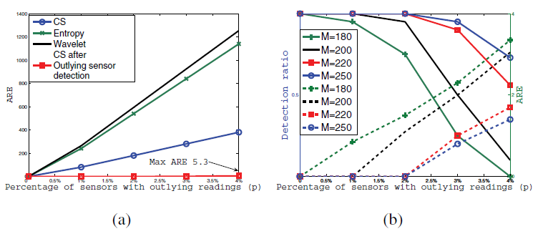

Fig.5. (a) The ARE of the three algorithms vs.

(b) Outlying reading detection ratio vs. (solid curves) and ARE vs. (dashed curves)

In Fig.5(a), we could notice that ARE increases as the percentage of the sensor nodes with outlying readings increases and compressive data gathering achieves the best signal recovery performance. This is because outlying readings can severely distort the data correlation. In addition to, authors show that by removing the outlying sensor readings, the true reading can be obtained with very low recovery error.

In Fig.5(b), we could notice that the detection ratio increases and ARE decreases as M increases.

3) Broken link detection and recovery: For broken link detection we consider the following scenario. Given a percentage , randomly choose links to be broken. Let be an -sparse vector where .

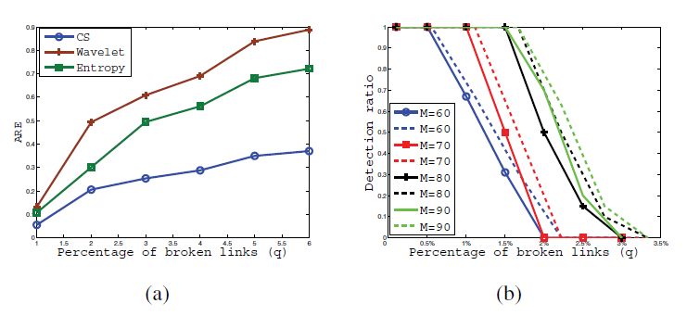

Fig.6. The performance of the three algorithms when there are broken links. (a) ARE vs.  (b) Broken link detection ratio vs. .

In Fig.6(a), it is observed that the ARE increases as  increases. We also could observe that compressive data gathering achieves a much better result than the algorithms based on entropy coding and wavelet transformation. This is because broken links that are far away from the sink may not severely affect the data recovery accuracy of compressive data gathering while the impact of broken links on the algorithms based on entropy coding and wavelet transformation is the same wherever the broken links are.

In Fig.6(b), it is noticed that as an overall trend, the larger the , the higher the detection accuracy we can achieve. And for a particular , the larger the , the lower the detection ratio.

# Conclusion

-In this paper, Authors investigate the problem of robust data gathering in WSNs based on the compressive sensing theory.

Firstly, propose an architecture for compressive data gathering

And then, develop two CS based methods

1. to identify outlying readings

2. to identify broken links

Finally, authors carry out an extensive simulation study and their results demonstrate that the proposed robust compressive data gathering approach outperforms other popular in-network compression algorithms.

# discussion

Appendix

Reference