|  |
| --- |
| Compressed Sensing Based Fingerprint Identification for Wireless Transmitters |

|  |  |
| --- | --- |
| Authors: | Caidan Zhao, Xiongpeng Wu, Lianfen Huang, Yan Yao, and Yao-Chung Chang. |
| Publication: | The Scientific World Journal, Volume 2014. |
| Speaker: | Ju-Sung Kang |

**Short summary**:

Most of the existing fingerprint identification techniques are unable to distinguish different wireless transmitters, whose emitted signals are highly attenuated, long-distance propagating, and of strong similarity to their transient waveforms.

Therefore, this paper proposes a new method to identify different wireless transmitters based on compressed sensing. A data acquisition system is designed to capture the wireless transmitter signals. Complex analytical wavelet transform is used to obtain the envelope of the transient signal, and the corresponding features are extracted by using the compressed sensing theory. Feature selection utilizing minimum redundancy maximum relevance (mRMR) is employed to obtain the optimal feature subsets for identification.

The results show that the proposed method is more efficient for the identification of wireless transmitters with similar transient waveforms.

# Introduction

The key process of individual identification is to extract the unique signal features that form a valid device fingerprint. i.e. The fingerprint of a transmitter should distinctly characterize it from the rest of the transmitters through its unique features presented in the signal waveform.

The transient feature extraction mostly utilizes the wavelet analysis or envelope analysis in the time-domain.

[17] : orthogonal Daubechies-4 wavelet, two types of wireless transmitters, recognition rate : 94.3%

[18] : genetic algorithms → wavelet coefficients, recognition rate : 90% ↑

[19] : energy envelope → statistical features, 7 Bluetooth devices, average recognition rate : 99.9%

[20] : spectrogram analysis → energy envelope → Polynomial fitting method, 4 network cards

[21] : complex analytic wavelet transform → Gaussian fitting method, recognition rate : 93%

Key ideas : the characteristics of wavelet coefficients extracted by the wavelet analysis methods are of little difference and with large number. → The compressed sensing theory can make the dimension of signals lower and all the information of original signal cannot be lost.

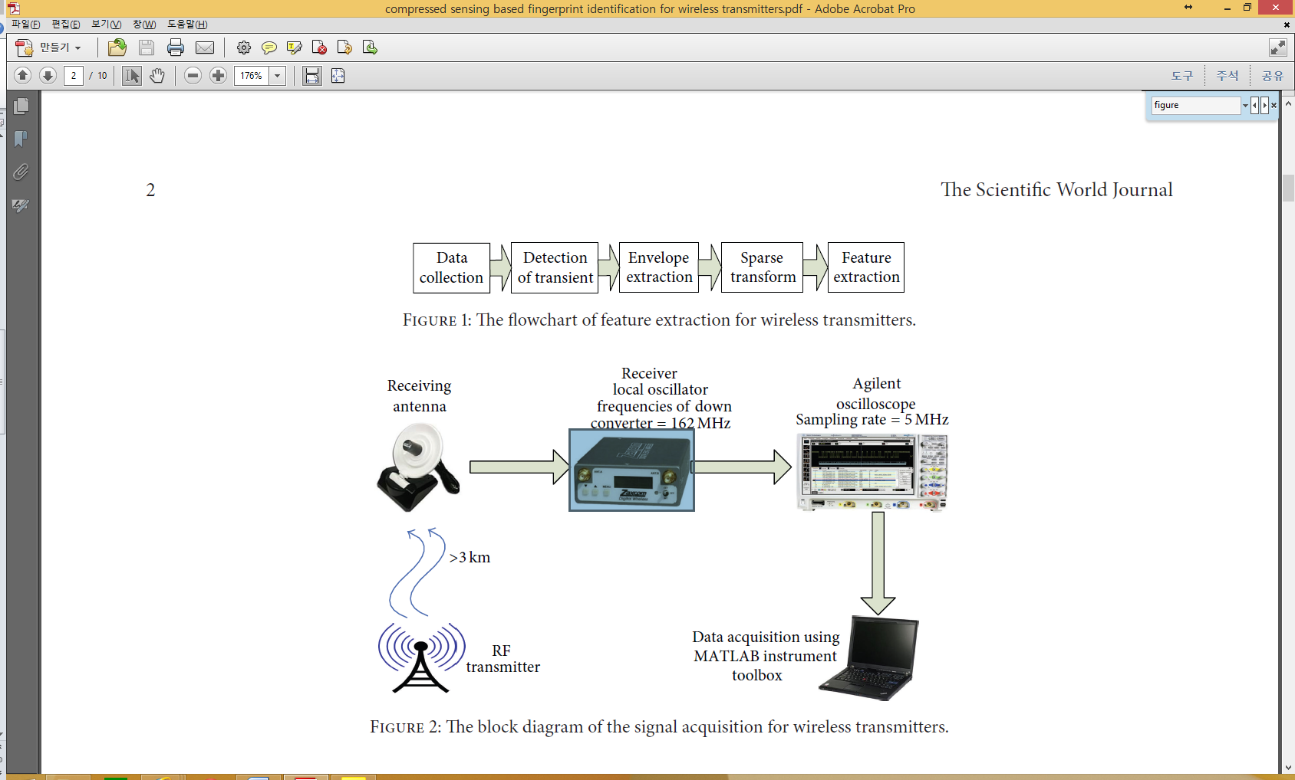

Detection of transient(Complex analytical wavelet transform) → Feature extraction(Compressed sensing theory) → Feature Selection(minimum redundancy maximum relevance (mRMR))

# Methodology

## 2.1. Data Collection.

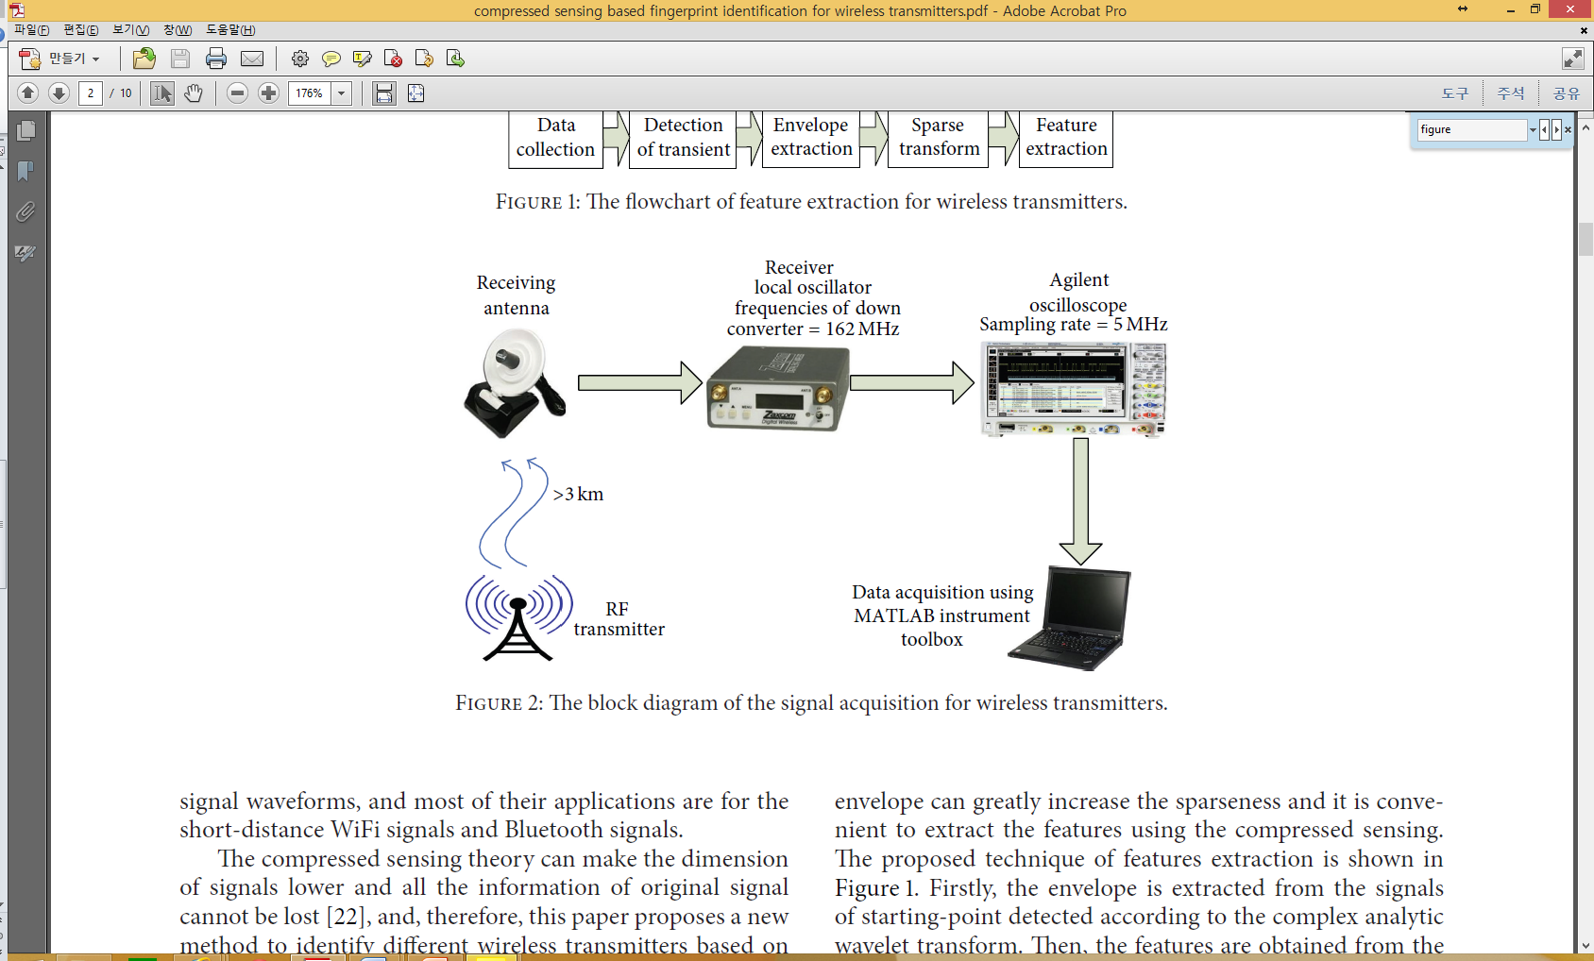

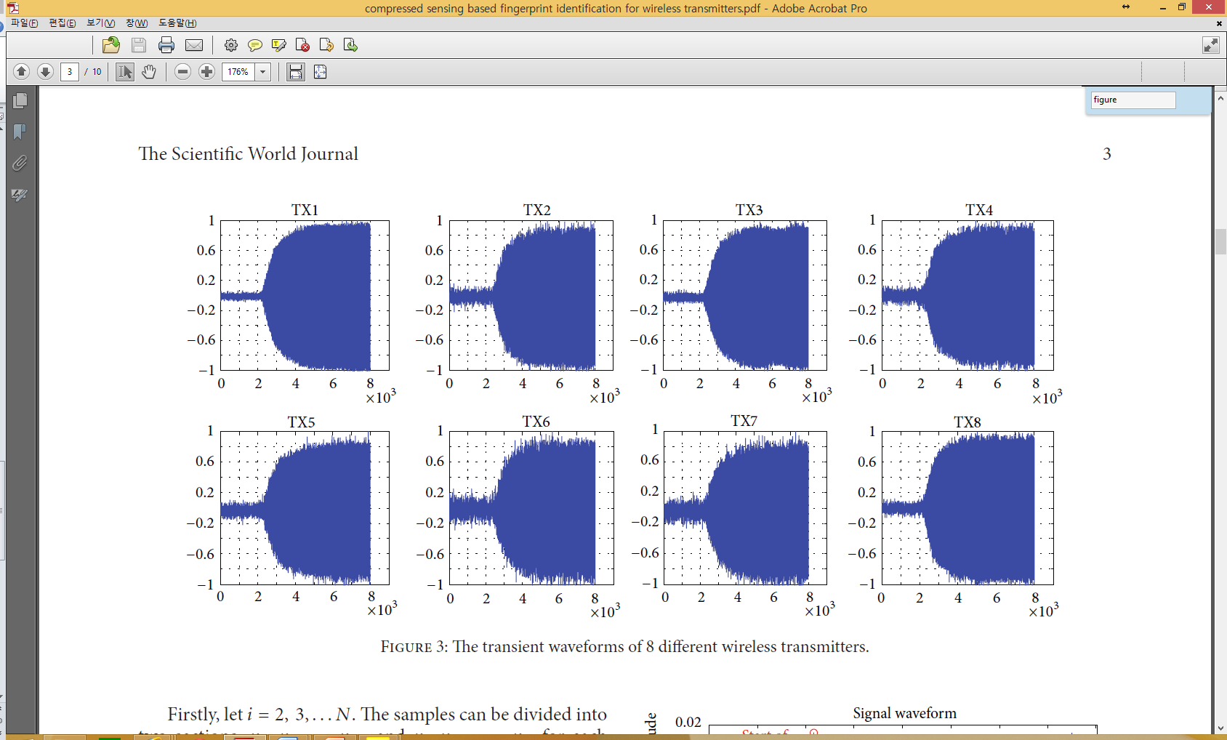

The sampling frequency : 5MHz. The distance between the Tx and Rx : > 3 km. The down-converted intermediate-frequency signal is collected by an oscilloscope. The MATLAB instrument toolbox is used.

The transient signal waveforms of 8 different wireless transmitters are used. 200 waveforms were captured and stored from each wireless transmitter.

→ The figure shows that there is no substantial difference among these waveforms.

## 2.2.Transient Extraction.

Accurate transient detection is the key step to extract the features.

→ Mean change point detection [23], analyze the transient based on phase detection [24].

→ Magnify the difference between the statistic of samples before and after the section, and the position of the maximum difference is determined to be the start of transient.

The sample sequence ,,…, is known. Let . The samples can be divided into two sections: ,,…, and ,,…,;

 (1)

 (2)

Now, the curve of 𝑆 − 𝑆𝑖 is plotted.

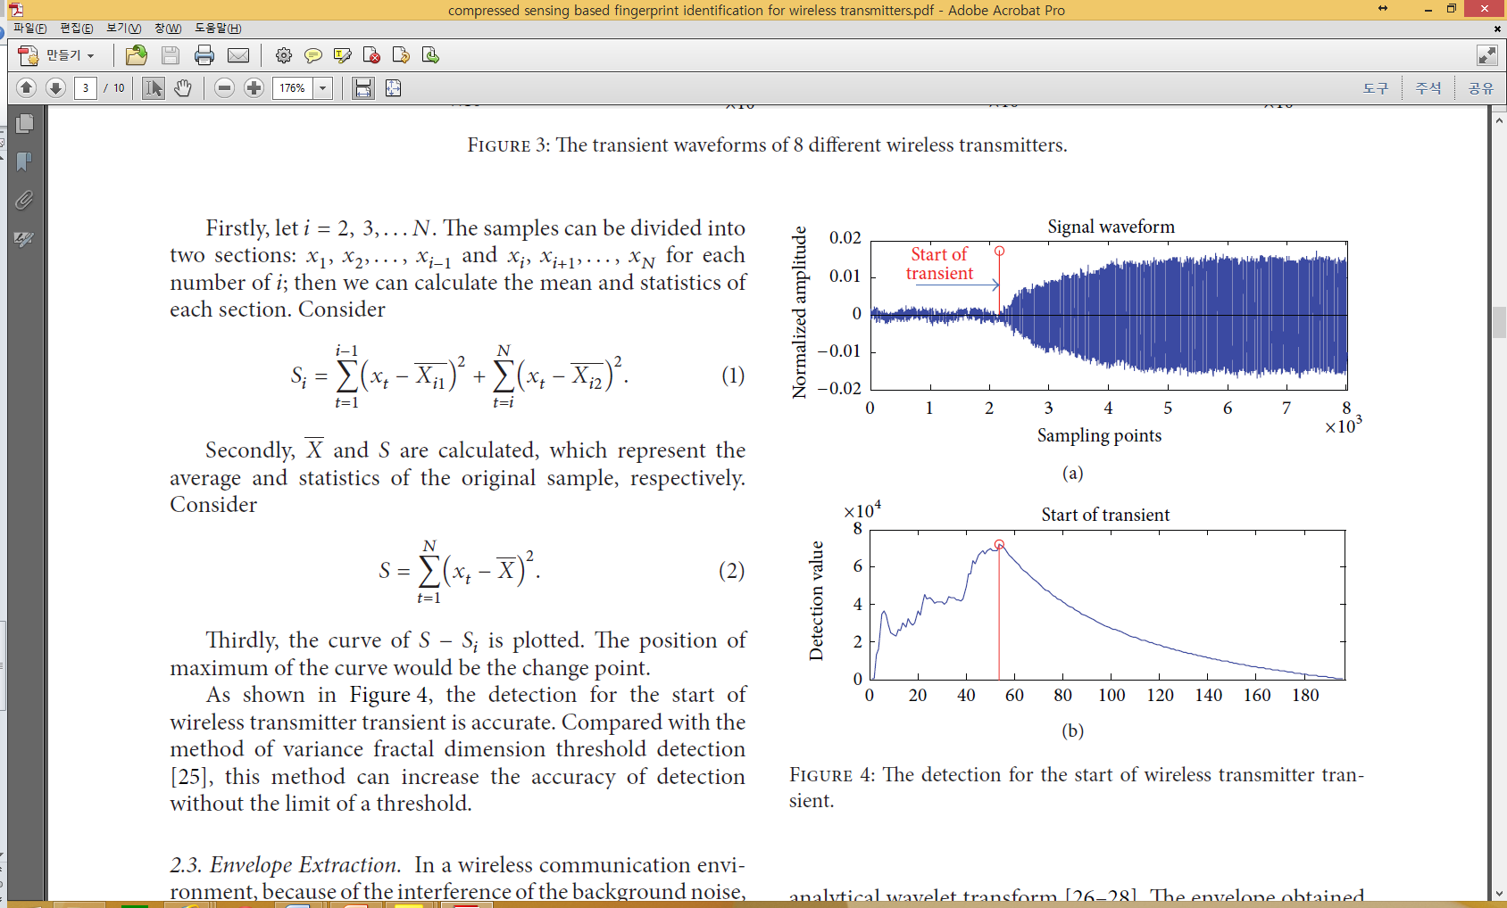

The position of maximum of the curve would be the change point. This method can increase the accuracy of detection than method of [25].

## 2.3.Envelope Extraction.

[26] : conventional Hilbert transform , Figure 5(b), not effectively eliminate the effect of the random noise, cause an influence on subsequent feature extraction step.

[19, 20] : a method of spectrogram analysis, Figure 5(c), limitation in short time window → obvious distortion can be exist.

[26 – 28] : complex analytical wavelet transform, inhibited effect of random noise property, smooth envelope curve with relatively small distortion.

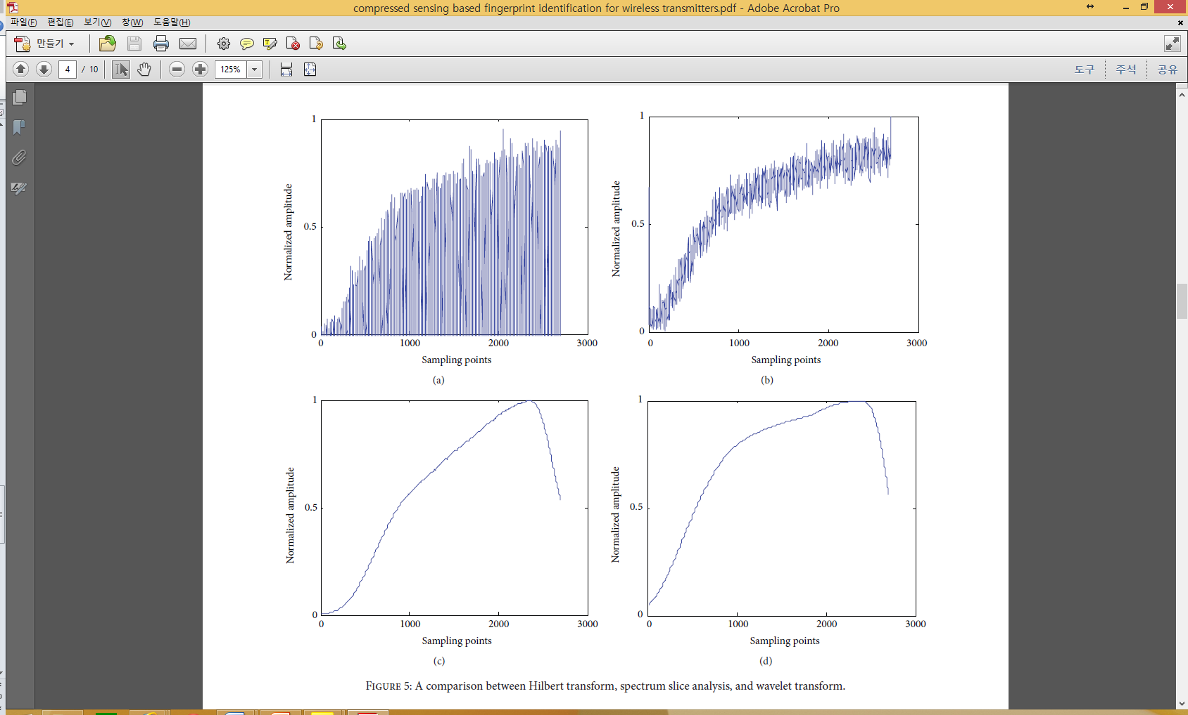

Morlet Wavelet transform (complex analytical wavelet transform) :

 (3)

 : Wavelet Shape Parameter (bandwidth),  : wavelet center frequency

 (4)

,  : time factor, : scale factor.

To obtain a smooth envelope curve, the parameter  and  of Morlet mother wavelet is adjusted.  and  are used in Figure 5(d) because its envelope curve is similar to the original signal and smoother.

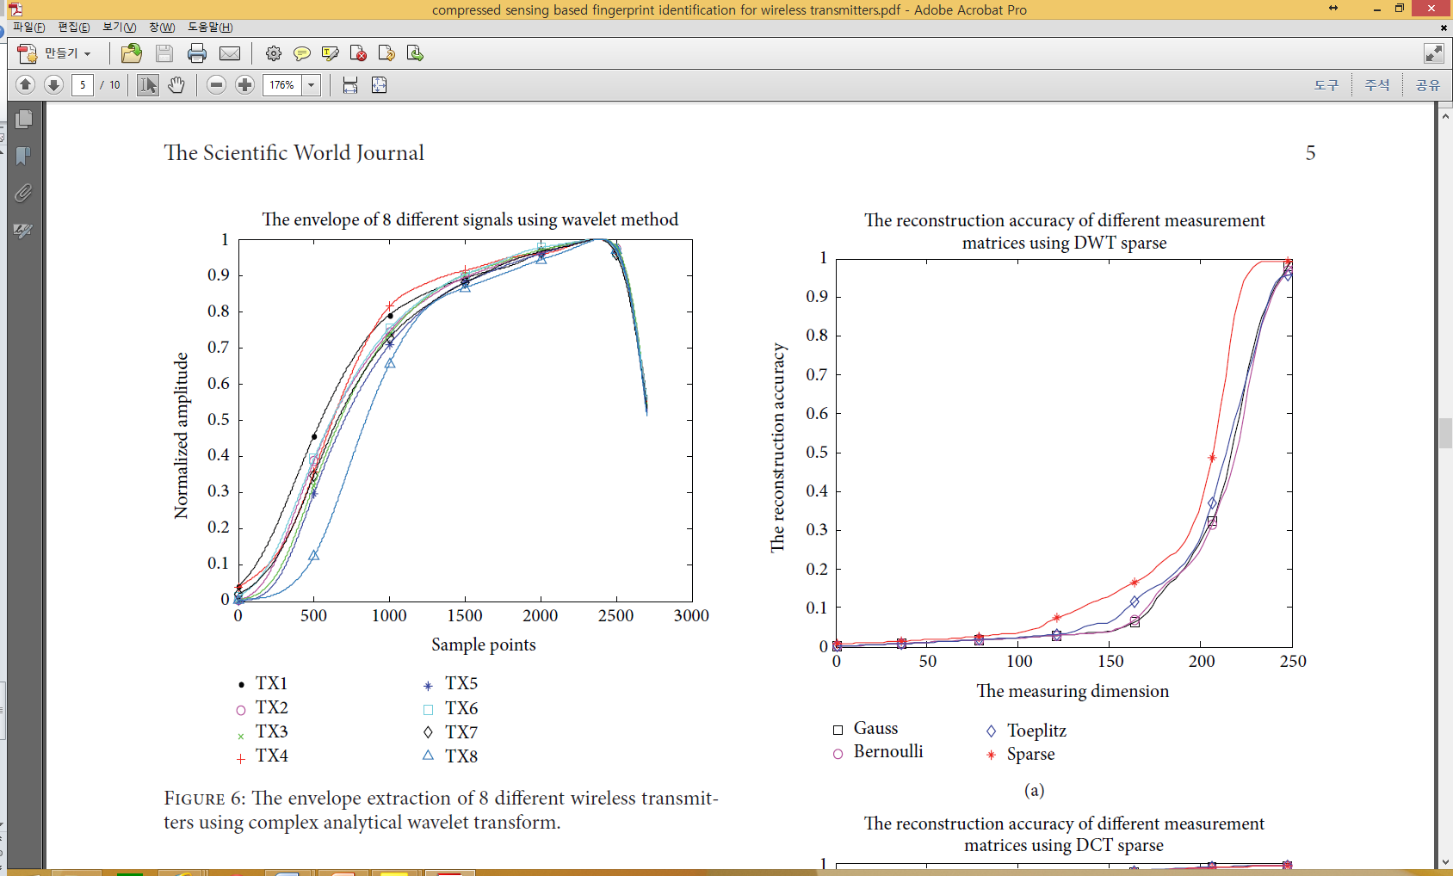

It can be seen that the envelopes have some differences between each other.

## 2.4.Feature Extraction Based on Compressed Sensing.

The method of this paper : extraction a feature based on compressed sensing.

An orthogonal sparse transformation such as DCT [29] and DWT [30] is performed for the envelope signal.

Envelope signal is . And  is able to be represented by the linear combination of . i.e.

 (5)

 :  orthogonal matrix for orthogonal transformation,  :  coefficient vector.

When  has  () nonzero coefficients, the signal  is sparse under the matrix .

(1) Linear measurement : The signal  is mapped to a measurement vector  which is a lower dimensional data.

 (6)

 :  () vector, feature vectors,  : , measurement matrix. Gauss matrix [22, 31], Bernoulli matrix [22, 31], Toeplitz matrix [32], sparse matrix [33].

→ The  is critical for feature extraction. It is required that the measurement matrix can make the dimension of feature vector 𝑧 as low as possible and all information of original signal cannot be lost.

(2) The reconstruction algorithm is used to confirm whether the features contain all information of the original signal.

 (7)

→ other suboptimal reconstruction algorithms : minimization algorithms. E.x. Bayesian algorithms (BCS) [30].

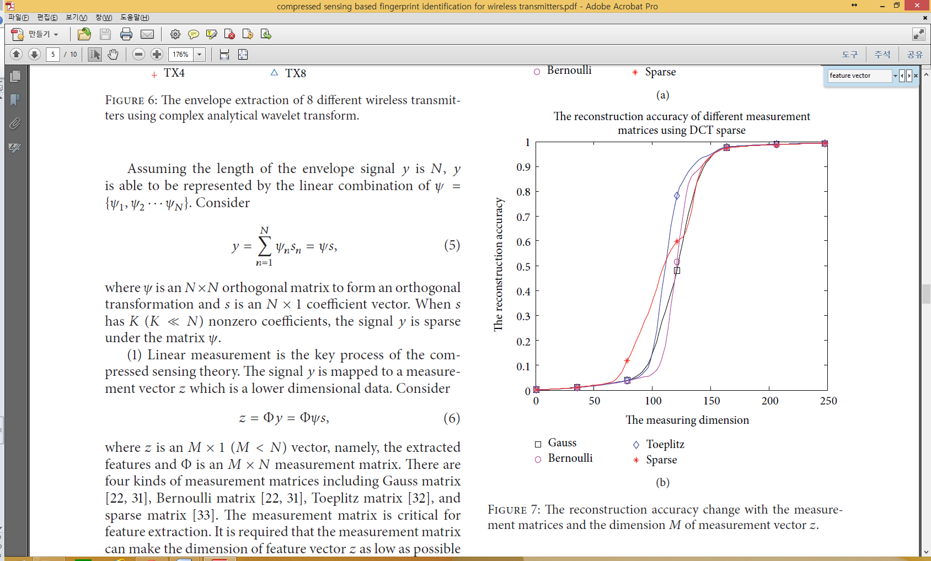

The reconstruction accuracy is influenced by  or type of measurement matrices.

→ Sparse matrix, M is 230 for DWT and 160 for DCT.

(3) From above, two feature vectors () are extracted based on the DCT and DWT.

# Recognition Results Analysis

Multiclassification SVM recognizer [34] is established.

“one-against-all” method : more training time. appropriate parameters are obtained by cross validation on the training data. → “one-against-one” method

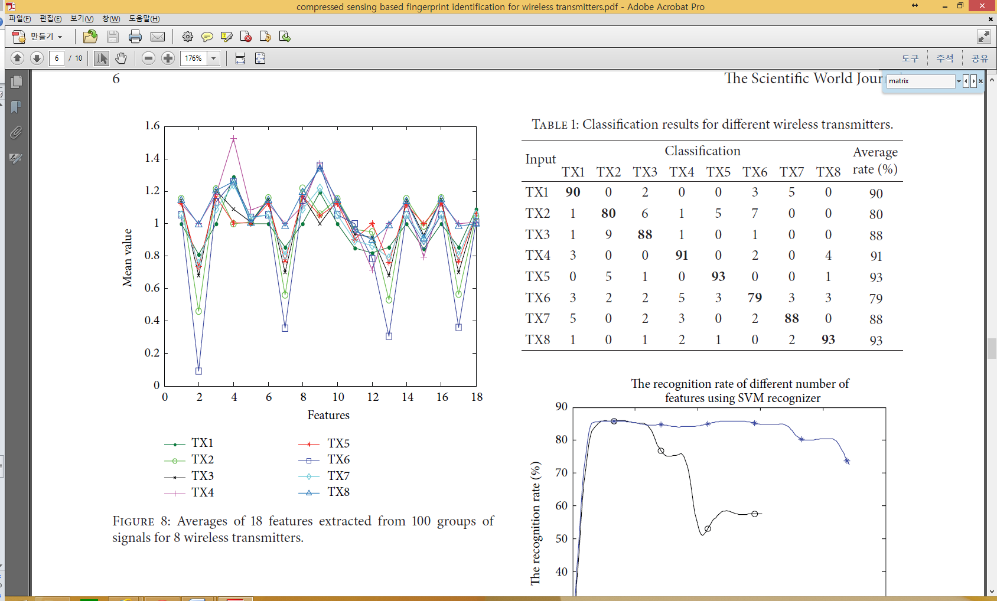

The number of features extracted by the compressed sensing is too much → a long time identification time, some irrelevant feature interferences.

mRMR [36] is used to optimize the features.

The distribution of 18 features’ average values extracted from the 100 groups of signal of 8 wireless transmitters is shown in the Figure 8.

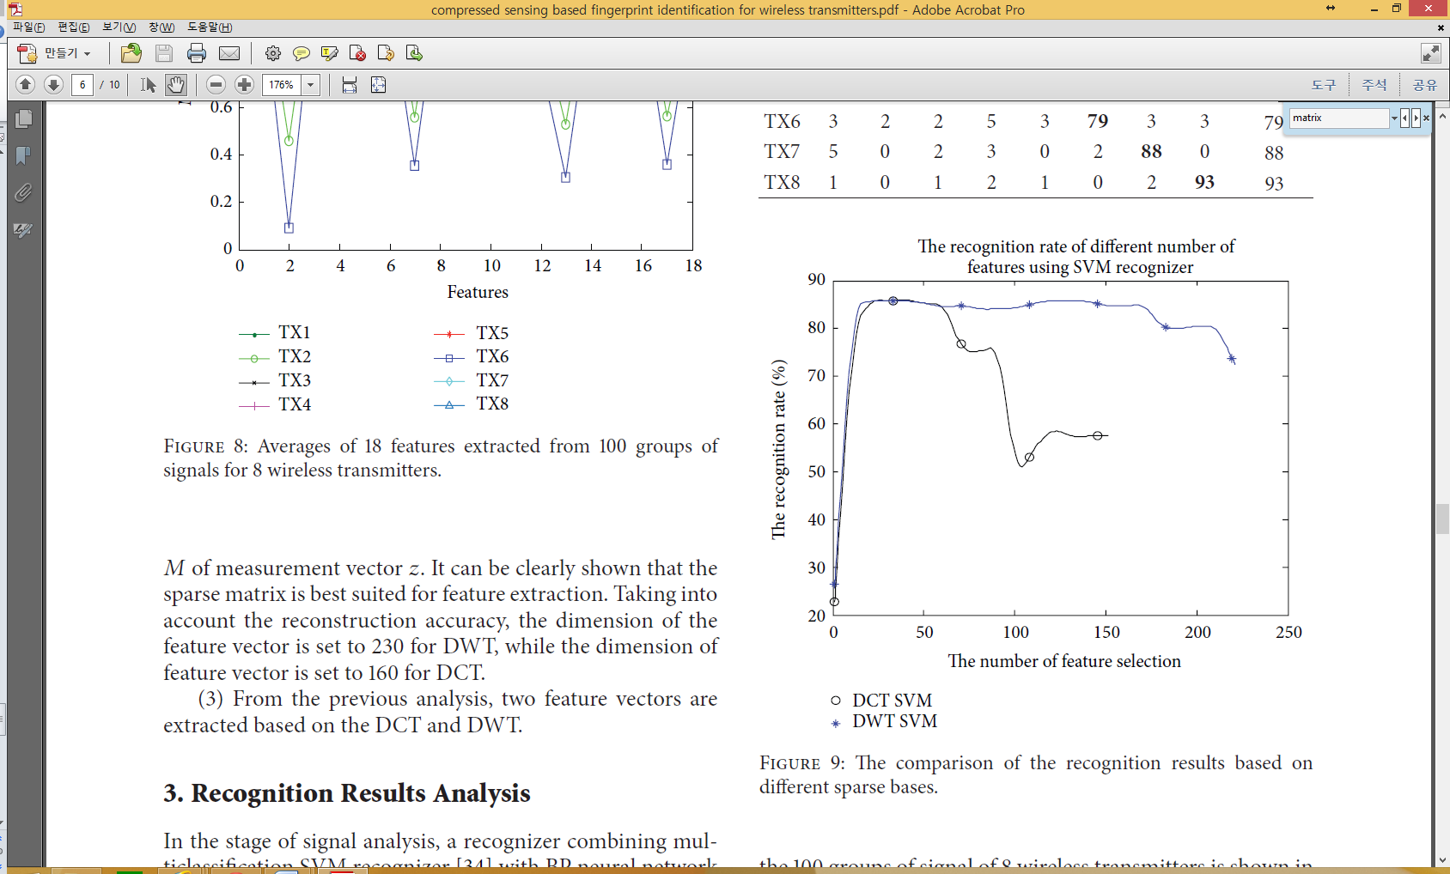

The identification effectiveness is changing with the number of selecting features and different properties of sparse bases.

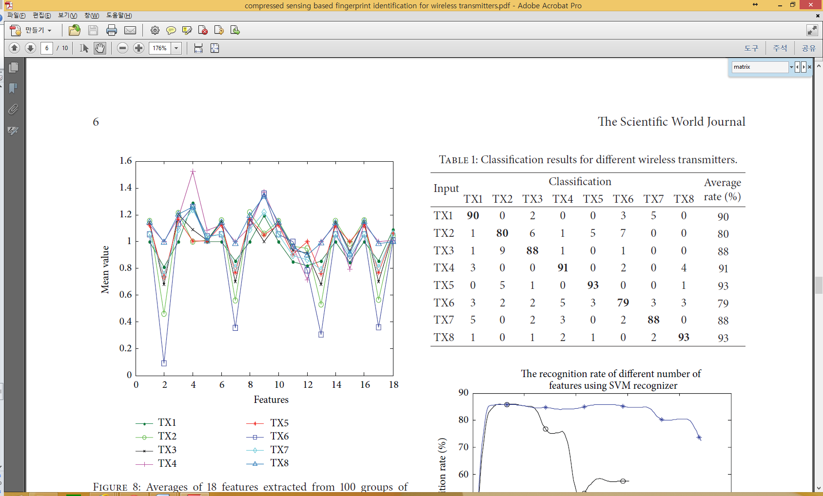

DCT sparse base, the SVM recognizer, identification of 8 different transmitters. For each transmitter, 100 groups are used for training and 100 groups for testing.

→ The average identification rate is 87.75%.



[19] : extracts the envelope statistic features from the energy spectrum envelope.

[21] : using the fitting coefficients of the envelope.

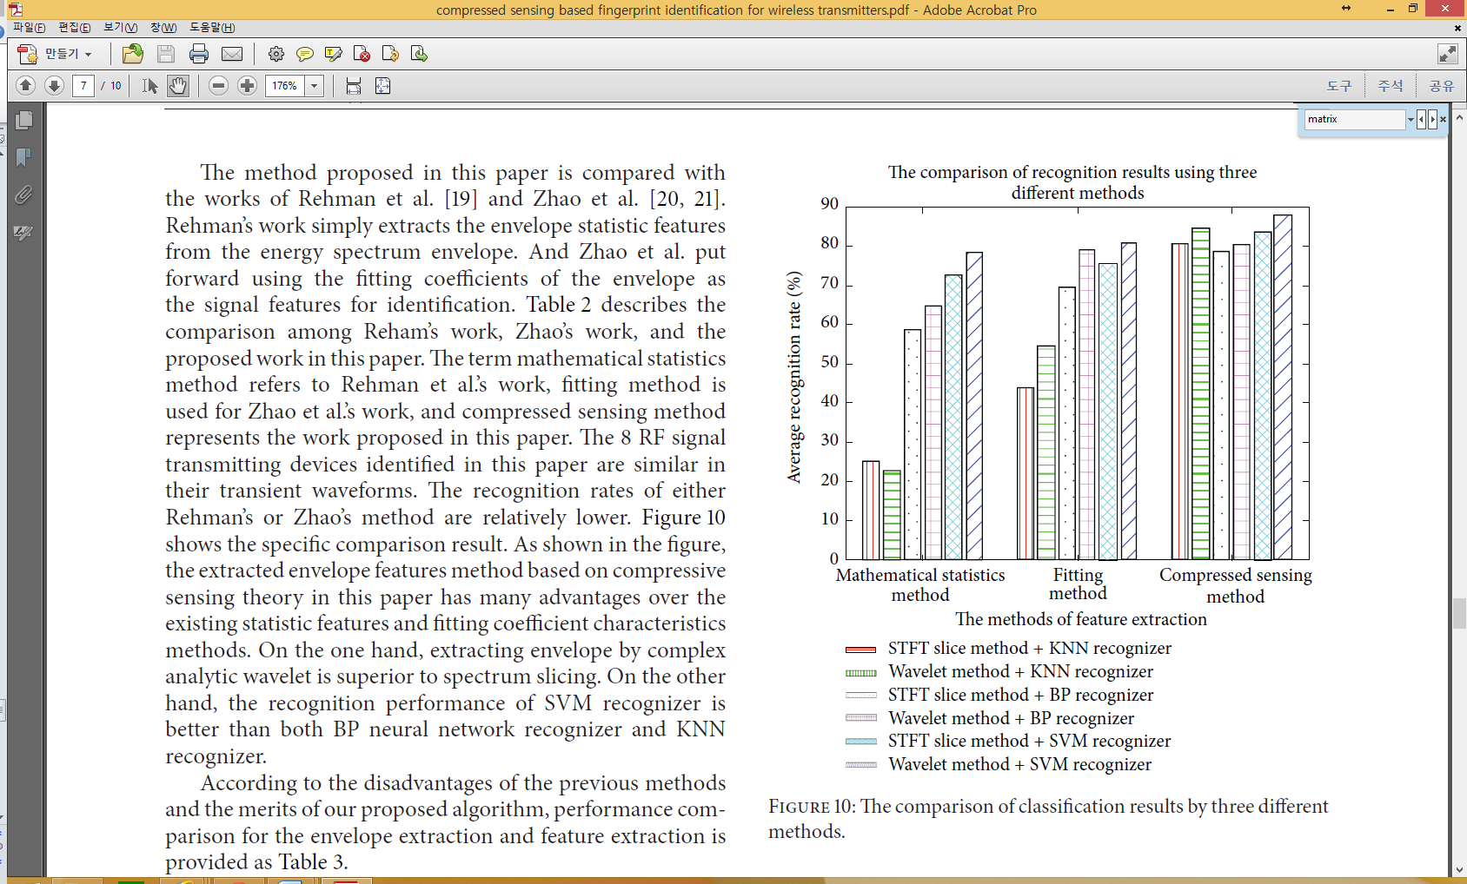

The recognition rates of either Rehman’s or Zhao’s method are relatively lower. : complex analytic wavelet > spectrum slicing, SVM recognizer > BP neural network recognizer, KNN recognizer.

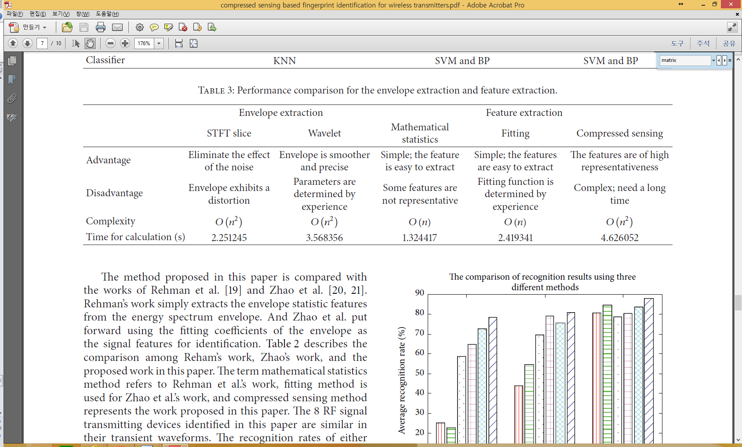

# Conclusions

This paper has proposed a fingerprint identification method for wireless transmitter signal based on compressed sensing. Complex analytical wavelet transform is used to obtain the envelope of the transient signal, and features are extracted by using the compressed sensing theory. A feature selection utilizing minimum redundancy maximum relevance (mRMR) is employed to obtain optimal feature subsets for identification. Finally, the recognition of 8 transmitters by the SVM recognizer is completely performed. From a series of experiments, it can be concluded that the method proposed in the paper can effectively identify the transmitter signals. Especially, the method put forward in the paper has better performance in the recognition of wireless transmitter signals when compared to the previous methods, such as extracting statistic features directly from the envelope, fitting coefficient characteristic.

# Discussion

# References

[17] H.C.Choe, C. E. Poole, A.M. Yu, andH.H. Szu, “Novel identification of intercepted signals fromunknown radio transmitters,” in *Wavelet Applications II*, vol. 2491 of *Proceedings of SPIE*, pp. 504–517, April 1995.

[18] M.-J. Lu, Y. Zhan, X.-C. Si, and X.-N. Yang, “Extraction of the transient characteristics of the communication radiating source and individual identification,” *Journal of Xidian University*, vol. 36, no. 4, pp. 736–740, 2009.

[19] S. Ur Rehman, K. Sowerby, and C. Coghill, “RF fingerprint extraction from the energy envelope of an instantaneous transient signal,” in *Proceedings of the Australian Communications TheoryWorkshop (AusCTW’12)*, pp. 90–95, February 2012.

[20] C.Zhao, L. Huang, L. Hu, andY. Yao, “Transient fingerprint feature extraction for WLAN cards based on polynomial fitting,” in *Proceedings of the 6th International Conference on Computer Science and Education (ICCSE ’11)*, pp. 1099–1102, August 2011.

[21] L. Huang, X.Wu, C. Zhao, andM. Gao, “Identification of radio transmitters fingerprint based on curve fitting,” in *Proceedings of the IEEE International Conference on Signal Processing, Communications and Computing (ICSPCC ’13)*, 2013.

[22] D. L. Donoho, “Compressed sensing,” *IEEE Transactions on InformationTheory*, vol. 52, no. 4, pp. 1289–1306, 2006.

[23] L. Huang, M. Gao, C. Zhao, and X. Wu, “Detection of Wi-Fi transmitter transients using statistical method,” in *Proceedings of the IEEE International Conference on Signal Processing, Communications and Computing (ICSPCC ’13)*, 2013.

[24] J. Hall, M. Barbeau, and E. Kranakis, “Detection of transient in radio frequency fingerprinting using signal phase,” in *Proceedings of the 3rd IASTED International Conference onWireless and Optical Communications*, pp. 13–18, July 2003.

[25] D. Shaw and W. Kinsner, “Multifractal modelling of radio transmitter transients for classification,” in *Proceedings of the IEEE WESCANEX Conference on Communications, Power and Computing Conference*, pp. 306–312,May 1997.

[26] T. Hou, “Detection of signal envelope based on the complex analytical wavelet transform,” *Journal of Xi’an University of Posts and Telecommunication*, vol. 16, no. 3, pp. 18–21, 2011.

[27] C. Liu and Z. Qiu, “Extracting vibration signal envelopes based on Morlet wavelet transform,” *Journal of Circuits and Systems*, vol. 5, no. 1, pp. 68–71, 2000.

[28] X. Yuan and J. Yu, “Complex analytical wavelet transform for the extraction and analysis of speech signal envelops,” *Acta Electronica Sinica*, vol. 27, no. 5, pp. 142–144, 1999.

[29] I. Naseem, R. Togneri, and M. Bennamoun, “Sparse representation for speaker identification,” in *Proceedings of the 20th International Conference on Pattern Recognition (ICPR ’10)*, pp. 4460–4463, August 2010.

[30] Y.-G. Cen and L.-H. Cen, “Sparse representation and reconstruction of signals based on the peak transform,” *Journal of Electronics&Information Technology*, vol. 33, no. 2, pp. 326–331, 2011.

[31] Y. Tsaig and D. L. Donoho, “Extensions of compressed sensing,” *Signal Processing*, vol. 86, no. 3, pp. 549–571, 2006.

[32] H. Rauhut, “Circulant and Toeplitz matrices in compressed sensing,” in *Proceedings of the Signal Processing with Adaptive Sparse Structured Representations (SPARS ’09)*, 2009.

[33] M. C. Angelini, F. Ricci-Tersenghi, and Y. Kabashima, “Compressed sensing with sparse, structuredmatrices,” in *Proceedings of the 50th Annual Allerton Conference on Communication, Control, and Computing (Allerton ’12)*, pp. 808–814, 2012.

[34] C. Sch¨uldt, I. Laptev, and B. Caputo, “Recognizing human actions: a local SVM approach,” in *Proceedings of the 17th International Conference on Pattern Recognition (ICPR ’04)*, 32–36, August 2004.

[36] Y. Cai, T. Huang, L. Hu, X. Shi, L. Xie, and Y. Li, “Prediction of lysine ubiquitination with mRMR feature selection and analysis,” *Amino Acids*, vol. 42, no. 4, pp. 1387–1395, 2012.