|  |
| --- |
| Compressed Sensing Detector Design for Space Shift Keying in MIMO Systems |

|  |  |
| --- | --- |
| Authors: | Chai-Mu Yu et al. |
| Publication: | IEEE Communications Letters, 2012 |
| Speaker: | Haeung Choi |

**Short summary**: A promising communication method, Massive MIMO is the large-scale multiple-input multiple-output(MIMO) technique which can achieve maximum diversity gain and large spatial multiplexing gain. However, massive MIMO also has many challenging problems such as heavy interference, expensive hardware cost, and large complexity of receiver. In spite of using generalized spatial shift keying(GSSK), which is one of methods to reduce the complexity of detection, the high complexity of optimal ML detector still becomes an obstacle. Author purposed a new (G)SSK detector applying the compressive sensing(CS) theory. Their detector, named normalized compressive sensing(NCS) (G)SSK detector can achieve considerable performance with low complexity compared with the optimal ML detector.

# Introduction

1. Spatial modulation (SM):

Encodes information in the combination of antenna indices and the conventional phase/amplitude, has attracted research attention in recent years. The SM facilitates energy efficiency and reduced hardware costs for multiple-input multiple-ouput (MIMO) systems. [1]

2. Space Shift Keying (SSK)modulation:

As a simplified variation of SM, the space shift keying(SSK) modulation activates only one antenna at any time instant and encodes information in antenna indices only.

|  |
| --- |
| Advantage |
| Only one RF chain is needed at  transmit antennas.  Reduction of detection complexity.  Reduction of accurate Inter-Antenna Synchronization. |
| Disadvantage |
| Low symbol rate |

3. Generalized Space Shift Keying

Generalized space shift Keying (GSSK) is a variant of SSK. It actives  transmit antenna at the same time, instead of one. Since the possible combination of antenna indices is , which is larger than , the symbol rate is higher than that of SSK. (But the detection complexity is also higher.)

4. Sparsity of (G)SSK modulated signal

Since each transmit antenna transmit 1 or 0, (G)SSK modulated signal can be expressed -sparse signal at time domain. So author considered applying the compressive sensing to it.

# System Model

Problem Formulation:































MIMO System can be formulated as



: received signal vector whose entries are received symbol at each receive antenna.

: transmitted signal vector whose entries are transmitted symbol at each transmit antenna.

:  channel coefficient matrix

:  noise vector

GSSK:  entries of  are 1 and the others are zero. -> -sparse signal

Assume  is a Rayleigh fading channel.

Considerable Detection Methods

1. ML detection

Maximum likelihood detection finds the solution which has maximum likelihood function:

,

where  is set of all possible - sparse vectors. Thus, ML detector examine  hypothesis.

2. Compressive Sensing

Compressive sensing problem is a framework that finds the sparsest solution among the many solutions. It can be written as an optimization problem:

 s.t. ,

where  is set of all possible - sparse vectors.

If the matrix  satisfies the RIP condition, the  minimization solution is equal to the  minimization solution. i.e.,

 s.t. 

Thus, now this detection becomes a  minimization problem.

# Proposed Method

## Author proposed CS based (G)SSK detection scheme, Normalized Compressive Sensing (NCS) detection.

NCS Detector:

From the system model,



where  is a channel coefficient matrix whose columns are normalized.  is a diagonal matrix, whose element  is norm of -th column of . As a result of normalization, the accuracy of detection is improved.

Since the channel is Rayleigh fading channel, the channel matrix  is a complex Gaussian matrix and  is also a complex Gaussian matrix. Gaussian matrix satisfies the RIP condition where the size of matrix approaches to infinite.[1]

# Performance Evaluation

1) NCS-OMP

Formulated detection problem to a CS recovery problem and reconstruct the transmitted signal by Orthogonal Matching Pursuit(OMP) algorithm.

2) ML(reference)

Detection by  hypothesis testing

3) Matched Filtering [2]?

, 

, where 

4) MMSE(pseudo inverse)



(SSK)

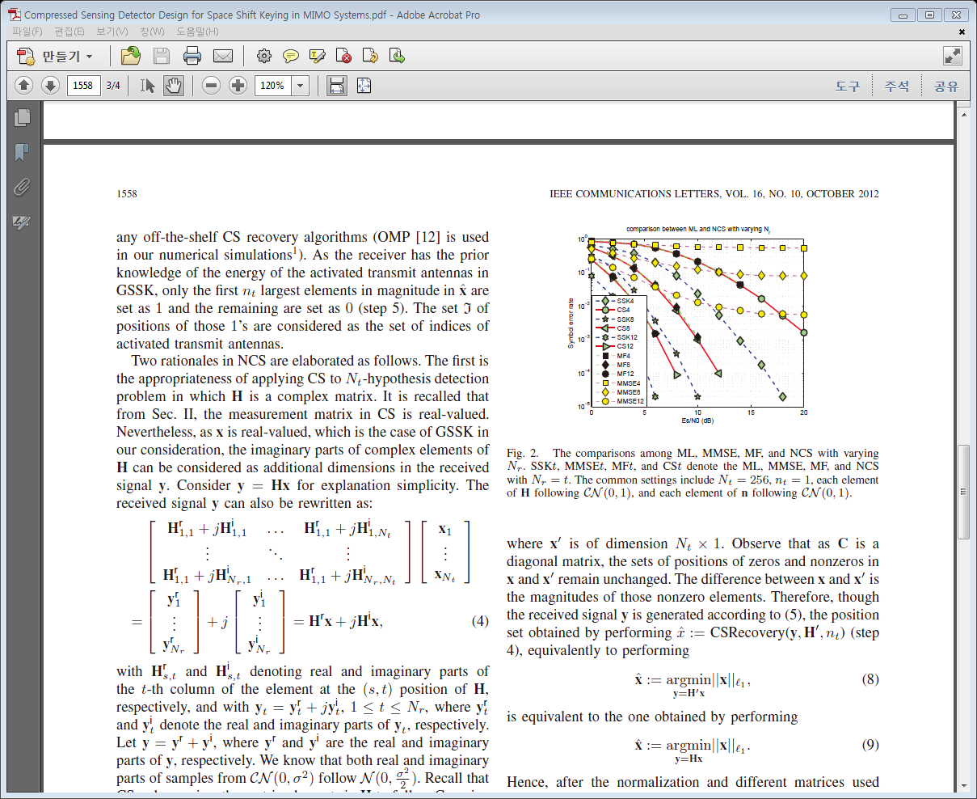

(GSSK)

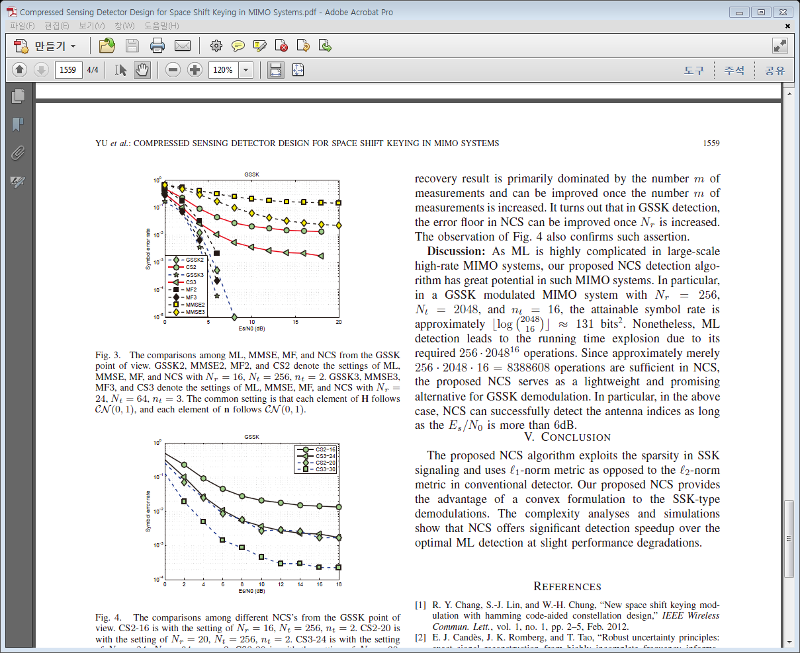

Complexity

NCS-OMP: 

ML: 

# discussion

After meeting, please write discussion in the meeting and update your presentation file.

Appendix

1. Restricted Isometry Property(RIP)

*Def 1*) RIP: a matrix  is said to satisfy the Restricted Isometry Property with parameters  for , if for all index sets  such that  and for all , one has

 [4]

2. Orthogonal Matching Pursuit(OMP) Algorithm

OMP is one of the one-step greedy algorithm to solve the underdetermined  minimization problem, i.e.,

 subject to ,

where  is a  matrix, , and  is a -sparse signal vector.

It finds the column index of  which have maximum correlation with . Then add that index to estimated support set and finds next index which have second-largest correlation. This procedure is repeated until finds  indices.

|  |  |
| --- | --- |
| OMP algorithm: | |
| Input:  measurement matrix  data vector  Sparsity | Output:  estimate vector |
| **Initialize:**  **Iteration count**  **Residual vector**  **Estimated support set**  **Iteration:**          **End**  **Output:** | |

Reference

1. R. Baraniuk, M. Davenport, R. DeVore, M. Wakin, “A Simple Proof of the Restricted Isometry Property for Random Matrices”, 2008, Constructive Approximation, Volume 28, Issue 3 , pp 253-263
2. S. Sugiura, C. Xu, L. Hanzo, “Reduced-Complexity QAM-Aided Space-Time Shift Keying” , 2011, GLOBECOM, IEEE.
3. S. Sugiura, S. Chen, L. Hanzo, “A Universal Space-Time Architecture for Multiple-Antenna Aided Systems”, 2012, IEEE Communications survey & tutorials, Volume 14, No. 2., second quarter.
4. Wei Dai, Olgica Milenkovic, “Subspace pursuit for compressive sensing signal reconstruction,” *IEEE Transactions on Information Theory, VOL. 55, NO. 5*, 2009.
5. Jian Wang, Byonghyo Shim, “On the recovery limit of sparse signals using orthogonal matching pursuit,” *IEEE Transactions on Signal Processing, VOL. 60, No. 9*, 2012.