|  |
| --- |
| Missing-Area Reconstruction in Multispectral Images Under a Compressive Sensing Perspective |

|  |  |
| --- | --- |
| Authors: | Luca Lorenzi, Farid Melgani, Gregoire Mercier |
| Publication: | IEEE TRANSACTION ON GEOSCIENCE AND REMOTE SENSING, July.2013 |
| Speaker: | Hyeong ho, Baek |

**Short summary**: The intent of this paper is to propose new methods for the reconstruction of areas obscured by clods. They are based on compressive sensing theory, which allows finding sparse signal representations in underdetermined linear equation systems.

# Introduction

Clouds in remotely sensed imagery may or may not represent an unwanted source of noise. In case they are viewed as a noise source, several methodologies have been developed in the past in order to cope with this problem. In this paper, they will focus on the approach which attempts to remove the clouds by substituting them with cloud-free estimations.

Recently, CS has been introduced by Donoho and Candes et al. CS theory aims at recovering an unknown sparse signal from a small set of linear projections. By exploiting this new and important result, it is possible to obtain equivalent or better representations by using less information compared with traditional methods.

In this paper, they propose three novel methods to solve the problem of the reconstruction of missing data due to the presence of clouds. Given a cloud-free and a cloud-contaminated image, each of the missing measurements is recovered by applying the CS theory in which cloud-free pixels are exploited.

# Problem Formulation

Let us consider two multispectral images and  acquired by an optical sensor at two different dates and registered over the same geographical area. Let us suppose that the two acquisitions are temporally close to each other.

We make the hypothesis that image  is obscured by the presence of clouds. We will call cloudy area in image  as target region  and the remaining part as source region . Image  does not contain clouds it is supposed cloud free. Their aim is to generate a new image  without clouds.

They assume that any pixel  can be expressed as linear combination of pixels in region .

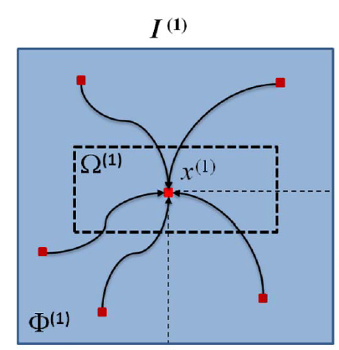

Figure Illustration of the reconstruction principle

In other words, in , we have



Where  is an unknown weight vector associated with the considered pixel . Once  is computed, if we assume that  and  are temporally close, so that the scene did not change in between the two observations, it will be possible to reuse the  coefficients to reconstruct the spatially corresponding pixel in the missing area .



Where  represents an estimation function.

# Reconstruction via CS

## CS solutions

* BP : A well-known solution for problem (1) is the BP principle. It suggests a convexificaion of the problem by using the  norm. Note that, if the original signal  is sufficiently sparse, the recovery via BP is provably exact.
* OMP : One of the easiest and fastest alternative techniques is the OMP, an improved version of the MP method. MP finds the atom that has the highest correlation with the signal. It subtracts off the correlated part from the signal and then iterates the procedure on the resulting residual signal.
* BP VS OMP : In general, BP and OMP algorithms provide good performances in reconstruction problems. Nonetheless, BP is considered more powerful than OMP, since it can recover with high probability all sparse signals and is more stable. On the contrary, OMP results attractive for its fast convergence and in its ease of implementation.

## Genetic Algorithm

GA are a part of evolutionary computation which solves optimization problems by mimicking the principles of biological evaluation.

In general, a common GA involves the following steps. First, an initial population of chromosomes is randomly generated. Then, the goodness of each chromosome is evaluated according to a predefined fitness function representing the aim of the optimization. Evaluating the fitness function allows keeping or discarding chromosomes, by using a proper rule based on the principle that, the better the fitness, the higher the chance of being selected. Once the selection of the best chromosomes is done, the next step is devoted to to the reproduction of a new population. This is done by genetic operators such as crossover and mutation operators. All these steps are iterated until some predefined condition is satisfied. In this situation, the fitness function are given below





# Experimental Results

## Data set Description and Setup

* Compare the reconstructed image with the original cloud-free image.
* Two aspects : 1. The kind of ground covers obscured and 2. The size of the contaminated area.
* For the purpose of comparison, we implemented two other methods developed to reconstruct cloudy areas in images. One consists in a recent work exploiting a multiresolution inpainting (MRI), whereas the second method estimates a missing pixel by contextual multiple linear prediction (CMLP).

## Results

* Contamination of Different Ground Covers : In Figure shows mask A covering a region that includes mainly an urban area, mask B obscuring an industrial zone, and mask C covering a vegetation area.

|  |  |  |  |  |  |  |  |  |  |
| --- | --- | --- | --- | --- | --- | --- | --- | --- | --- |
| Method | Mask A | | | Mask B | | | Mask C | | |
| PSNR | Complexity | Time [s] | PSNR | Complexity | Time [s] | PSNR | Complexity | Time [s] |
| MRI | 22.54 | - | 2856 | 16.05 | - | 2517 | 33.77 | - | 2898 |
| CMLP | 20.99 | 1 | 1 | 20.11 | 1 | 1 | 24.05 | 1 | 1 |
| OMP | **23.96** | 3 | 4 | 20.60 | 3 | 4 | 31.97 | 3 | 4 |
| BP | 22.22 | 294 | 66 | **24.74** | 168 | 59 | 30.67 | 301 | 60 |
| GA | 23.78 | 148 | 68621 | 23.15 | 95 | 26312 | **32.01** | 138 | 43193 |

In general, MRI can re return visually satisfactory results only when the missing area refers to a uniform region such as a vegetation region.

The OMP algorithm produces very sparse reconstruction solution. On the contrary, the BP algorithm selects a large number of weight coefficients. Finally, GA can be viewed as a compromise between the two previous methods. Despite the very long time needed to estimate the reconstruction model, it results sparser than BP but less parsimonious than OMP.

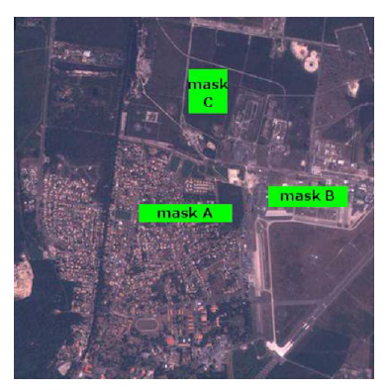

Figure Masks adopted to simulate the contamination of different ground covers.

* Contamination with different size : Figure shows the three different masks adopted to simulate different increasing cloud cover sizes.

|  |  |  |  |  |  |  |  |  |  |
| --- | --- | --- | --- | --- | --- | --- | --- | --- | --- |
| Method | Mask 1 | | | Mask 2 | | | Mask 3 | | |
| PSNR | Complexity | Time [s] | PSNR | Complexity | Time [s] | PSNR | Complexity | Time [s] |
| MRI | 24.27 | - | 2995 | 22.85 | - | 10176 | 23.82 | - | 22353 |
| CMLP | 24.61 | 1 | 1 | 24.43 | 1 | 2 | 25.46 | 1 | 2 |
| OMP | 26.36 | 3 | 5 | 26.42 | 3 | 16 | 27.39 | 3 | 21 |
| BP | 26.45 | 338 | 61 | 26.82 | 332 | 143 | **28.25** | 329 | 973 |
| GA | **26.72** | 173 | 69231 | **27.10** | 168 | 103342 | 28.15 | 170 | 259459 |

To get higher PSNR values, one needs to resort to CS techniques. Indeed, our implementations return better results in terms of PSNR in all the simulations. The result form this viewpoint underline the main weakness of the GA solution i.e., its expensive computational needs.

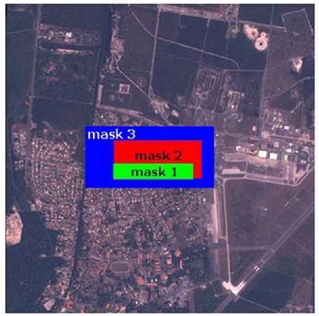

Figure Masks adopted to simulate the different sizes of contamination.

# Conclusion

This paper deals with the complex and important problem of removal of clouds from images. First we have shown how two common CS solutions, namely, the OMP and BP algorithms, can be formulated for a cloud-contaminated-image reconstruction problem. Then, we have proposed a solution for solving the CS problem exploiting the capabilities of GA.

The experimental results point out the superiority of the proposed methods compared to two reference methods for cloud removal. OMP has the advantage of being sparser and significantly faster than BP and GA, but it is the less robust method. And BP is much less sparse than OMP. GA represents a good compromise between the OMP and BP methods, mainly because it is more robust than OMP and more sparse than BP.

# discussion

After meeting, please write discussion in the meeting and update your presentation file.

Appendix

Reference