|  |
| --- |
| Ultra-Wideband Compressed Sensing : Channel Estimation |

|  |  |
| --- | --- |
| Authors: | Jose L. Paredes, Member, IEEE, Gonzalo R. Arce, Fellow, IEEE, and Zhongmin Wang. |
| Publication: | IEEE Journal of Selected Topics in Signal Processing, Octovber 2007 |
| Speaker: | Ju-Sung Kang |

**Short summary**:

In this paper, they have introduced two novel ultra-wideband (UWB) channel estimation approaches based on compressive sensing (CS).

The proposed approach relies on the fact that transmitting an ultra-short pulse through a multipath UWB channel leads to a received UWB signal that can be approximated by a linear combination of a few atoms from a pre-defined dictionary which means sparse representation of the received signal.

The key in the proposed approach is in the design of a dictionary of parameterized waveforms (atoms) that closely matches the information-carrying pulse shape leading thus to higher energy compaction and sparse representation, and, therefore higher probability for CS reconstruction.

In the first approach, the CS reconstruction capabilities are exploited to recover the composite pulse-multipath channel from a reduced set of random projections. This reconstructed signal is subsequently used as a referent template in a correlator-based detector.

In the second approach, from a set of random projections of the received pilot signal, the Matching Pursuit algorithm is used to identify the strongest atoms in the projected signal that are related to the strongest propagation paths that composite the multipath UWB channel.

# Introduction

1. Ultra-wideband (UWB) communications

- High bandwidth, lower-power consumption, shared spectrum resources, ranging from short-distance high-data-rate application to long-distance low-data-rate application.

- An ultra-short duration pulse is used as the elementary pulse-shaping to carry information  simplicity in the transmitter (carry-less signal), little impact on other narrowband radio system, rich in multipath diversity.

- Interference cancellation, antenna design, timing synchronization, and channel estimation.  requirement of high-speed ADC converters. : Such formiable sampling rates are not feasible with state of the art ADC technology.

- This paper focuses on this goal by casting the problem of USB channel estimation and detection into the emerging framework of CS.

2. Compressed sensing

- The remarkable result of CS reveals that with high probability, a signal, , with a large number of data points that is -sparse in some dictionary  of basis functions, can be exactly reconstructed using only a few number of random projections of the signal onto a random basis  that is incoherent with .

- The number of projections is much smaller than the number of samples in the original signal leading to a reduced sampling rate and to a reduced use of ADCs resources.

1. Basic assumption

- When the short duration pulses propagate through multipath channels, the received signals remain sparse in some domain and thus CS is applicable.

* 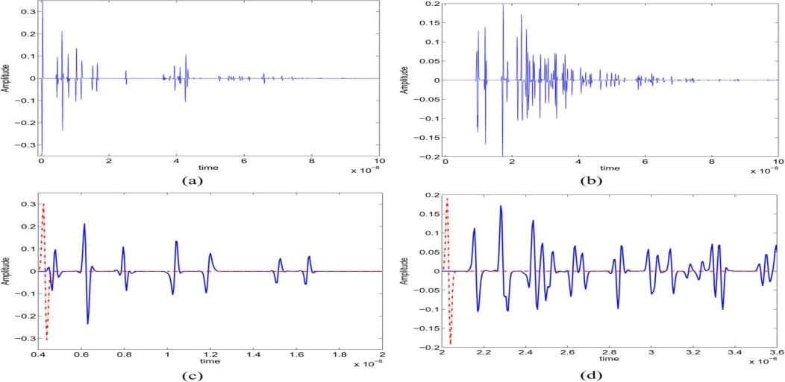

Fig. 1. Effect of UWB channel (indoor propagation in residential environments) on the transmitted pulse for two different propagation scenarios: (a) line-of-sight (LOS); (b) non-line-of-sight (NLOS); (c) zoom-in of (a); and (d) zoom-in of (b). Transmitted pulse (–.–) is also shown in (c) and (d).

* Gaussian monocycle(ns), IEEE 802.15.4a channel model 1 and 2(CM1, CM2).

- As depicted in above figure, the received UWB signal is composed of set of spaced clusters of the transmitted pulse which captures the statistical characteristics of multipath arivals in a UWB channel.

- It can be seen relatively long time intervals between clusters and rays where the signal takes on zero or negligible values. It is precisely this signal sparsity of the received UWB signals that is exploited in this work.

# Ultra-Wideband Compressive Sensing.

- The sparsity of the signal can be in any domain and the number of random measurements is much smaller than the number of samples in the original signal leading to a reduced sampling rate and reduced use of ADCs resources.

1. Compressive sensing overview.

-  : N-point discrete-time representation of signal.

-  : a set of K measurements 

-  :  measurement matrix, rows are basis vectors of the space 

- If  is sparse,  can be written as a superposition of a small number of vector taken from a dictionary  of basis

 (1)

* , and measurement matrix  is incoherent with the dictionary .

-  is a vector that contains M nonzeros coefficients where Z is the number of elements (atoms) in the dictionary .

- The signal f can be recovered from the solution of convex, nonquadratic optimization problem known as basis pursuit.

- But solving the optimization problem is computationally expensive and is not suitable for real-time application. So, there are more efficient recovery algorithms such as matching pursuit, orthogonal matching pursuit, and tree-based matching pursuit.

TABLE I : MATCHING PURSUIT ALGORITHM

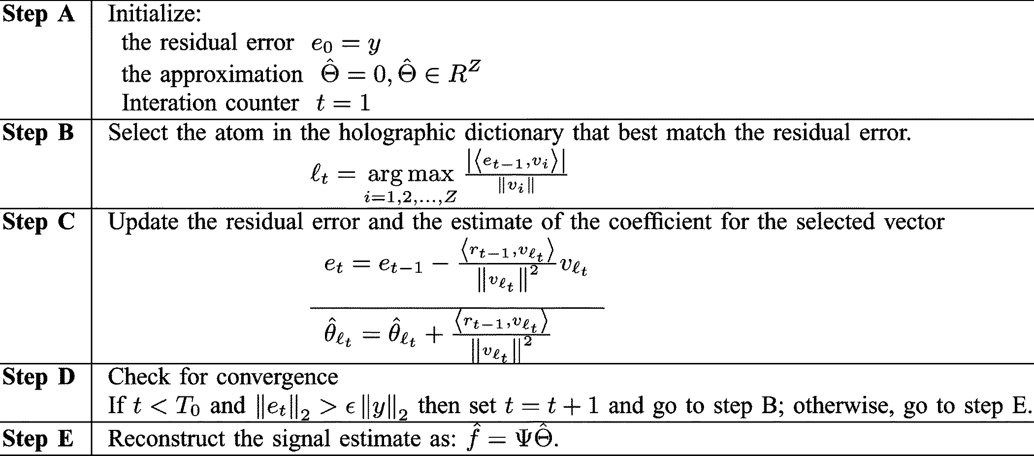

- MP is a computationally simple iterative greedy algorithm that tries to recover the signal by finding(in the measurement signal) the strongest component (atom of dictionary), removing it from the signal, and searching again the dictionary for the strongest atom that is presented in the residual signal.

- This procedure is iteratively repeated until the residual signal contains just insignificant information.

- Signal reconstruction is then achieved by linearly combining the set of atoms found in the measurements.

- ,  : maximum # of algorithm iterations,  : the minimum energy that is left in the residual error signal.

2. Processing UWB signals Using CS.

- The received UWB signal model

 (3)

-  : transmitting pulse,  : noiseless UWB channel.

- We call it as composite pulse-multipath channel.

- Typically, a Gaussian pulse or its derivatives are used as .

- ,  is a polynomial of degree n that depends on the order of the derivative used.

-  is the impulse response of the UWB channel

 (4)

-  : gain factor,  : delay factor, L : # of propagation paths.

- In our analysis, the set of delays and gains are generated according to the models proposed by the IEEE 802.15.4a working group in [15] . But we restrict our analysis to real-valued UWB channel models where there is not pulse distortion.

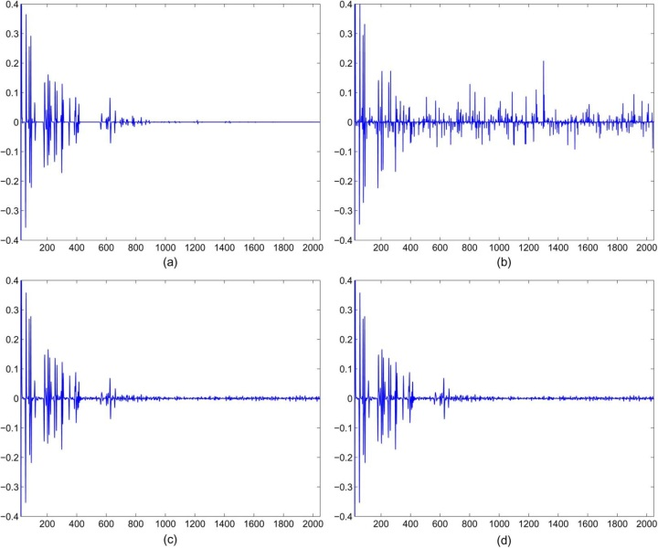

Fig. 2. (a) Received UWB signal for a realization of an indoor residential channel with LOS propagation (CM1). (b) CS reconstruction using time-sparsity model, with 500 random projections. (c) CS reconstruction using multipath diversity, with 500 random projections. (d) CS reconstruction using multipath diversity, with 250 random projections.

1) UWB signal reconstruction Using Time Sparsity Models :

- A first approach is assuming that the signal is sparse in the time domain.

- This signal model is adequate for the UWB channel in industrial environments with LOS propagation.

- 

- T : sampling period, N # of samples

- , K*N random matrix with entries i.i.d.

- Since we are assuming sparsity in the time domain, the dictionary 

- Running the MP algorithm with the  and the random projection  yields the results show in fig.2.

- Fig. 2(a) : the 2048-point channel for a realization of an indoor residential channel with LOS propagation obtained from [15]. This is the signal targeted for reconstruction from a reduced set of random projections.

- Fig. 2(b) : the reconstructed signal obtained using 500 random measurements. Note that it fails to recover many of the signal details yielding a poor performance.

- Increasing the # of random projection means that higher sampling rate and demanding ADC resources.

- Appealing approach : to design a dictionary of parameterized waveforms where the received UWB signal can be compactly represented, increasing thus the sparsity of the underlying signal.

- This approach is motivated by the fact that the received UWB signal given by (3) can be thought of as a linear combination of the signal contributions of the various propagation paths that compose the UWB multipath channel.

2) UWB signal Reconstruction Using Multipath Diversity.

- Since CS theory relies on the fact that the underlying signal is sparse in some dictionary of basis or tight-frames, it is important to define a suitable dictionary to represent the underlying UWB signal.

- Alternatively, we can generate a new dictionary just inspecting the characteristic of the received UWB waveform.

- Since the received UWB signal is formed by scaled and delayed versions of the transmitted pulse and since the dictionary should contain elements (atoms) that can fully represent the signal of interest, it is natural to think that the elementary function to generate the atoms of the dictionary should be closely related to the pulse waveform used to covey information, i.e., the Gaussian pulse or its derivatives.

- Therefore, the dictionary is generated by shifting with minimum step  the generating function, , leading to a set of parameterized waveforms given by

 (5)

- Dictionary  : delayed versions of the UWB transmitted pulse.

- The other definitions are same with Time Sparsity Model cases.

- , T : sampling period, N # of samples, , K*N random matrix with entries i.i.d.

- The MP algorithm is then applied on the random projected signal, y, and the dictionary 

-  is the discrete time dictionary defined by uniformly sampling the atoms of the dictionary D.

- Fig. 2(c) and (d) show the reconstructed signal using 500 and 250 random measurements, respectively. As it can be seen from Fig. 2(c) and (d), CS successfully recovers the desired signal from random projections

- Furthermore, comparing Fig. 2(b) and (c), it can be seen that reconstruction using multipath diversity outperforms reconstruction using time sparsity model

- Therefore, by building a dictionary that is closely matched to the underlying waveform, a notable performance gain is achieved in the reconstruction

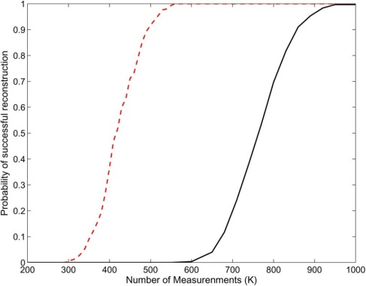

Fig. 3. Probability of success reconstruction for UWB signal for two different propagation scenarios: LOS - - - and NLOS —.

3. UWB Channel Estimation Using CS

- Consider the composite pulse-multipath channel, given by (3), where the channel parameters  related to the various propagation paths have to be estimated.

- The number of multipath components in (4) that form the UWB channel can be quite large, leading to a large time dispersion of the transmitted pulse [3].

- But only some paths have the amount of original energy. (e.g. 1160  70) Therefore, we limit ourselves to estimate the  most significant paths that composes the UWB channel impulse response

- Furthermore, the reconstruction step in the MP algorithm can be thought of as a weighted sum of the elements in the dictionary, that is .

- Since each element in the dictionary is a shifted version of the transmitted pulse, it turns out that  is an estimate of the path gain related to the th propagation path.

- Furthermore, the path delay is directly determined by observing the time-location of the th atom found in the received UWB signal.

- Let  and let let  for  be sorted elements of the set . Also let  be the index in the sparse vector of the kth sorted element. For  :

 (6)

# Ultrawideband Detection Based on Compressive Sensing

- Until now, we have the assumption of noiseless conditions. But we have to consider the noise and interferences.

1. UWB Signal Models.



Figure. Placement of pilot waveforms for PWAM, TR, and preamble (, , ).

- Consider a peer-to-peer UWB communication system where the th binary information symbol is transmitted by sending ultra-short pulses in the symbol interval , that is [22]

 (7)

-  : frame time ; time interval between two consecutive pulses.

-  : binary information symbol that modulated the amplitude of the pulse stream.

-  : pulse duration ; .

-  nonoverlapped pulses are transmitted for each information symbol.

- The channel is static during a burst of  consecutive symbols. ( is fixed during the burst of  symbols).

- Let  : there is no inperpulse interference.  : max delay spread of multi path channel.

- The received waveform during the first frame of the kth transmitted information symbol

 (8)

-  : zero mean AWGN that models thermal noise and other interference like multi user interference.

- Since  and the UWB channel is fixed, the received signal during the kth information symbol can be represented by periodically repeating the noiseless part of  every  seconds.

 (9)

- Two common approaches in detection problem : correlator based detector and Rake receiver.

- In the UWB correlator-based detector, it is assumed that the channel impulse response is completely known at the receiver to define the reference template that is used in the demodulation stage.

- Likewise, for the RAKE-based receiver the channel taps  related to the most significant propagation paths are assumed to be known a priori to define the set of templates for the bank of correlators and the weights for MRC [28].

- In either case, the need for UWB channel estimation arises.

- The problem of UWB channel estimation using CS under the data-aided framework. : We use known pilots symbols in each packet to estimate the channel impulse response. Based on these pilots, the channel is estimated either by CS template reconstruction (Section II-B2) or CS channel tap estimation (Section II-C). The remaining  symbols that convey information are decoded based on the acquired channel characteristics.

- Under this setting, the received UWB signal (9) can be conveniently rewritten as shown in (10)

 (10)

- ,  : time turation of the pilot waveforms.

- The received UWB signal is observed over nonoverlapped time intervals  for  the received pilot waveform in a frame time is :

 (11)

2. CS correlator based detertor

- A first approach exploits the CS reconstruction is a correlator-based detector.

- By observing the received UWB signal in a frame-long interval and random projecting the observed signal, a noisy template can be recovered using MP algorithm. Since  pilot waveforms are used for channel estimation, the estimate composite pulse-multipath channel is formed by averaging over  noisy templates. This approach is computationally demanding as a noisy template is recovered for each received pilot waveform.

- Alternatively, the random projected signals corresponding to the received pilot waveforms can be averaged and input to the MP algorithm for template reconstruction. This latter approach requires less computation since the MP algorithm is performed just once. Furthermore, by ensemble averaging the random projected signals, the effect of AWG noise is mitigated.

- Thus, CS template reconstruction is achieved by random projecting the frame-long received signals, ensemble averaging the random projected signals, and using MP algorithm to recover an estimate of the composite pulse-multipath channel.

- Once the template has been estimated, it can be used as correlator template to enable integrate-and-dump demodulation at frame-rate sampling.

- Since each symbol is present in  frames, the decision statistics for the th symbol is formed by adding up the  correlator output samples related to the transmitted symbol.

 (12)

-  is the CS estimate of the composite pulse-multipath channel.

- It can be extended to symbol-rate directly.

3. CS rake receiver

- Rake-based detectors relies on the assumption that the UWB channel parameters, path delays and path gains, related to the most significant propagation paths are known at the receiver [4], [21].

- Consider the received pilot waveform given by (11) for , where  and  are the UWB channel taps to be estimated.

- To reduce the effect of AWGN on the estimation of the UWB channel parameters, the CS projected pilot signals are averaged to obtain a reduced-noise projected signal that is used in the MP algorithm to estimate the channel parameters as described in Section II-C.

- Thus, CS channel estimation is performed using the ensemble average of the random projections leading to a reduced computational cost and minimizing the noise effect.

- After the estimation of parameters, the CS Rake Receiver is followed.

- Let  be the channel parameters related to the strongest paths obtained using CS channel estimation.

- The received signal, , is fed to a bank of  correlators with templates given by the atoms  for .

- The outputs of these correlators contain the energy captured by the strongest paths and are combined via maximum ratio combining (MRC) [29] to obtain sufficient statistic for detecting the th bit transmitted during the th frame.

 (13)

- Recalling that  pulses are used to transmit an information symbol, the decision statistic for symbol detection is formed by summing up the MRC outputs for  consecutive frames.

 (14)

# Simulation Results

- The Proposed CS-based detectors are compared to that of correlator detectors used in [16], [22]. :  and tradition correlator (i.e. analog-template estimation followed by correlator based detector.).

-  symbols are transmitted.

1. BER Performance for Different Propagation Scenarios :

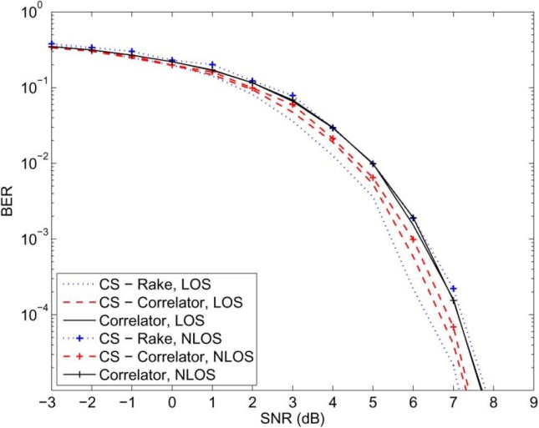

Fig. 4. Indoor residential BER performance for CS-Correlator, CS-Rake, and traditional correlator with .

- The CS-Correlator outperforms the traditional correlator for all range of SNR.

- This shows that the reconstructed template using CS framework, , is more reliable for symbol detection than the one obtained by averaging the received pilot signal, .

- This performance is expected since a denoising operation is inherently applied on the recovered signal yielding a template that is a linear combination of the transmitted pulses.

- The performance of CS-correlator for LOS channel is better than that for NLOS channel.

- This is also expected since NLOS channel introduces more multipath components than LOS channel, yielding thus a received UWB signal with less sparsity.

- CS-Rake outperforms the correlator-based detectors for LOS channel and yields competitive performance to that yielded by the traditional correlator for NLOS channel.

- As can be seen, CS-Rake degrades its performance for dense multipath channel since the CS channel estimation is unable to resolve the strongest paths among the multiple closely spaced propagation paths.

2. BER Performance for Different Number of Pilot Symbols :

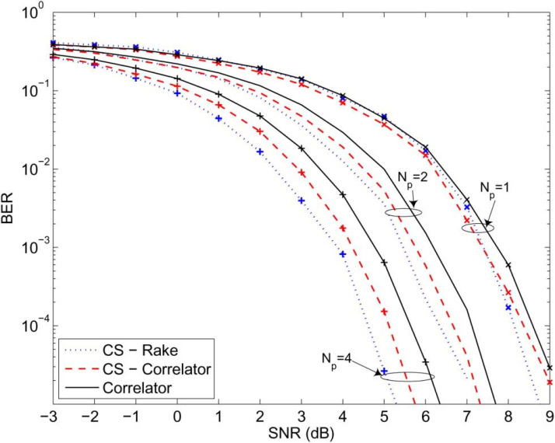

Fig. 5. BER performance for different number of pilot symbols, with 

- Increasing the number of pilot waveforms, improvement in the channel estimation is achieved, leading to a performance gain on all the methods.

3. BER Performance for Different Number of Projections :

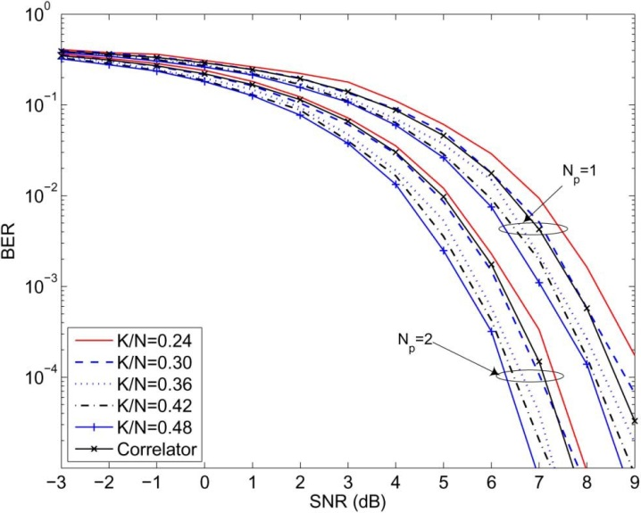

Fig. 6. BER performance for different number of projections.

- As expected, the CS-correlator’s performance improves as the number of projections increases.

- More interestingly, by sampling the random projected signal at 30% of the signal’s sampling rate, the CS-Correlator achieves the same performance as that yielded by the traditional correlator.

- Thus, with reduced ADC resources, the CS framework is able to reconstruct a template as good as the one obtained sampling the received UWB signal at a much higher sampling rate.

# discussion

- What is the relation between estimated parameters and CS?

Because of the UWB property, and the equation (3) we can use the result of MP for estimate the parameters.

- What is the value of dictionary? (form time domain to discrete domain)

 From the uniformly sampled , we can generate the dictionary  as shifted version of pulse signal.

- How to reduce the # of samples?

 If we think about one frame, in tradition method, we need all sample point of frame (e.g. 2048) but, by using CS, form only 250 samples, we can reconstruct the original signals.